|  |
| --- |
|  |
| Social Innovation as Valuation and Outcome Category of SNSF Funded Research |
| Report |

Zentrum für Soziale Innovation

June 2022

**Social Innovation as Valuation and Outcome Category of SNSF funded Research**

ZSI – Zentrum für Soziale Innovation

Suggested citation: Schuch, K., Lampert, D., Neuhuber, T. Koller, K., Demir, U. and L.-A. Plumhans (2022). Social Innovation as Valuation and Outcome Category of SNSF funded Research. ZSI: Vienna.

Contact:

Klaus Schuch (schuch@zsi.at)

Linke Wienzeile 246

1150 Vienna

Austria

More information on the ZSI is available on the internet (www.zsi.at).

Vienna: Centre for Social Innovation, June 2022

Table of Content

Table of Content 2

1) EXECUTIVE SUMMARY 6

2) INTRODUCTION 6

2.1 Rational and background of this study 6

2.2 Study design and applied methods 6

3) SOCIAL INNOVATION AS A RESEARCH CATEGORY 7

3.1 Meaning of Social Innovation 7

3.2 Attributes of Social Innovation 7

4) SOCIAL INNOVATION IN SNSF FUNDED PROJECTS 8

4.1 Familiarity and self-assessment – a first approximation 8

4.2 Extent of transdisciplinarity in SNSF funded projects 13

Involvement of non-academic actors in different project phases 19

4.3 Productive interactions: challenges and attempted solutions 26

Challenges of transdisciplinarity 26

Skills for transdisciplinary research 31

5) TOWARDS NEW SOCIAL PRACTICES? MOTIVATION, INTENTION AND TARGETED OUTCOMES 33

5.1 Motivation and intention 33

Intention to benefit social groups and tackle social purpose 37

Intended change amongst whom? 42

Intended change of what? 44

5.2 Targeted outcomes and solutions 48

Further outcomes of SNSF funded research projects 58

Communication and Dissemination of results 60

Exploitation and follow-up activities 63

6) LIMITATIONS AND BARRIERS ON THE ROAD TO IMPACT 66

7) EXCURSUS: THE VIEW FROM PRACTICE PARTNERS 70

Motivation and social purpose 70

Impact and change for practice partners 71

How can change and impact be facilitated? 72

Interactions with academic partners and challenges in these interactions 74

Benefits for practice partners 76

Sustainability and exploitation 77

8) WRAP-UP 1: VALUATION OF FURHTER OUTCOME CATEGORIES OF SNSF FUNDED RESEARCH 78

9) WRAP-UP 2: TOWARDS A MODEL OF ASSESSING SNSF’ CONTRIBUTION TO SOCIAL INNOVATIONS 84

10) LITERATURE 85

11) ANNEX 89

**List of Tables**

Table 1**:** Analytical dimensions to identify social innovations 6

Table 2: Kruskal-Wallis and Pairwise Wilcoxon rank sum test results on SI-Familiarity by research domains 12

Table 3: Correlation matrix between the deliberate planning for benefits for and the nature of involvement of target groups outside academia 16

Table 3: Distribution of different motivation types 34

Table 4: Correlation matrix between transdisciplinary experience, the motivation to address a specific problem, and the motivation to improve the human condition/welfare 35

Table 5: Distribution of impulses from the non-academic world (n = 360) 37

Table 6: Distribution of impulses from the non-academic world (multiple choice) 38

Table 7: Distribution of target group goals 41

Table 8: Distribution of intended change 45

Table 9: Direct contribution to target group(s) 49

Table 10: Correlation matrix between the motivation to improve the human condition/welfare and the direct contribution of the project results to target groups 51

Table 11: Impact statements – change affected through the funded research project 54

Table 12: Correlation matrix between citizens' level of involvement and selected outcome variables 56

Table 13: Dissemination channels 59

Table 14: Self-assessment in terms of transdisciplinary experience, familiarity with SI, project's contribution to SI 89

Table 15: Level of interdisciplinary and transdisciplinary involvement 89

Table 16: Nature of transdisciplinary involvement per stakeholder group 90

**List of Figures**

Figure 1: Overview on the Research Design 5

Figure 2: Multi-method approach 6

Figure 3: SI-familiarity, familiarity with transdisciplinarity, and project’s contribution to SI (self-assessment) 9

Figure 4: Distribution of self-assessed SI-Contribution 10

Figure 5: Distribution of the familiarity with SI 10

Figure 6: Distribution of the familiarity with SI between different scientific domains 11

Figure 7: Level of interdisciplinary and transdisciplinary involvement 13

Figure 8: Stakeholder groups involved in transdisciplinary research 13

Figure 9: Nature of transdisciplinary involvement per stakeholder group 14

Figure 10: Relation between the deliberate design for benefits for and the nature of involvement of target groups outside academia in the research process 15

Figure 10**: R&D phases and procedures for social innovation research** 18

Figure 11**: Transdisciplinary advantages during project phases** 24

Figure 12: Distribution of different motivation types 33

Figure 13: Relation between transdisciplinary experience and the motivation to affect change outside academia 35

Figure 14: Distribution of extent to benefit target groups outside the academic world 36

Figure 15: Distribution of extent to benefit target groups outside the academic world across scientific domains 37

Figure 16: Distribution of impulses from the non-academic world (multiple choice) 39

Figure 17: Distribution of intended change 45

Figure 18: Interview findings differentiated between change categories and target groups 46

Figure 19: Direct contribution to target group(s) 49

Figure 20: Relation between the motivation to improve the human condition/welfare and the direct contribution of the project results towards... 50

Figure 22: Uptake of project results by policy-makers 52

Figure 23: Kind of uptake of project results by policy-makers 53

Figure 24: Impact statements – change affected through the funded research project 53

Figure 25: Types of scalability 55

Figure 26: Relation between citizens' level of involvement and selected outcome variables 56

Figure 27: Distribution of dissemination channel 60

1. EXECUTIVE SUMMARY

Our proposal aims to trace contributions of research funded by SNSF to social innovations, and to systematise these contributions in a valuation framework. In addition, we aim to identify to what extent contributions to social innovation in SNSF-funded research projects are possible at all, and where further support measures, either provided by SNSF or from outside (e.g. by the universities), could create an added value that could not be tapped so far.

1. INTRODUCTION

2.1 Rational and background of this study

Our proposal aims to trace contributions of research funded by SNSF to social innovations, and to systematise these contributions in a valuation framework. In addition, we aim to identify to what extent contributions to social innovation in SNSF-funded research projects are possible at all, and where further support measures, either provided by SNSF or from outside (e.g. by the universities), could create an added value that could not be tapped so far.

2.2 Study design and applied methods

Our proposal aims to trace contributions of research funded by SNSF to social innovations, and to systematise these contributions in a valuation framework. In addition, we aim to identify to what extent contributions to social innovation in SNSF-funded research projects are possible at all, and where further support measures, either provided by SNSF or from outside (e.g. by the universities), could create an added value that could not be tapped so far.

Figure 1: Overview on the Research Design

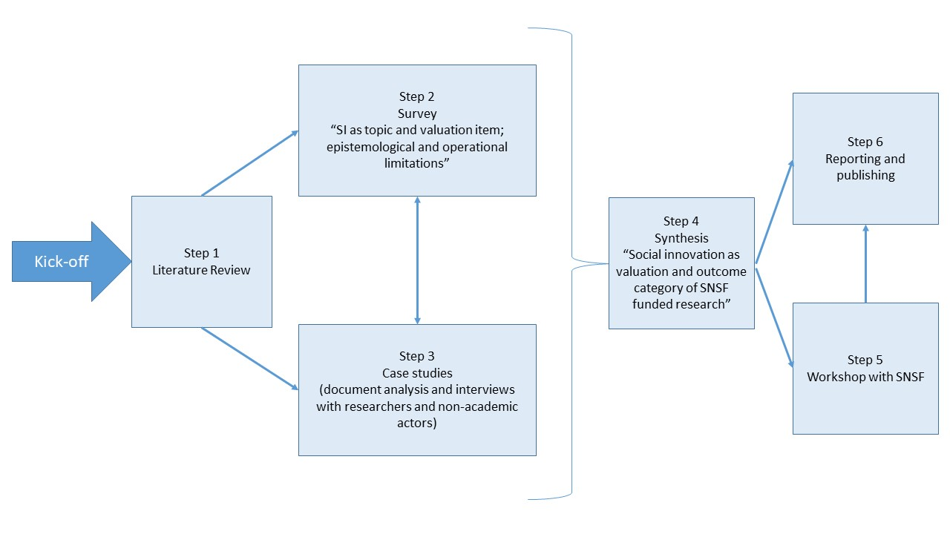

Source: Own illustration

Our proposal aims to trace contributions of research funded by SNSF to social innovations, and to systematise these contributions in a valuation framework. In addition, we aim to identify to what extent contributions to social innovation in SNSF-funded research projects are possible at all, and where further support measures, either provided by SNSF or from outside (e.g. by the universities), could create an added value that could not be tapped so far.

Figure 2: Multi-method approach

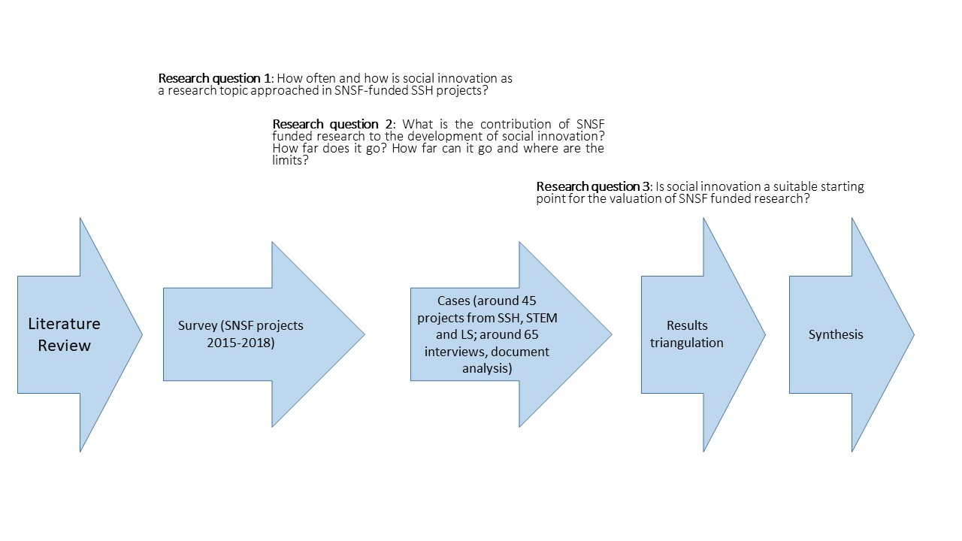

Source: own illustration

1. SOCIAL INNOVATION AS A RESEARCH CATEGORY

3.1 Meaning of Social Innovation

Our proposal aims to trace contributions of research funded by SNSF to social innovations, and to systematise these contributions in a valuation framework. In addition, we aim to identify to what extent contributions to social innovation in SNSF-funded research projects are possible at all, and where further support measures, either provided by SNSF or from outside (e.g. by the universities), could create an added value that could not be tapped so far.

3.2 Attributes of Social Innovation

Our proposal aims to trace contributions of research funded by SNSF to social innovations, and to systematise these contributions in a valuation framework. In addition, we aim to identify to what extent contributions to social innovation in SNSF-funded research projects are possible at all, and where further support measures, either provided by SNSF or from outside (e.g. by the universities), could create an added value that could not be tapped so far.

Table 1**:** Analytical dimensions to identify social innovations

|  |  |
| --- | --- |
| Analytical dimensions | 1. Social innovation results in a *changed social practice* (= object of a social innovation). |
| 1. A social innovation must be *new in a specific context or for a specific actor.* |
| 1. A social innovation is *developed to fulfil a social purpose* in that sense that it aims to better cope with needs and problems than is possible by using existing practices |
| 1. Social innovations are *intentionally solution-oriented* *and prompted by actors or a constellation of actors*. They do not just happen and they are not the same as social change, but they can contribute to it. |
| 1. A social innovation is more than an idea and must be *put into practice* (i.e. difference between idea, invention and innovation in analogy with techno-economic innovation) |

Source:

Our proposal aims to trace contributions of research funded by SNSF to social innovations, and to systematise these contributions in a valuation framework. In addition, we aim to identify to what extent contributions to social innovation in SNSF-funded research projects are possible at all, and where further support measures, either provided by SNSF or from outside (e.g. by the universities), could create an added value that could not be tapped so far.

1. SOCIAL INNOVATION IN SNSF FUNDED PROJECTS

Both the survey directed to a representative sample of the SNSF funded PIs as well as the follow-up interviews with a subset of survey participants were geared towards extracting SI related aspects in SNSF funded projects. This chapter discusses three main parts of the analysis, namely;

* self-reflection of the SNSF funded Principal Investigators (PIs) regarding their familiarity with SI and transdisciplinarity as well as their self-assessment of social innovation contributions of their research projects,
* transdisciplinarity involvement of non-academic actors in the SNSF funded projects,
* perceived challenges respectively attempted solutions in creating and maintaining “productive interactions” with non-academic actors.

4.1 Familiarity and self-assessment – a first approximation

The first step of capturing social innovation (SI) in SNSF funded research projects was to gather researchers’ perception of their own familiarity with the topic and their projects’ relation to social innovation. This reflection has been addressed both in the survey and the follow-up interviews with SNSF funded PIs.

First we scrutinised the PIs *experience with* *transdisciplinary research*. There are several ways to understand the concept of transdisciplinarity. In the context of this study, we depart from the Swiss Academy of Sciences' definition[1] of *transdisciplinary research* as a “[…] *societal problem solving with scientific knowledge production in a process of co-producing knowledge*.” Following-up this definition, we define transdisciplinary research as a research process that includes non-academic knowledge embedded in non-academic actors in a consultative, contributory, cooperative or co-creating way. With this definition, we refer to Shirk et al. (2012)[2], who differentiate five ways of participation of non-academic actors in research:

1. contractual projects (professional researchers are commissioned by citizens, public authorities, municipalities or other organisations)
2. contributory projects (citizens collect data for scientific projects)
3. collaborative projects (citizens not only collect data, but also help refine the study design, analyse data and / or disseminate results)
4. co-created projects (which are designed jointly by researchers and the public and for which at least some of the citizens are actively involved in aspects of the research process), and finally
5. collegial contributions (where people without academic qualifications carry out independent research and share their results with researchers).

The general background for this understanding is the insight that research, which is early and continuously involving non-academic actors with a specific purpose, has positive effects both on conducting more user-centred research and on the impact of research (Staley, 2009)[3]. There is well-established knowledge that 'public engagement' is suitable for various RTI[4]-political issues, not at least in cases of scientific and technology conflicts or related value conflicts. Public involvement enables alternative rationalities, problem perspectives and solution preferences to be taken into account. It contributes to the democratization of scientific and technological developments, enables knowledge transfer (in both directions) and creates awareness (Schuch et al., 2016)[5].

At this point, however, it has to be noted, that also possible disadvantages or risks might occur: ‘involvement’ generally connotes terms of inclusion, openness and democratization. Nevertheless, the associated processes and activities may include also ethical risks of exploitation, manipulation and control. Moreover, not infrequently, the definition of the terms ‘participation’, ‘engagement’ or ‘involvement’ is diffuse. Public participation[6] is often understood as umbrella term. The *functional understanding of public participation* has different granularities and ranges from information, inclusion, participation, co-creation, to co-determination. In this broad sense, participation fulfills several functions that are oriented towards the degree of involvement and empowerment of the public: information function, consultation function, involvement function, collaboration function and empowerment function.

In view of social innovation (SI), scholarly literature goes as far as stating that *transdisciplinary aspects* are central (and necessary) to SI-related research. Murray et al. (2010, p. 3)[7] define SI *as social in their ends and their means*. By *social in their means,* the authors refer to an inclusive approach that not only reaches out, but also includes the target groups or beneficiaries of a social innovation in an intervention. Thus, it can be argued that *transdisciplinarity* needs to be regarded as a centrally important indicator for SI-relevant endeavours. In contrast to this notion, however, our theoretical framework does not consider *transdisciplinary involvement* as sine qua non (i.e. as a necessary prerequisite) for research projects to contribute to SI. That said, we still expect it to be more influential than other factors.

Table 2: Distribution of transdisciplinarity experience among scientific domains

|  |  |  |  |  |  |  |
| --- | --- | --- | --- | --- | --- | --- |
| rating | Biology and Medicine  (n=106) | | Humanities and Social Sci.  (n=126) | | Math., Nat. and Engi. Sci.  (n=124) | |
| *0..lowest*  *10..highest* | **abs** | **%** | **abs** | **%** | **abs** | **%** |
| 0 – 3 | 34 | 32.07% | 23 | 18.25% | 36 | 29.03% |
| 4 - 6 | 29 | 27.35% | 26 | 20.63% | 35 | 28.22% |
| 7 - 10 | 43 | 40.56% | 77 | 61.11% | 49 | 39.51% |
| *Total* | 106 | 100% | 126 | 100% | 124 | 100% |
| *no resp.* | 2 |  | 2 |  | 5 |  |

When asked about their ***experience with transdisciplinary research***, 48 % of respondents to the survey (n= 352) stated that they are experienced with transdisciplinary research (7 and higher on a 0-10 scale; 10 being the maximum), and 26 % replied to be somewhat experienced. Another 26 % responded that they were not experienced (3 and below; 0 being the minimum). Figure 3 (first row) provides a visual overview on this distribution. We can thus conclude that a high share of PIs funded by SNSF are experienced with transdisciplinary research. Please note, however, that experience with transdisciplinary research does not automatically mean, that transdisciplinary practices were employed in the projects scrutinised by our survey.

Although the distribution of transdisciplinary experience (0…10 from lowest to highest) by age group showed some variance, a general trend was not visible. Even the younger age groups among the PIs are spread across a spectrum from low to high degree of transdisciplinary research experience.

Figure 3: SI-familiarity, familiarity with transdisciplinarity, and project’s contribution to SI (self-assessment)

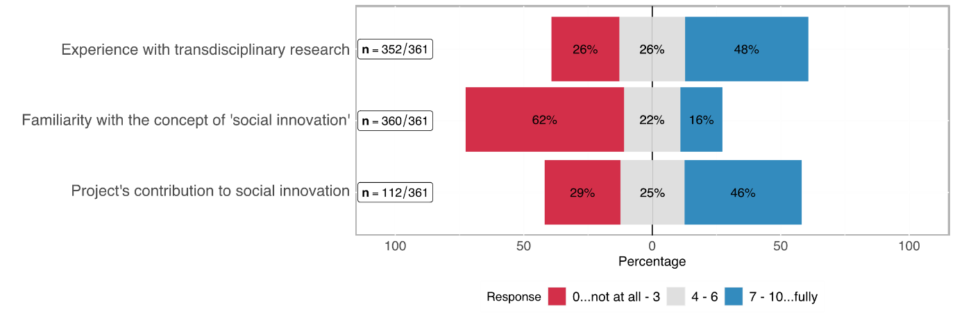

As regards the ***familiarity with social innovation (SI)***, 360 participants responded. 62 % of whom stated to be *not at all* to *barely* familiar with the idea of SI (3 and below on a 0-10 scale), roughly 22 % consider themselves as moderately familiar (4-6 on that scale), and 16 % as *high* to *highly familiar*. Figure 3 (second row) provides a visual overview on this distribution.

This variable is particularly interesting when further analysing whether researchers from a scientific domain are more familiar with the concept than researchers from another scientific domain. Figure 5 delivers answers this specific question. Overall, we can summarise that a rudimentary conceptual understanding of SI is not (yet) common sense in the scientific world.

Table 3: Distribution of project's contribution of SI (self-assessment) among scientific domains

|  |  |  |  |  |  |  |
| --- | --- | --- | --- | --- | --- | --- |
| rating | Biology and Medicine  (n=18) | | Humanities and Social Sci.  (n=67) | | Math., Nat. and Engi. Sci.  (n=24) | |
| *0..lowest*  *10..highest* | **abs** | **%** | **abs** | **%** | **abs** | **%** |
| 0 – 3 | 5 | 27.77% | 14 | 10.89% | 14 | 51.85% |
| 4 - 6 | 5 | 27.77% | 18 | 26.86% | 5 | 18.51% |
| 7 - 10 | 8 | 44.44% | 35 | 52.23% | 8 | 29.62% |
| *Total* | 18 | 100% | 67 | 100% | 27 | 100% |
| *no resp.* | 90 |  | 61 |  | 98 |  |

Out of the 113 *eligible*[8] participants, i.e. those who believe to be more familiar with SI (5 or higher on a scale from 0 to 10), 112 chose to answer the question regarding the ***contribution of their specific SNSF funded project to SI*** (see bottom row of Figure 3). Of those, 29 % stated that their project contributed little to nothing to SI (3 and below on a 0-10 scale), while 46 % stated that their projects contribution to SI was high to very high (7 or higher on a 0-10 scale). Figure 4 shows this distribution in detail.

If we combine the number of PIs with a self-assessment of an average or higher familiarity with the concept of SI (5 or higher on a scale from 0 to 10) (n= 113) with the number of PIs who perceived that the contributions of their SNSF funded projects for SI were high or very high (n= 51), than we can conclude that 14.1% of all scrutinised SNSF funded projects (n= 360) have a clear attribution to SI. In other words, 14.1% of all responding PIs from SNSF funded projects are characterised by a sufficient understanding of the concept of SI and a high outcome-orientation towards SI. Although this share of PIs is overall not large, it is definitely not a negligible group!

Figure 4: Distribution of self-assessed SI-Contribution

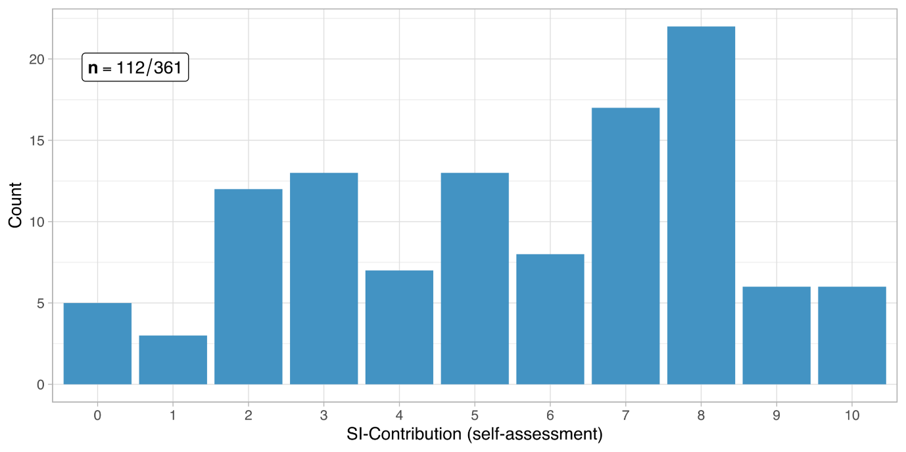

We further explored if there is a difference between scientific domains when it comes to the familiarity of researchers with the concept of SI. The distribution of survey participants in our sample across the three domains is balanced, each represents roughly one third of the overall number of SNSF funded PI. As Figure 5 shows, the share of researchers from the Humanities and Social Sciences increases with each higher degree of *familiarity with SI* while the share of the other two domains dwindles in comparison.

Figure 5: Distribution of the familiarity with SI

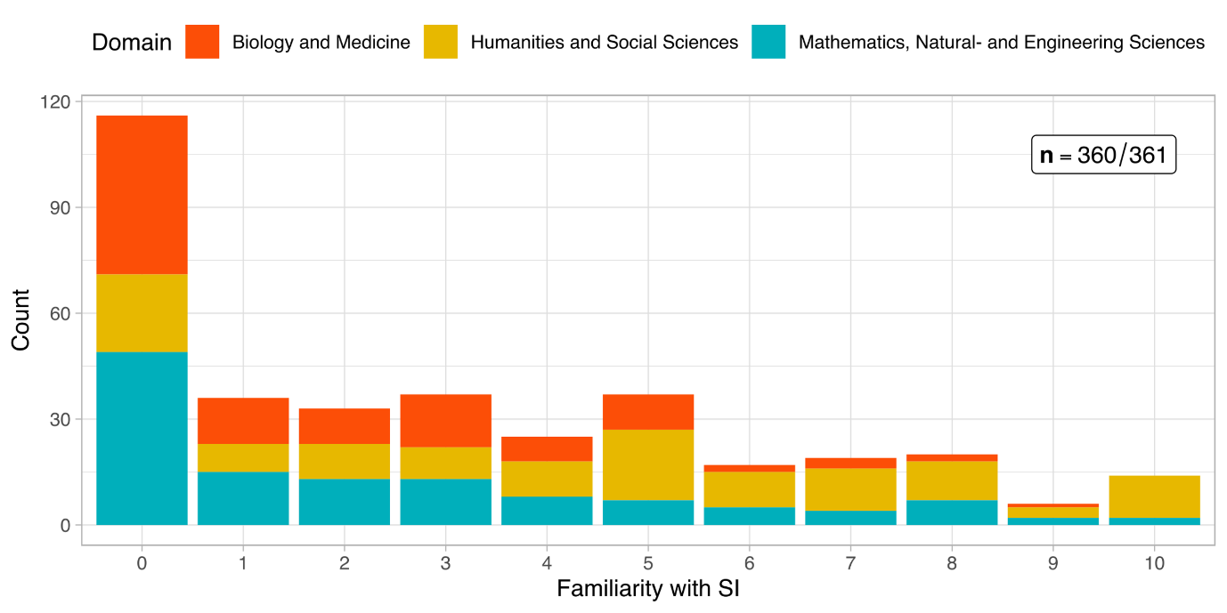

Following the literature on SI characteristics in varying research domains (Schuch 2019; Paunov et al. 2017)[9], we were assuming that

* H2: *the familiarity with SI* depends on the *research domain*.

The analysis of the survey results yielded a statistically significant difference in SI-familiarity between the scrutinised three major scientific domains applied by SNSF (Kruskal-Wallis[10] [K-W] rank-sum test; 𝛘2 = 45.7, df = 2, p-value < 0.05).

Figure 6 suggests that *Humanities and Social Sciences (SSH)* show a generally higher *familiarity with SI*. A post-hoc test (see Table 4) confirmed a statistically significant difference compared to the other two domains (Pairwise comparisons using Wilcoxon [P-W] rank-sum test[11] with Bonferroni correction, p-value < 0.05 for each pairing). On the other hand, the domains Mathematics, Natural -, & Engineering Sciences and Biology & Medicine do not differ from each other significantly with regards to the SI-Familiarity ([P-W] p-value > 0.05).

Figure 6: Distribution of the familiarity with SI between different scientific domains

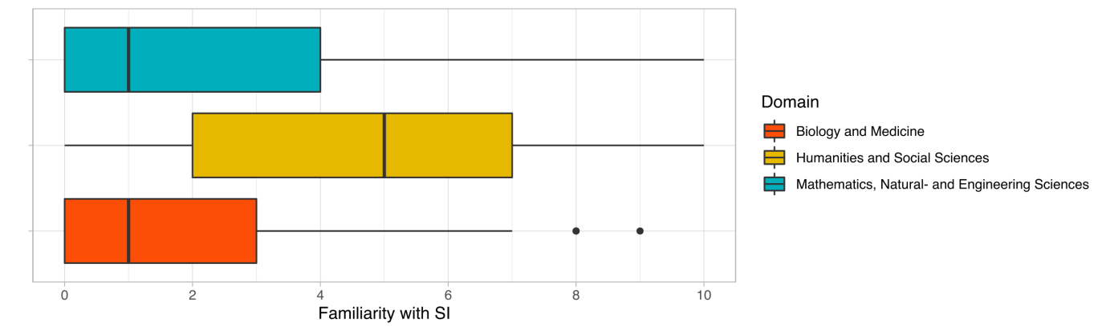

Table 4: Kruskal-Wallis and Pairwise Wilcoxon rank sum test results on SI-Familiarity by research domains

|  |
| --- |
| Kruskal-Wallis rank sum test:  data: familiarWithSI.response. by domain  Kruskal-Wallis chi-squared = 45.694, df = 2, p-value = 1.196e-10  Pairwise comparisons using Wilcoxon rank sum test with continuity correction:    Biology and Medicine  Humanities and Social Sciences 2.0e-09  Mathematics, Natural- and Engineering Sciences 1  Humanities and Social Sciences  Humanities and Social Sciences -  Mathematics, Natural- and Engineering Sciences 2.8e-07  -- P value adjustment method: bonferroni  **RESULT**   * H2: K-W test with a p-value way below α shows we can reject the null hypothesis. This means, that there is a statistically significant association between the familiarity with SI and research domains. However, the only significant difference is yielded for SSH, compared to the other two domains (P-W). |

We can thus confirm that the concept of Social Innovation is significantly more known in the domain of SSH than in the other two SNSF domains. However, SI itself is not a category limited to SSH, but occurs throughout all three SNSF domains, predominately in SSH.

4.2 Extent of transdisciplinarity in SNSF funded projects

We measured *transdisciplinary involvement* by levels pf inclusion of different types of societal actors and groups in the research process. Although by far not as central as the *interdisciplinary* cooperation (i.e. the cooperation of different disciplines within a SNSF funded research project), different types of transdisciplinary engagement constitute a noteworthy part of SNSF funded research projects.

As shown in Figure 7 transdisciplinary involvement of societal actors and groups such as *citizens*; *policy makers and representatives of public administration and governmental agencies*; *institutions providing welfare or education*; or *companies*, yield somewhat similar distributions among the surveyed projects (22 % - 27 % of marginal to high involvement). An exception to this rather equal distribution is media, which was quite often integrated in SNSF projects, but rarely centrally. Thus, we assume that media was mainly engaged for pure dissemination purposes.

Survey results show that interdisciplinary cooperation is already common in the majority of projects funded by the SNSF. 41 % of the respondents noted that the involvement of academicians from other disciplines was quite central to their specific project (see Figure 7). In total 78 % of the projects were carried out in collaboration with researchers from other disciplines.

Figure 7: Level of interdisciplinary and transdisciplinary involvement

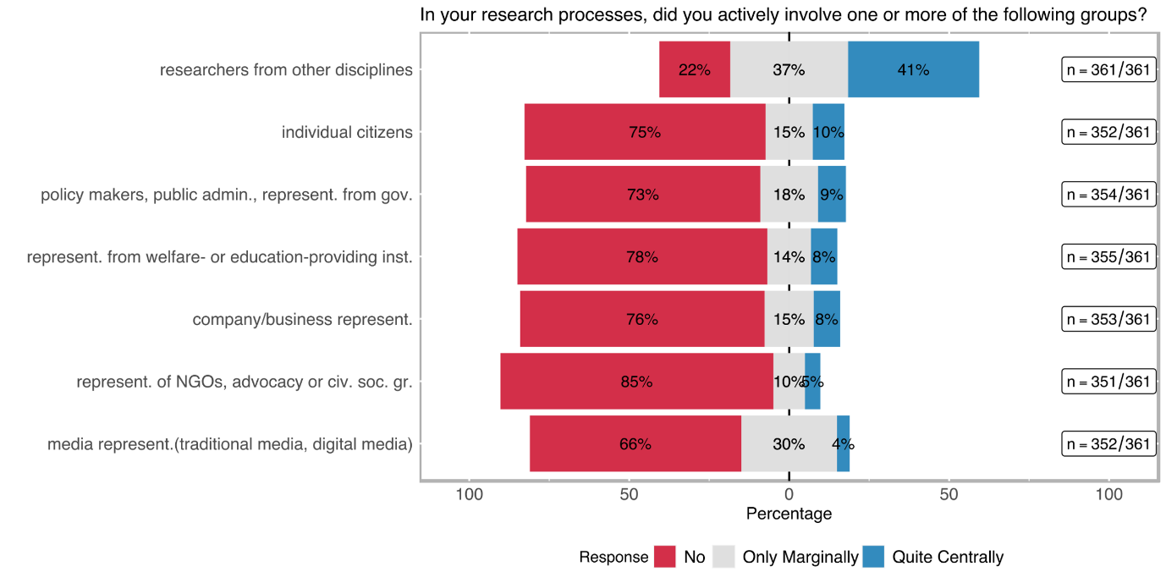

For around 8%-10% of the respondents, the involvement of individual citizens (e.g. as beneficiaries, customers, or concerned persons); policy makers, representatives from public administrations and governmental agencies; company/business representatives (incl. farmers) or representatives from welfare- or education-providing institutions (such as schools, kindergartens, hospitals, or care centres) was quite central. The involvement of representatives of NGOs, advocacy or other civil society groups was quite central to only 4.8% of the respondents (see Figure 7). It should be noted, that multiple answering to the question of involvement of various societal actors and groups in one project was possible.

Figure 8 shows how many projects chose to work with more than one non-academic group during their implementation. Only 37 % of the scrutinised projects did not include non-academic actors or societal groups. This means on the other side, that more than 60% of SNSF funded projects involved non-academic actors at least marginally in their research process. In fact, the share of projects that include at least one, two or three different non-academic actors or groups amounts to 48 %; 9 % of the surveyed projects include even more than 3 (out of 6) different types of non-academic actors or groups.

Figure 8: Stakeholder groups involved in transdisciplinary research

The centrality of the involvement of non-academic actors and groups indicates to which extent specific groups were involved in the project. We approximate centrality with the *nature of involvement* (indicated with the labels; *consultative, contributory, collaboratively, co-created* as explained in section 4.1).

Figure 9 shows that *transdisciplinary involvement* is mostly *consultative* or *contributory*. *Collaborative transdisciplinary* involvement is more likely employed when welfare/education institutions or company/business representatives are involved in the project (20 % and 22 % respectively). A co-creation approach is rarely being followed in the SNSF funded projects: the highest co-creative involvement belongs to projects that include individual citizens (10 %).

Figure 9: Nature of transdisciplinary involvement per stakeholder group

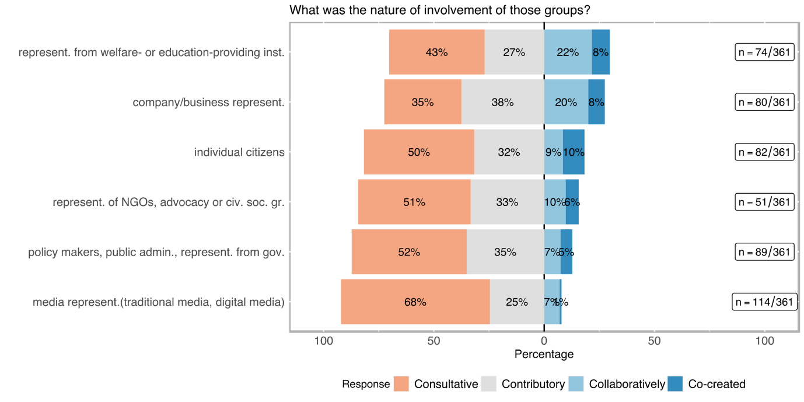

Literature suggests that a deliberate planning of benefits for non-academic groups correlates positively with the exercised nature of their involvement in research processes (Mauser et al., 2013). Therefore, we tested the following hypothesis by selecting three different societal groups*,* namely (i) *citizens*, (ii) *civil society organisations & NGOs*, and (iii) *welfare & educational institutions.*

* H4.1 *the level of the deliberate planning of benefits for non-academic target group(s)* correlates positively with the nature of their involvement in research processes

Figure 10: Relation between the deliberate design for benefits for and the nature of involvement of target groups outside academia in the research process

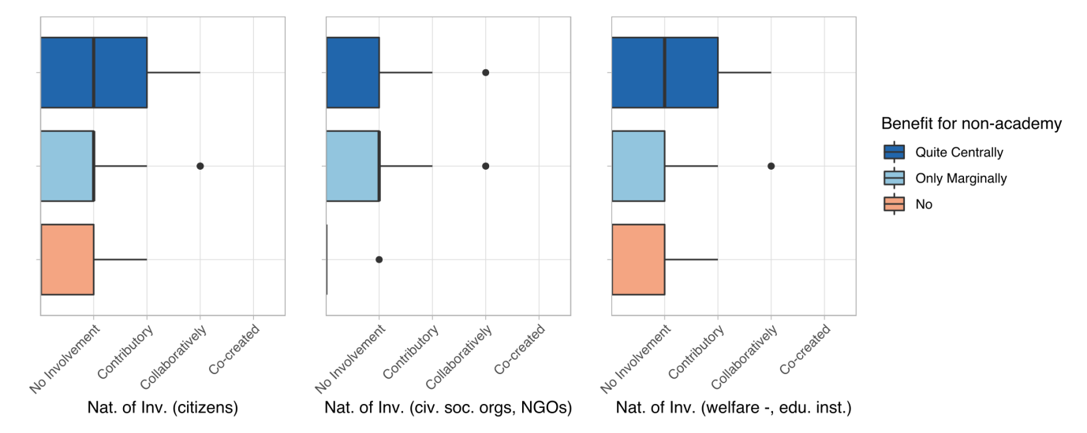

Figure 10 suggests no or only a small correlation between the intent to create direct *benefits for target groups* on the one hand and the *nature of involvement* of those target groups in research processes on the other hand. Looking more closely at the three selected societal target groups, it turns out that the correlation between deliberate benefit-orientation and the *nature of involvement* of **citizens** as well as **civil society organisations & NGOs** in the research process is weak (rho < 0.15 for each; relation is displayed in Table 3) and not statistically significant (p-value > 0.05 for each pairing). Only the relation between the *nature of involvement* of the **representatives of welfare and educational institutions** in the research processes and the benefit-orientation of the project design is significant; still displaying only a weak correlation (rho ≈ 0.3).

Although we can observe a modest relation, a deliberate design to benefit specific societal groups does not seem to correlate overall with a deeper level of involvement of societal groups in research processes. In other words, the intention to create benefits for specific selected groups does not necessarily correlate with more intense engagement practices. Maybe the welfare and education sector is an exception to this, because one can speculate that more deep engagement practices with stakeholders from these two sectors are already more often practiced. Another explanation attempt is that the welfare and education sectors are more formalised (and thus easier to handle) than the other scrutinised sectors of NGOs and citizens, which are certainly characterized by a higher variability and a lower possibility of standardizing transdisciplinary collaboration.

Table 5: Correlation matrix between the deliberate planning for benefits for and the nature of involvement of target groups outside academia

|  |
| --- |
| Correlation:  Benefit for non-academy citizens civ. soc. org.  Benefit for non-academy 1.00 0.15 0.05  citizens 0.15 1.00 0.37  civ. soc. org. 0.05 0.37 1.00  welfare inst. 0.31 0.51 0.16  welfare inst.  Benefit for non-academy 0.31  citizens 0.51  civ. soc. org. 0.16  welfare inst. 1.00  Sample Size:  Benefit for non-academy citizens civ. soc. org.  Benefit for non-academy 360 82 51  citizens 82 82 34  civ. soc. org. 51 34 51  welfare inst. 74 41 23  welfare inst.  Benefit for non-academy 74  citizens 41  civ. soc. org. 23  welfare inst. 74  P-Values  Benefit for non-academy citizens civ. soc. org.  Benefit for non-academy 0.1882 0.7077  citizens 0.1882 0.0294  civ. soc. org. 0.7077 0.0294  welfare inst. 0.0077 0.0007 0.4541  welfare inst.  Benefit for non-academy 0.0077  citizens 0.0007  civ. soc. org. 0.4541  welfare inst.  **RESULT**   * H4.1: the *intention to benefit society* and the *nature of involvement of citizen* and *civil society groups (incl. NGOs)* in research  processes have p-values > 0.05. This means that we cannot reject  the null hypothesis for each of these, i. e. there is no statistically significant relationship between the two analysed variables. * H4.2: the *intention to create benefits* for stakeholders from the  welfare and education sector has a statistically significant re­ lationship (α < 0.05) with the *nature of involvement*, although it  correlates relatively weakly (rho=0.3). |

Through the interviews, we could further identify that for many principal investigators (PIs) inter- and transdisciplinary research designs and implementation practices were considered as a central element of novelty in their research. While novelty is usually related to scientific discoveries, new scientific methods, innovative research questions or academically induced innovations, several interviewees reported that the novel part of their research was the way they approached the project by applying new concepts or techniques that were either new for them or for their respective fields.

Some interviewees highlighted that by simply introducing aspects from other disciplines into their research, the potential impact of the results and findings for academics and practitioners alike multiplied. Other interviewees mentioned that “minor” adjustments in research designs drastically affected the outcomes of projects. Similarly, it was emphasized that while interdisciplinarity is common in many research fields, some PIs decided to incorporate interdisciplinary aspects, albeit uncommon in their specific field, because they believed that such an approach could contribute to a more holistic perspective on the researched topics, e.g. at the interface between fundamental and applied research but also at the interface between natural and social sciences. Overcoming disciplinary boundaries and designing research projects not only according to the standards of one field but two or more was perceived as very innovative with a potential to lead to higher impact both in and outside of academia.

Almost half of the interviewed PIs reported that the novel aspect of their research was the contribution to practice, for example, the improvement of teachers’ training or medical treatment. Other interviewees argued that their innovative aspects lay within the transdisciplinary aspects of their research designs. However, not all of the interviewees who identified relevance for practice, applied transdisciplinary elements in their research. On the other hand, all of the interviewees who conducted transdisciplinary research argued that their research projects were tied to phenomena in the practical world.

Interview partners argued that there is a “feedback loop” between academia and practice, which offers a ground for learning. One interviewee recounted that while practitioners can learn from academic knowledge, researchers can benefit from incorporating “practical knowledge” into their projects.

*“First of all, we describe what the professionals do because, in the institutions, we often don't know what the professionals do. There is a diversity of practices, so it is really important to go to the institutions, to go to the field, to describe what professionals do. And there is a knowledge that is built up among social workers - so this is something that is attributed to all professionals, but in social work, as it is highly experimental, it is even stronger. There is something of an invention in the work. So, it's very important to be able to produce knowledge for that. Already for professional training, there is something of social innovation, because the idea is to allow the training of social workers to be nourished by the new knowledge that is built up in the field. Because obviously, in the institutions, in addition, the problems evolve. They evolve all the time. There is this basic innovative side.” Interviewee 1*

Furthermore, some interviewees mentioned that although their research is generally more theoretical and fundamental, they understand their scientific activity always as related to practice. While some interviewees claimed that the boundaries and limits of fundamental research are its limited impact outside of academia, others highlighted that these boundaries can be overcome by incorporating translational science aspects into the project from the start but also at later stages, e.g., by flexibly including stakeholders, pursuing dissemination strategies or undertaking exploitation activities.

Involvement of non-academic actors in different project phases

We also aimed to understand in which phases of the project non-academic actors and/or social groups have been involved. We differentiate between three different project phases.

1. Firstly, the proposal phase, which is defined as the stage during which the project plan and research design is developed, and the application to the SNSF is initiated. Sometimes, exchanges with non-academic actors or groups went back to a time when the concrete project idea was not mature. Yet, some of these interactions may prove to be invaluable for the project outline and the subsequent execution.
2. The second phase is the implementation phase. This stage refers to the period where a project has already started and tasks (e.g. data collection) aimed at achieving the projects’ objectives are undertaken.
3. The third and last phase of a project is the exploitation phase, where results are prepared in a way to facilitate uptake and use (e.g. by patenting) and dissemination activities are carried out (see Figure 9).

Our interviews with a selected subset of survey participants also focused on these different phases of potential transdisciplinary involvement. Most interviewees[12] reported interactions with non-academic actors. Most often, their transdisciplinary approach was intentionally included in the research design. In some cases, the communication and exchange with actors outside of academia emerged during the research implementation when interviewees noticed that a particular aspect of an issue could only be solved in conjuncture with others. However, there were also cases where the exchange took only place with other researchers.

Figure 10**: R&D phases and procedures for social innovation research**

**Source:** Own illustration based on the stages of SI according to Murray et al. (2010) and the Societal Readiness Levels Concept of the Innovation Fund Denmark.

In the following paragraphs the findings from the interviews are structured along identified non-academic groups involved in SNSF projects (media; project specific target groups; practitioners; businesses; other researchers; wider public; political actors and policy-makers; NGOs, civil actors and interest groups; foundations, association and museums), acknowledging however that some of these groups overlap.

1. **Media:** Interactions with the media mostly occurred during the exploitation phase. In most cases, this happened incrementally instead of being planned as part of the research project. Interviewees highlighted that in order to reach a wider audience, it was crucial to publish in non-academic media too. However, exchanges with media can also be problematic since a researcher has less control over what is being transmitted. One interviewee mentioned that although he wanted to raise awareness amongst society, he tried to communicate the outcomes in a very neutral way.

*“I think, in everything that I said, I try always to stick very closely to what we have done in our study and what findings we have. I think that was helpful in the sense that, I was not commenting on some general refugee issues, but “this is the study we have conducted. It has all these limitations, but that is what we found.” And that minimises the risk of being instrumentalised from any party.” Interviewee 6*

One interviewee highlighted that it is helpful to know someone who works at a media outlet and to develop a network of journalists. This way, researchers can benefit from a greater involvement and can thus be ascertained that their findings are communicated in a value-free way. Furthermore, it was emphasized that researchers often are not skilled in communicating with the public. They often use too scientific vocabulary and miss rhetorical skills. Hence, working with journalists can both extend the audience as well as overcome deficient communication skills.

Other researchers spoke to specific media that reach out to certain target groups, e.g. people with certain illnesses or handicaps. Another interviewee reported that he talked to a university magazine, which – in his opinion - had two main advantages. Firstly, such a channel operates on a less normative basis and communicates more value-free than certain daily newspapers. Secondly, university magazines are aimed at students who hence get the opportunity to read about the research that was undertaken at the university. This can help arouse interest for research projects amongst students in general as well as communicate subject-relevant information without the learning character of classroom teaching.

Only one interviewee reported that interactions with the media took place before the exploitation phase of the Project. Accordingly, his team worked together with journalists in order to recruit people for their experiment.

1. **Target group:** Exchanges with a project’s specific target group mostly happened during the implementation phase. Most often, target groups were included in the project through data collection (e.g., interviews or surveys). However, the degree of inclusion differed greatly between projects. While some project teams talked to their target group solely for the purpose of data acquisition, others continued working with them throughout the project. Several interviewees emphasized the need to empower the target group and to ensure that relevant stakeholders, i.e., practitioners and policy-makers, hear them. Yet, all interviewees who worked with their target group(s) stressed that it is crucial to talk to affected people when writing about them. Otherwise, as expressed by one interviewee, social science misses its goal to deliver outcomes that are as close as possible to the reality of those affected. But also researchers who did not have a social science background argued similarly. One natural scientist highlighted that as soon as science affects one or several groups of people, they should be given a chance to participate in the project and express themselves.

Some interview partners also mentioned interactions with target groups already in the proposal phase. For example, one PI recounted that before the project started, his team talked to acquaintances who could be possible project participants to better understand the phenomenon under scrutiny. Accordingly, this enabled the concerned researchers to adapt the proposal as well as to refer back to an already existing pool of project participants, which saved time during the project implementation phase.

In a few circumstances, the target group was also included in the exploitation phase of a project. One interviewee reported that she consulted her target group while simultaneously talking to practitioners and decision-makers in order to assure that the target group is not misrepresented.

Another interview partner reported that his team included participants even in the writing process:

*“[A]s regards the extracts from interviews that we inserted into scientific productions, we always sent the articles back to the people concerned. They had the whole article, not just their quotes, and we told them that's what we said, and some of them gave us feedback on their quotes but also on the article itself, by providing clarifications, explaining such and such a thing that they thought we might have misunderstood. It's very interesting because we're used to feedback from colleagues, everyone knows that, it's very interesting too, but the fact that we also have feedback from the actors themselves is quite interesting.” Interviewee 7*

1. **Practitioners:** Practitioners were included in all project phases. Some PIs reported that they talked to practitioners in the proposal phase to ensure their participation in the later stages of the project. It was highlighted several times that practitioners can contribute to the proposal by expressing their more applied and practical knowledge, which generates several benefits: First, the proposal incorporates several perspectives making the research propositions more holistic. Second, it increases the chances of the proposal to be funded, as funding organisations allegedly often value a transdisciplinary research design. Third, it makes the undertakings more applicable to “the real world” and, subsequently, outcomes more usable for experts outside academia. Fourth, practitioners can give valuable feedback to a proposal, which enables researchers to make necessary adjustments. One interviewee for example, who spoke to a Swiss association for retirement during the proposal phase noted that this exchange improved her proposal significantly and helped to sharpen her research question. Fifth, the early inclusion of practitioners could even change the direction of a research project more drastically as practitioners raise researcher’s attention to certain problems that appear in their work. Early interactions with practitioners can touch upon issues that have hardly been considered in research so far.

Several interview partners highlighted the continuous contact with practitioners, which allows them to revert to a network of praxis partners who might be interested in conducting projects together. Exchanges during the proposal phase can facilitate later access to the practice field as practitioners might have contacts they can pass on by acting sometimes as gatekeepers.

In many cases, practitioners were also consulted during the implementation phase. They helped with data collection either directly by participating in interviews or indirectly by providing secondary data. In other contexts, practitioners supported researchers with the planning and refinement of their method (e.g., drafting questions for surveys). There were also interactions beyond the immediate data collection and analysis phase:

*“So, perhaps it should be said that during the project, we are not in an approach where we come to the field, we collect the data and we leave. When the data is collected, there is also a whole restitution process, which takes place during the project. Every three or four months. Afterwards, it depends on the project. The idea is: during the course of the project, between the beginning, the collection of data and the end of the analysis, there are moments of intermediate feedback. We are also in the process of giving the teams our understanding, our working hypotheses and how we understand them. If they don't validate, we say to ourselves that there is something we haven't understood. So, participation is important. It is really important.” Interviewee 1*

Some interview partners confirmed interactions with practitioners in the exploitation phase and even after the end of the project. In many cases, these exchanges took place within the scope of conferences or events, when findings were presented and discussed. In some circumstances, feedback regarding the interpretation of results was obtained. One interviewee claimed that when he discussed the results of the project, praxis partners provided criticism and their perceptions, which partly changed his view of the results. Generally, contact with practitioners during the exploitation phase seems to foster discussions and dialogue. Five interviewees mentioned that they included professionals from practice in the writing process, for example as co-authors of scientific publications. One interviewee claimed that this also helps with dissemination outside academia because practitioners carry project outcomes into their specific practice fields and communicate them to other professionals.

While in most circumstances, interactions with practitioners prevailed throughout the course of the projects, some PIs said that interactions with new practitioners took place at the end of their projects. For example, one researcher said that once the results of the project were available, the project team approached practitioners directly in order to share insights and to provide data.

1. **Industry/Businesses:** Only natural and engineering science projects exhibited exchanges with companies or industry representatives. Six interviewees reported that they reached out to businesses. Mostly, these interactions took place in the exploitation phase. All of these interviewees claimed that it is essential to build relationships with industrial partners in their field to make project results usable. A few interviewees also mentioned that in order to make a project usable, commercialisation is crucial. This, however, is only possible with the support of industry partners and, more specifically, with larger investments. In some cases, research agreements were made after the SNSF funded project ended. Such agreements benefited both sides as researchers obtain further funding for their research, and businesses benefit from research undertaken in their niche. However, it was emphasised that such agreements can be difficult and time-consuming to negotiate and do not always succeed.

Another aspect is the explicit search for investors or venture capitalists. One interviewee, for example, reported that after the successful end of his project, he wanted to make his product more accessible by entering the market. In order to make his product ready for the market, he needed considerable investments, which he hoped to raise by specifically approaching businesses.

Some of these interviewees also mentioned exchanges during the implementation phase with industry. These interactions comprised mainly the provision of resources and technical discussions. It was highlighted that most often links to businesses are already established when working in a field for several years. Hence, interviewees referred to a “successful synergy” between researchers and companies who continuously work together and benefit from the resources and knowledge of the respective partner.

1. **Other researchers:** Many interviewees reported interactions with other researchers during the proposal phase. For example, one PI highlighted that in order to better understand the issue at stake, it was crucial to incorporate different perspectives early on. While in some cases other researchers were only consolidated, others worked on the proposal collaboratively. It was also noted that the proposal phase is vital for building a consortium of research partners. According to several interviewees, if a research design is supposed to be interdisciplinary, collaboration with other researchers should begin during the proposal phase to ensure that competencies are mobilised, and research partners have the chance to get to know each other as early as possible.

Interactions with other researchers during the implementation phase can be divided into two main categories. Firstly, exchanges limited to discussions at infrequent meetings. In these cases, the goal of exchange was to share and examine preliminary findings with other researchers who were otherwise not involved in the project. Contrarily, some interactions took place more synergistically, mostly with researchers who participated directly in the project. Meetings then took place more frequently and updates and feedback were provided more in detail.

During the exploitation stage, formal interactions with other researchers happened mostly at conferences. Some interviewees also mentioned that apart from conferences, they approached or were approached by other researchers with the objective to talk about future research collaborations.

When it comes to informal exchanges, interviewees stressed that they talked a lot to colleagues from the same organisations, which in many cases also proved to be fruitful for further cooperation and knowledge transfer.

1. **Wider public:** All interactions with the wider public took place during the exploitation phase. These interactions happened within the scope of non-scientific conferences, conventions or specific events. One interviewee reported that his project team engaged in discussions with citizens not only at public events but also in everyday life. The aim of these discussions was to raise awareness of the research topic and to get insights into the public’s perspectives.
2. **Political actors and policy-makers:** Almost three fourth of the interviewees interacted with policy-makers at some stage of their project. During the proposal phase, most interactions regarded the presentation of the project idea and discussions for further collaboration. One interviewee mentioned that she found it essential to include decision-makers early on and to keep them updated about the project in order to achieve a shift in perspectives. Similarly, others highlighted that interactions with policy-makers were useful to prove the practice-relevance of the project idea and to get people on board who are directly confronted with specific issues. Another interview partner claimed that policy-makers are essential to promote the project and its implementation in a larger context, which is why they should already be involved in the proposal phase.

During the implementation phase, interactions were more restricted than in the proposal phase. Three main reasons for interacting with policy-makers during the implementation phase could be identified. First, some researchers engaged with policy-makers for feedback reasons. More specifically, interactions took place in order to provide updates to political actors and to obtain guidance and recommendations. Second, policy-makers were contacted with the aim of receiving resources or data. Thirdly, decision-makers were actively involved in the data collection process, e.g., by participating in interviews.

In the dissemination phase of the projects, interactions with policy-makers took mostly place in the form of presentations. While this is an important aspect of dissemination, one interviewee stressed that the informal aspects of such meetings are almost more important than the formal ones. Accordingly, coffee breaks are helpful to widen one’s network, talk about more details of the project as well as discuss further collaborations. In some cases, the dissemination only occurred through the delivery of a report, which, according to two interviewed PIs, reduced the impact the results could have. Other interviewees stressed that while there was indicated interest of policy-makers at earlier stages of the projects, no final meetings were scheduled.

1. **NGOs, civil actors, interest groups:** Ten interviewees reported interactions with either NGOs, civil actors or interest groups. While most of these exchanges happened during the later stages of the projects, some PIs contacted this stakeholder group before the official start of the project. Two interviewees stressed that communication with NGOs during the finalisation of the proposal was crucial for the idea development. Another interviewee said that he contacted an NGO in order to ensure further cooperation during project implementation, which then ultimately led to a collaboration agreement.

After the proposal phase, NGOs and civil actors were included in the projects mainly with respect totwo aspects. Firstly, they provided field access to the research teams. This was especially important for projects that worked with vulnerable groups or that were implemented in other (mostly developing) countries. Since NGOs usually operate on a very immediate level and know the field very well, researchers that come from different backgrounds are enabled through the cooperation to acquire knowledge about the specific context as well as to build a relationship with people from this field. Secondly, NGOs were also consulted for data collection (e.g., field studies, interviews) and participation in workshops. Beyond these two main aspects, a few interviewees also stressed the continuous feedback they got from NGOs. This led to the refinement of the project orientation and sharpened the implementation plan.

During the exploitation phase, NGOs, civil actors and interest groups were mainly involved in the dissemination of results at conferences or meetings. While most of these interactions ended after the project completion, two interviewees underlined that there are still ongoing collaborations with NGOs.

1. **Foundations, associations and museums:** Lastly, also institutions and organisations such as foundations, associations and museums were identified as actors within SNSF funded projects. However, interactions with this stakeholder group were only marginal. Two interviewees reported that they contacted associations operating in their field during the proposal phase in order to receive contacts to other stakeholders (e.g., the target group). Another interviewee mentioned that he used the interaction with an association for the revision of his proposal. Generally, there were no exchanges with such institutions or organisations during the implementation phase. During the final stage of the projects, some interviewees communicated with foundations and museums to enhance the circulation of their findings.

In general, our findings highlight important advantages for inclusion of non-academic actors and/or groups in the different phases of a research project (see Figure 11). These include in the proposal phase contributions to idea development, proposal refinement, access to “insider knowledge” and establishment of useful contacts. In the implementation phase the advantages centre around aspects such as support in data collection, adaptation of research designs, provision of external resources and field access. In the exploitation phase the main advantages consist of feedback on results, discussions and dialogue, co-authoring and dissemination through more general as well as more specific communication channels. We can also conclude that many SNSF funded projects are by no means confined to an “ivory-tower” mentality. On contrary, they include various non-academic actors throughout the different phases of a project to increase the relevance and potential outcome of their projects.

Figure 11**: Transdisciplinary advantages during project phases**

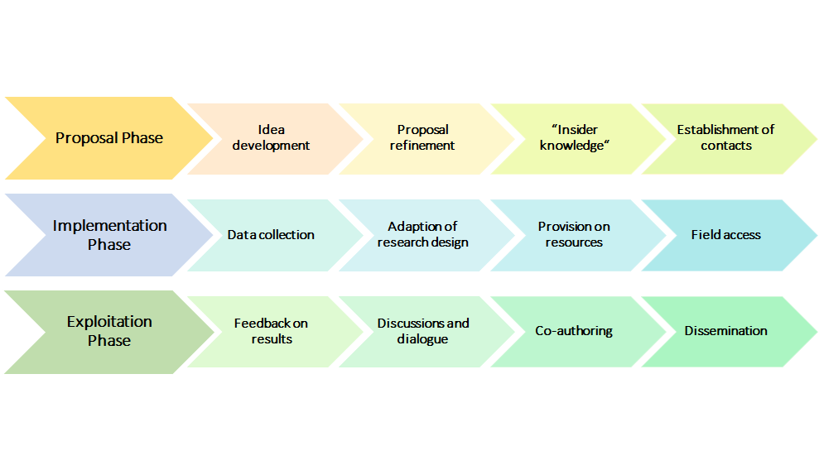

4.3 Productive interactions: challenges and attempted solutions

When asked about challenges that PIs experienced during transdisciplinary research processes and ways how they aimed to overcome them, the identified challenges and attempted solutions and skills were manifold. We have summarised them according to the following grouping:

Challenges of transdisciplinarity

1. **Systematic and regulative challenges:** In some cases, interviewees experienced systematic barriers when interacting with non-academic stakeholders. This was especially the case when researchers mainly worked abroad and were confronted with regulations unknown in Switzerland. Additionally, some research institutions in Switzerland (e.g., Pädagogische Hochschule, Art Universities), which are not allowed to award their own PhDs, found it difficult to act within the SNSF project framework as they depend on other institutions with regard to PhD students.
2. **Certain Stakeholders are hard to reach:**

* It was reported that stakeholders belonging to institutions like official authorities, public administration, or other actors within the political and legal system, are more interested in controlling and delivering their own narratives than being questioned in the context of a research project.
* Institutions like hospitals or schools are usually very busy with tight schedules, which makes it difficult to recruit anyone for a research project. Moreover, managing a hospital (or other state-funded welfare providing institutions) also has a lot to do with politics. In complex institutions like schools and hospitals, multiple stakeholders with multiple interests are involved, who sometimes try to implement their own interests and downsize interests diametric to their own.
* Interviewed PIs reported, that accessing and approaching non-academic groups belonging to a marginalised group or groups in precarious situations is difficult. These groups often have little motivation to talk about their situation to outsiders or/and are too busy taking care of their own problems and thus are often not ready to deal with requests from researchers. Marginalised groups also often hold a defensive stance because of their precarious situation, so that even talking about their situation becomes challenge on its own.

*“Of course, not all groups of people can be approached with the same ease, and there is of course what we find is, that above all, the people who are actually most affected, namely those in economically and socially precarious situations […]” Interviewee 5*

*“On the other hand, it is […] difficult to approach the really precarious people, people in precarious situations, excuse me, because of course they often see themselves pushed on the defensive by their precarious situation to such an extent that they don't feel like it at all, having to talk about it.” Interviewee 3*

* Interviewees also reported that some interest groups and associations (e.g. patient associations) tend to be sometimes suspicious vis-a-vis a research project and question the researchers’ ‘true/hidden’ intentions.

1. **Challenges in communication:** Communication between academic and non-academic stakeholders can be challenging due to different knowledge, different practices or norms, different priorities or perspectives regarding the same topic or because they simply seem to speak different languages.

*“The point is to make it possible to communicate to someone exactly what was actually relevant in the project, that is, this transferability of what one has actually experienced and worked out philosophically or politically, philosophically or literary-theoretically, whatever one may call it.” Interviewee 9*

1. **Different knowledge ….**

* **… about scientific or methodological concepts:** One PI described issues in presenting generalised statistical results. Single practice partners involved in data collection did not feel represented and felt like their own experience was not reflected in those statistical results. On the other hand, we also learned that presentations for practice partners who have sufficient experience in statistics should not be too simplified.
* **… about the prevalence of issues or disorders:** One interviewee involved in medical research reported that the medical practitioners underestimated the relevance of the research topic. They did neither understand nor listen when they were told about it because they were differently trained in dealing with this particular issue.
* **… about how scientific investigations can be relevant in practice and everyday life:** As one interviewee elaborated, it is also part of a researcher’s job to establish connections to increase relevance for non-academic audiences. Accordingly, it is essential to make abstract concepts accessible and concrete. However, it is often difficult to communicate this relevance not at least because the languages of the researchers and the practice partners can differ greatly (see below for a more detailed discussion).
* **…**. **theories and representations of phenomena:** Practice partners develop their own explanations of the issues they encounter every day (e.g. why a child acts in a certain way) and can have different representations of certain issues and concepts than researchers have. The confrontation of these differences can result in conflict, and connecting such different theoretical explanation attempts can become difficult.

*“And I think such differences in perspective and also differences in, so to speak, theorizing of the whole, simply has its potential for conflict.” Interviewee 20*

1. Also **different practices** **in decision-making** by public institutions or policy-makers can hamper productive interactions and prompt researchers to find a work-around, e.g. by talking to an NGO instead of the public administration to reach their goal. In particular, in political and legal research, practices and norms are highly dependent on political interests and political majorities, which can also fluctuate over the course of one research project.
2. **Different practices in using results:** While researchers are encouraged (by SNSF, their university, and the whole of the scientific community) to publish a lot and in particular in open access formats, this is disadvantageous for industry partners, who aim to protect a result and keep it to themselves in order to profit from it.
3. Sometimes practice partners seem to get the feeling that researchers are **criticising their practices** simply by investigating these practices, which can result in conflict. This is particularly difficult as researchers often depend on existing practice contacts to gain access to the field and to certain gatekeeper institutions. Thus, they could become reluctant in challenging their practice partners. To maintain balance between doing rigorous and independent research and keeping contacts for further studies was experienced as challenging by some interviewed PIs.

*“There's this feeling of someone stepping on their toes, pointing out what was wrong.” Interviewee 4*

1. **Different priorities, interests and perspectives:** When interacting with non-academic practice partners and contacts, interviewed PIs were confronted with many different expectations of what their research should achieve. The scientific aspect of producing and disseminating knowledge can easily collide with the interests of practitioners, the industry, or the media, which sometimes are detrimental to rigorous scientific processes. We identified several areas of (potential and sometimes real) conflict of interests:
2. **Producing knowledge vs. solving practical problems:** Researchers and practice partners often have different interests. Researchers want to focus on research, while practice partners want to solve their problems. Research takes a long time, is meticulous, and it is often unclear whether it will actually result in anything useful as the primary purpose of research is to produce knowledge (also knowledge about things that do not work). Practice partners often have the expectation that research can solve their current problems by providing specific solutions. This can result in a mismatch of expectations. In addition, the problems researchers identify in their projects might differ from what practitioners experience as problems, which can also lead to the rejection of results. Convincing practitioners of scientific results that are not in line with their everyday experience is a challenge.

*“[…] the expectation, an excessive expectation of research, that it can solve problems that research doesn't actually solve at all, because it primarily produces knowledge.” Interviewee 9*

1. **Producing knowledge vs. making profit:** Similarly, researchers and practice partners from industry sometimes differ in their interests. Since industry partners focus on getting a product ready for market entry and making a profit, they are more focused on certain usable parts of the project and not necessarily on the overall research process. Additionally, they might differ in their conclusions and have different ideas of how to utilise the results.

*“I think the main challenges for me was that we, me and my researcher, we were always thinking at the modelling level - let us say, how could these things better capture what we wanted to capture, while at the company level, if I remember, the interest was much more - how easily can we implement this, how fast they can go.” Interviewee 19*

1. **Producing new knowledge vs. sticking to own practice:** Phenomena investigated in research projects are often complex and multi-faceted. Some of the interviewed PIs encountered challenges in the communication with non-academic partners, especially when they were not interested in experiencing new facets of the phenomenon at study but rather stuck to their area of expertise or were discussing the phenomenon from a perspective irrelevant to the researcher. Some of the interviewees experienced a certain unwillingness of those non-academic partners in engaging in a discussion about new insights concerning a specific topic. This reluctance might be caused by the effort it takes to include these new insights into practice: the new insights might require changing protocols and routines, but they might also take more time and investments of already scarce resources.

*“So, clinicians can be very reluctant to get into research issues, because they don't think that's their goal. They don't want to add preparatory time, they don't want to complicate clinical protocols.” Interviewee 7*

1. **Being accurate vs. catchy headlines:** Some of the interviewed PIs were in contact with media representatives, e.g. journalists, who interviewed them. They reported that they aimed to present their research accurately and objectively, whereas journalists were allegedly more interested in generating a catchy headline to spike interest. Particularly in research with vulnerable groups, PIs were concerned that these would be exploited or put at risk in exchange for a catchy headline.

*“It is clear to me that the newspapers have a certain way of reporting the news that is not necessarily convertible for us or should be.” Interviewee 10*

*“The media are of course looking for the catch, i.e. the headline they can make of it, that was / sometimes you have to swallow a bit and accept that they are looking for headlines, but that’s okay.” Interviewee 6*

1. **Conflicting relationships with stakeholders:** It is important to realise that various different stakeholders associated with a research project can also have conflicting relationships with each other, for example through diverging interests, or because they are embedded in a hierarchy defined by different priorities and perspectives. Negotiating these relationships and deciding on which interests to focus can be a challenge for researchers.

*“You always will have different groups of people and probably this raises the problem of who are the stakeholders, so, when in social innovations teams they say, "oh make it usable for stakeholders", okay, but who are the stakeholders, are there conflicts within the stakeholders, are hierarchical effects in the sense that, for example very clearly in the kind of work that I do.” Interviewee 2*

1. **Negotiating:** If practice partners are more strongly involved in the planning and or implementation of a research project, challenges can arise when negotiating the terms of joint contracts or agreements with them as there are different understandings of the phases in a project and research cycles or what to conclude from research results.
2. **Different language – different terms, concepts, horizons of understanding:** Some of the interviewed PIs expressed challenges regarding the use of a certain professional language, which hampers understanding, both in the sense of country-related language issues and discipline/field-related issues. This includes the naming or mentioning of specific acronyms, names, and terms that are used in certain disciplines or sectors.

* Especially when dealing with highly formalised institutions such as political, legal or administrative actors, who have their own formal “language”, conflicts and frustration can arise when the communication does not work, which can also lead to withdrawing of partners.

*“And then also to understand the whole language of the administration, so to speak, and the whole language of the political structure in general, we have seen that, with all the good will that is present, there are also a lot of areas of friction, it there are a lot of misunderstandings, there are a lot of people who get out of this process relatively quickly in frustration.” Interviewee 8*

* In some practice contexts, non-academic partners have difficulties in understanding scientific terms and concepts. Sometimes they show a general reluctance towards “scientific language”, as they feel it is too abstract and too distant from their everyday work.

*“Perhaps the scientific language is not understood, or no attempt is made to understand it, that there is a certain defensive attitude towards research, the findings from science, that is complicated and has little to do with my practice.” Interviewee 11*

* Language difficulties not only arise when communicating with practice partners but also with researchers from other disciplines. It can be a challenge to find a common terminology and jointly identify common goals and strategies in interdisciplinary settings. Collaboration between disciplines thus requires that researchers listen to each other, teach each other, and learn together. These challenges are relevant because – according to the interviewees - funding schemes increasingly require or foster interdisciplinary projects and teams. Still, this is experienced as very difficult for some researchers.
* Researchers also need to adapt their behaviour and communication towards practice partners, as pointed out by one interviewee. It is not helpful if researchers tell practice partners what to do, because they know very well which problems they experience. Communication should rather be approached as joint development of ideas and solutions. At the same time, presentations of research results should be adapted to the level of knowledge and usual language of the audience. *“[…] who are really far away from an academic education, and you want to somehow sensitise them to the topic, but at the same time present serious research - and that is sometimes not so easy.”* *Interviewee 3*
* Some PIs also experienced language barriers when dealing with international practice partners or stakeholders. These barriers can result in missing some subtleties when conducting interviews in qualitative research but also when interacting and networking. This makes accurately communicating exhaustively difficult and sometimes excludes stakeholders and potential beneficiaries from benefiting from research.

1. **Resistance and opposition:** Some researchers experienced resistance and opposition to their project in discussions with non-academic partners or contacts. One interviewee mentioned that they felt offended by the research activities (e.g. questioning a concept, evaluating the success or failure of activities). This resistance came from people who felt attacked; they started to avoid interactions and questioned the meaningfulness of the project.

Skills for transdisciplinary research

The interviewed PIs identified skills, which they regarded as essential to enhance the cooperation and facilitate exchange with non-academic stakeholders.

1. **Value-free communication:** Several interviewees stressed that value-free communication can facilitate the exchange with stakeholders, especially when dealing with controversial topics. According to one PI, this is particularly crucial when talking to the media since statements might be used out of context to emphasise the media's narrative around a certain topic. Another interviewee stressed that while it is common in her field to have a normative perspective on the topic, she tried to stay as objective as possible in order not to bias the research. It was also stressed that value-free communication is helpful to break down barriers between two opposing sides who might have remarkably different opinions on the research phenomena under scrutiny.

*“If you (…) have an interest in seeing it through, then you know, it is part of developing relationships, right, with these individuals, and multiple meetings and engagements, and so after a while you start to learn their language and, you know, how they are approaching a problem, and they start to learn yours, and what you can do or cannot do. And then you start to appreciate when they are uncomfortable, because they do not quite understand what you are saying. And they appreciate when you are uncomfortable, because you do not understand quite what is involved, right. So, it may be uncomfortable, but it is part of the fun of breaking out of your box, and in this case, with the purpose of engaging in a project that would have greater societal innovation" Interviewee 12*

1. **Concreteness:** Similar to the issues of value-free communication, some interviewees mentioned concreteness as a useful skill for interactions with actors outside academia. A message should be as clear and easily understandable as possible not to leave room for misinterpretation, which could create problems for both parties, sometimes even leading to conflicts. One interviewee claimed that in order to talk to decision-makers or businesses, he tries to avoid “irrelevant information” and always uses facts and figures to underline his main points. Another interviewed PI stressed that vagueness causes uncertainty, which leads to inefficient communication. This can, inter alia, be avoided by using examples.
2. **Making a topic accessible:** Another related aspect to those mentioned above is the skill to make a research topic as accessible as possible. Several PIs stressed that different stakeholder groups have different knowledge of and interests in the researched issue. Hence, in order to ensure the participation of and effective communication with stakeholders, the topic should be apprehensible for as many stakeholders as possible. The interviewees highlighted that different ways of communication tailored to a certain target audience are useful to make the discourse around a project as inclusive as possible.
3. **Practice experience:** Additionally, a few interviewees stressed that their previous experience of working with non-academics had helped them to acquire skills needed for transdisciplinary research. Two interviewees, who also work at non-academic institutions, underlined that this allows them to gain knowledge from inside the field as well as constant feedback from practice partners. Others highlighted that the success of transdisciplinary exchange strongly depends on the level of experience in communicating with non-academic stakeholders.
4. **Staying in discussion:** In order to facilitate communication with stakeholders, many interviewees emphasized the need to create long-term contacts. Although this is not possible for some stakeholder groups (e.g. society at large), staying in touch with professionals, institutions or civil actors can help build up trust and maintain and deepen relationships in the field. One interviewee summarized this the following way:

*“So, it is an evolutive thing, but I understand that as a continuous, in time, a continuous trust relationships, relationship, where people from one session to the other, one meeting to the other, one gathering to the other, they get to know you better, and I talk abundantly about what I am doing and in a way that evolves also in time, it is very informal, but I think it is central for the circulation of ideas.” Interviewee 2*

Hence, preserving a network of relevant stakeholders can be beneficial in many ways. First, it eventually leads to more in-depth interactions as people get to know each other and build up trust. Second, the cultivation of productive relationships can stimulate the development of projects and future project ideas.

1. **Create knowledge transfer:** One central aspect that was highlighted by many interviewed PIs is the creation of knowledge transfer. This has several facets. Firstly, some interviewees claimed that including students (through teaching but also through inclusion in projects) is an essential way to transfer knowledge. Others stressed that dissemination at conferences and events fosters knowledge transfer between different universities but also different stakeholder groups.

Some interviewees stressed that more support regarding the transfer of knowledge would be helpful to promote either internal exchange, inter-departmental exchange or transdisciplinary endeavours. One interviewee mentioned the concept of “open innovation” which fosters the circulation of knowledge instead of a *“one-sided, one-way transfer”*, where universities can play a key role.

1. **Personal commitment from partners:** A few interviewed PIs expressed the necessity of personal commitment from all sides. According to one interviewee, research is time and energy consuming, which is why efficient cooperation can reduce the workload for everyone involved. However, cooperation can also be very tiring, especially if partners are not fully committed. This unnecessarily consumes time and energy, which would be better needed to finish projects properly. Another interviewee criticized funding schemes where researchers are “forced” to collaborate because an international consortium is required. Accordingly, while this collaboration can work out very well, it can also go very wrong when people do not know each other and are *“pick’n’mixed”.*
2. **Mediating role/broker:** The uptake of a mediating role can benefit transdisciplinary research. One interviewee who worked with stakeholders that had significantly opposing interests stressed the importance of *“sharing information, objectifying the debate and putting the arguments back on the table in a disciplined discourse”.* Accordingly, researchers who bring together diverse stakeholders also need to be skilled in negotiating interests and de-escalating conflicts. Another interviewee claimed that in order to bring the practice and the academic side together, researchers have to take on a mediating function:

*“And I think that from the point of view of communication, of course you have to, you have to try to shape communication in such a way that it is understood by the practice contexts. And that needs both sides. So for me, creating relevance to practice is actually the task of science and practice together. And that presupposes that one has an understanding of both worlds. So we often talk about a double competence profile that we want to bring along or develop.” Interviewee 13*

1. **Knowledge brokers:** Some researchers who experienced challenges in communication tried to facilitate communication through the help of third parties, which can be regarded as knowledge brokers. This can be NGOs, project partners, who also have experience in applied fields, or well-meaning contacts from the practice field, who are in support of the research project under scrutiny. A knowledge broker should be someone who is familiar with the routines and practices of the respective institution, is familiar with the people that work there and are in charge, and can convey the project’s relevance, thereby also implementing a first transfer of knowledge. However, a knowledge broker needs to be similarly acquainted with communicating with researchers too, meaning they need to understand the issue at hand, be familiar with research processes and research methodologies, and with academic discussions. Thus, a knowledge broker is a bridge that is firmly anchored in research and practice. They are especially important, when dealing with topics regarding more vulnerable or excluded groups. Then knowledge brokers also act as a voice representing them, if it is difficult for them to speak for themselves, for example, in the form of interest associations and NGOs. A second setting in which knowledge brokers are particularly important is politics and in exchange with public administration, where tacit knowledge is required for efficient communication and knowledge transfer.

*“The first thing I have to do is, I have to, within each of these ministries or organisations, identify an “insight champion”, someone who works in this ministry, who is convinced of the project and can convince his peers why this is a useful thing to try for the ministry. Because, these people are embedded in the organisation, speak the language of the organisation, and so are much more effective than I will ever be in making a case for trying that.” Interviewee 9*

1. TOWARDS NEW SOCIAL PRACTICES? MOTIVATION, INTENTION AND TARGETED OUTCOMES

5.1 Motivation and intention

Intention and agency are central elements of the applied definition of social innovation (see Table 1). The type of motivation that drives academics is important to understand the content orientation, the design, and the results orientation of the research project under scrutiny. While it can be assumed that the pursuit of knowledge per se is an important underlying motivation of researchers, alternative motivations beyond this, such as contributing to more immediate economic or social value, cannot be taken for granted. And even if this is the case, researchers set different boundaries in terms of the added value they want to bring to the economy or society, whether as a free will decision or as a requirement on the part of the research funder[13]. While social sciences and humanities scholarship, for instance is often committed to do research for the good of society, the interest of researchers is often not oriented towards producing usable results, let alone actual solutions, but rather to raise awareness and influence society to create capabilities of self-understanding in different contexts (Reale et al. 2018; Benneworth 2015; Nussbaum 2010).

The initial motivation types measured through the survey consist of three main categories, namely,

1. motivation to *better understand a natural, technical, economic, or social phenomenon* (basic academic motivation that drives research),
2. to *directly address a natural, technical, economic, or social problem* (use-inspired research)*,*
3. to *improve the human condition/welfare* (motivation to create change outside of academia).

The basic academic motivation to better understand a natural, technical, economic or social phenomenon was strongly emphasised by the PIs in the survey (see Figure 7): 84 % of the survey respondents rated academic motivation greater or equal to 7 on a 0-10 scale. This was followed by the motivation to directly address a problem (64 % of the respondents noting equal or higher levels than 7). Improving the human condition/welfare, i. e. the motivation closest associated with social innovation, namely to cause change outside of academia, was more balanced in comparison. 35 % of the respondents replied with levels equal to or smaller than 3 and 45 % with levels equal to or higher than 7. Please refer for more detailed responses to Table 3.

Figure 12: Distribution of different motivation types

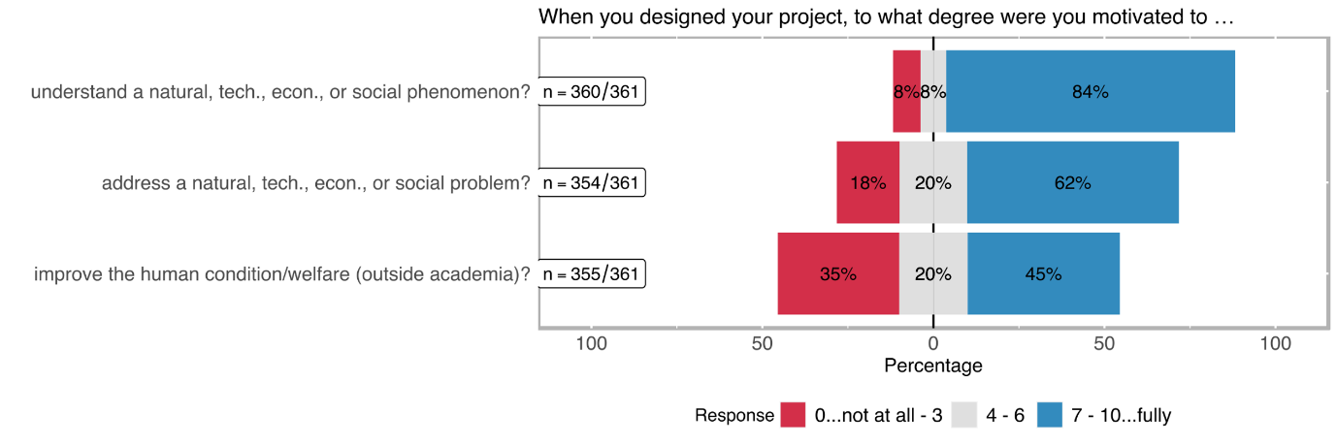

We can conclude that the motivation portfolio of SNSF-funded principal investigators (PIs) is not one-dimensionally oriented towards only the basic scientific motivation of better understanding a phenomenon, but includes also a remarkable share of problem-orientation and use-inspiration including a quite strongly expressed notion of doing good for human condition/welfare. A high proportion of SNSF-funded projects have thus the motivational potential to more directly contribute to innovation and change, including social innovation, through their research.

Table 2 details the results aggregated in Figure 14. The extreme values are interesting. Almost 58% of the PIs who responded to the survey (n= 361), ranked the intrinsic scientific motivation to understand a phenomenon with the highest mark (i.e. 10 on a scale between 0 and 10). An explicit refusal of the motivation to improve human condition/welfare with the lowest mark was provided by roughly 13% of the responding PIs, which is almost the same share as approvals with the highest mark.

Table 6: Distribution of different motivation types

|  |  |  |  |  |  |  |
| --- | --- | --- | --- | --- | --- | --- |
| rating | better understand a natural, technical, economic, or social phenomenon?  (n=360) | | directly address a natural, technical, economic, or social problem?  (n=354) | | improve the human condition/welfare (outside academia)?  (n=355) | |
| *0..lowest*  *10..highest* | **abs** | **%** | **abs** | **%** | **abs** | **%** |
| 0 | 14 | 3.89% | 23 | 6.50% | 47 | 13.24% |
| 1 | 1 | 0.28% | 7 | 1.98% | 23 | 6.48% |
| 2 | 8 | 2.22% | 25 | 7.06% | 30 | 8.45% |
| 3 | 6 | 1.67% | 10 | 2.82% | 26 | 7.32% |
| 4 | 12 | 3.33% | 16 | 4.52% | 16 | 4.51% |
| 5 | 9 | 2.50% | 28 | 7.91% | 43 | 12.11% |
| 6 | 6 | 1.67% | 26 | 7.34% | 12 | 3.38% |
| 7 | 17 | 4.72% | 36 | 10.17% | 41 | 11.55% |
| 8 | 42 | 11.67% | 56 | 15.82% | 53 | 14.93% |
| 9 | 38 | 10.56% | 28 | 7.91% | 15 | 4.23% |
| 10 | 207 | 57.50% | 99 | 27.97% | 49 | 13.80% |
| *no response* | *1* |  | *7* |  | *6* |  |

In the academic literature, it is often pointed out that transdisciplinary research practice usually also aims to go beyond the pursuit of scientific understanding of a phenomenon, and in particular also pursues problem-solving objectives. Thus, one of our central hypothesis was to test if transdisciplinary research experience is in SNSF funded projects strongly related to the willingness, firstly, to research real-life problems and, secondly, to contribute to the improvement of the human condition/welfare.

* H1: the *transdisciplinary experience* of the interviewed researchers correlates with
  1. the *motivation to address a problem outside of academia*, and
  2. the *motivation to improve human condition/welfare*.

The analysis of the relation between *transdisciplinary experience* and *the motivation to address a (non-academic) problem* (see Figure 3) did not yield a statistically significant correlation (correlation coefficient rho[14] ~ 0.01 with a p-value > 0.05[15], see Table 3). This means that more *transdisciplinary experience* does not necessary imply a higher *motivation to address a problem outside of academia* [a] or vice-versa, the motivation to address a real-life problem is not necessarily based on transdisciplinary experiences.

Figure 13: Relation between transdisciplinary experience and the motivation to affect change outside academia

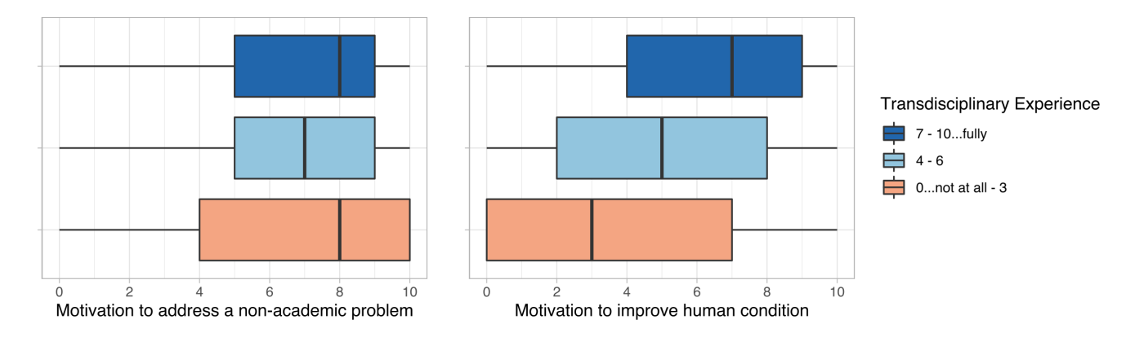

On the other hand, the *motivation to improve the human condition* correlates relatively stronger with *transdisciplinary experience*. Although it is statistically significant (p-value < 0.05), there is only a weak positive correlation (rho ≈ 0.33) between the two [b] (see Table 3). Still, researchers who explicitly want to improve the human condition/welfare, i.e. not only to investigate a technical, social, ecological or medical problem, but who aim to contribute to a change aspect (i.e. an improvement) are firmly based in transdisciplinary experience horizons. In more general words, a significant relationship between experience in dealing with transdisciplinary research and the intention to change exists. How far this intention to change is related to a change in social practices (or, for example, the provision of a better medicine to improve the life of a patient) was not further investigated in the survey. However, we expect that the interviews still to be analysed will provide information on this.

Table 7: Correlation matrix between transdisciplinary experience, the motivation to address a specific problem, and the motivation to improve the human condition/welfare

|  |
| --- |
| Trans._Exp. Mot._to_add_Pr. Mot._to_imp._HC  Trans._Exp. 1.00 0.01 0.33  Mot._to_add_Pr. 0.01 1.00 0.27  Mot._to_imp._HC 0.33 0.27 1.00    P-Values:  Trans._Exp. Mot._to_add_Pr. Mot._to_imp._HC  Trans._Exp. 0.8272 0.0000  Mot._to_add_Pr. 0.8272 0.0000  Mot._to_imp._HC 0.0000 0.0000  **RESULT**   * H1a: Since the p-value is greater than α (0.05), we cannot reject the null hypothesis, which indicates that there is no association between the motivation to solve a specific problem and transdisciplinary experience * H1b: the p-value is smaller than α, we can reject the null hypothesis. There is a statistically significant relationship between the trans- disciplinary experience and the motivation to improve the human condition. The correlation between the two is, however, weak positive (rho = 0.33). |

Intention to benefit social groups and tackle social purpose

As also evidenced by the interviews with PIs from SNSF funded projects, a broad spectrum of social intentions of PIs with regard to benefiting the public exists. Nevertheless, approximately 37 % of the respondents reported that their projects were not specifically designed to benefit any social group outside the academic world (see Figure 14). Almost exactly the same share responded that groups outside of academic world were targeted to a minor extent by their research projects. 25 % of the respondents finally noted that their projects were specifically designed to generate a benefit for the general population or a specific social group outside the academic world.

Figure 14: Distribution of extent to benefit target groups outside the academic world

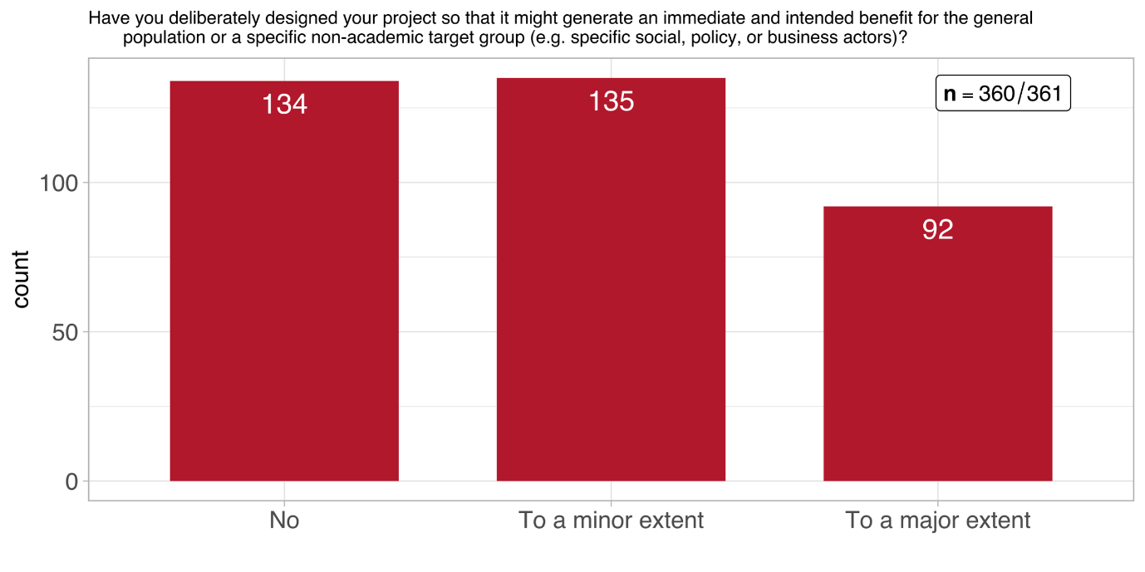

Figure 15 breaks these numbers down by scientific domain. It clearly shows that *Mathematics, Natural- and Engineering Sciences* have the highest number of projects, which do not intent to benefit any target groups outside academia. Out of the three scientific domains, *Humanities and Social Sciences* can – unsurprisingly – claim the highest number of projects, which intend to contribute to a large extent to target groups outside academia. Still, 25% of SSH projects were so designed that they do not target a specific non-academic group. If these projects relate more to humanities or economics or any other SSH discipline could not be identified due to lack of data.

Figure 15: Distribution of extent to benefit target groups outside the academic world across scientific domains

Table 5 shows these values broken down by *funding instrument*. Apparently, none of the three scrutinised funding instruments of SNSF excels in terms of a considerably higher share of a response category compared to the overall distribution across categories. The exception seems to be *interdisciplinary projects* but their numbers in each of the response categories are too low to be considered solid evidence. In fact, this kind of distribution largely reflects the distribution by funding instruments across all further questions. Therefore, we refrain from presenting tables or figures on the distribution of items differentiated by funding instrument, which offer little information value.

Table 8: Distribution of impulses from the non-academic world (n = 360)

|  |  |  |  |  |  |  |
| --- | --- | --- | --- | --- | --- | --- |
|  | Project funding | | Singergia | | Interdisciplinary projects | |
| response | abs | % | abs | % | abs | % |
| no | 115 | 37% | 15 | 33% | 4 | 36% |
| to a minor extent | 117 | 38% | 18 | 40% | 2 | 18% |
| to a large extent | 75 | 24% | 12 | 27% | 5 | 45% |
| *no response* | *1* |  |  |  |  |  |

Before exploring in more detail the social purpose of the projects (if any), we were interested in exploring what kind of problems were addressed within the funded SNSF projects. As expected, every project had its unique problem focus, which however can be broadly classified into five categories:

1. Medical focus: e.g., medical treatment and better understanding of illnesses
2. Political focus: e.g., migration, democracy and political systems
3. Ecological focus: e.g., waste and air pollution, sustainable city planning
4. Social focus: e.g., education and training of teachers, unequal housing conditions; social work
5. Economic focus: e.g., market shocks and financial markets
6. Issues in humanities: e.g. art and theology

While the problems addressed in some SNSF funded projects can be easily classified into one of the above groups, some fall into several categories. Correspondingly, some interviewees argued that their research objectives touch upon several problem foci and are not entirely falling under just one category. One interviewee thus highlighted:

*“I think my focus was more of an ecological nature, although of course that interacts, or the ecological and the social have very strong interactions, interrelationships.”*

Agency, however, has not only an intrinsic component (motivation), but can also be triggered by impulses from outside the academic world. Most of the impulses from the non-academic world that motivated the interviewed PIs to start their projects relate to specific health/medical problems (33 %), followed by specific societal problems (26 %) or specific technical problems (19 %) (see Table 6). The outside impulse least mentioned by the surveyed PIs was to tackle a specific economic problem (8 %).

Table 9: Distribution of impulses from the non-academic world (multiple choice)

|  |  |  |
| --- | --- | --- |
| response | abs | % |
| a specific societal problem | 94 | 26.04% |
| a specific economic problem | 29 | 8.03% |
| a specific ecological/natural problem | 53 | 14.68% |
| a specific health/medical problem | 118 | 32.69% |
| a specific technical problem | 70 | 19.39% |
| Other | 62 | 17.17% |

Figure 16 shows some clear, but rather trivial attributions: SSH respond primarily to social impulses, biology and medicine to health impulses and the natural sciences and engineering to technical impulses. While this is not surprising, what is more interesting is the fact that all three of the SNSF's major scientific disciplines are fed by different sources of impetus.

Figure 16: Distribution of impulses from the non-academic world (multiple choice)

During the interviews, we were also asking PIs if there was a social purpose in their research and whether this purpose was already there at the beginning or whether it emerged during the project. The existence of a social purpose as a driver for research is important, because as described in Section 3.2, it is one of the key factors defining social innovation.

More than half of the interviewed PIs identified a clear social purpose; half of these had a SSH background.[16] Conversely, this means that a research project that is not explicitly an SSH project cannot necessarily have a social purpose or contribute to social innovation (SI).

For almost all interviewees, the social purpose did not change during their projects’ duration. For the remaining, however, the social purpose intensified during project implementation. One interviewee, for example, reported that the research team designed the project without having a precise social goal in mind. This then changed as more exchanges with stakeholders took place and dissemination activities started. Hence, communication and interaction can help alter perspectives and put research in a social context.

We were also interested in how the researchers aimed to achieve the intended social purpose through their projects. We distinguished the answers of the surveyed PIs into three categories:

1. **Prevention:** Some PIs noted that the main instrument for achieving the social aim of their project was to prevent certain situations or circumstances. In many cases, this was the prevention of an illness or psychological disorder.
2. **Better understanding:** This category was by far the most prominent feature of addressing a social purpose. It corresponds to the overall motivation pattern of SNSF funded PIs as evidenced by the statistical results discussed above. Many interviewees highlighted that much was unknown in their research field, which made it necessary to delve deeper into details in order to better understand the research phenomena. It further became apparent that most often inter- or transdisciplinary research designs had the goal to conceive phenomena differently. By bringing different actors or disciplines together, research problems can be explored utilizing the advantages of different angles. A few interviewed PIs also stressed that while their main goal was to better understand a research phenomenon, this was indirectly linked to the adjustment and improvement of practices. For instance, it was argued that providing new information for practitioners or the policy level presents the basis for action and decision-making. On the other hand, one interviewee stressed that the aim of fundamental research is to better understand a problem, which per se limits the opportunities for impact.

*“But our goal was first and foremost a scientific one in the sense that we wanted to develop a better understanding and explanations and not necessarily to change the world - that was not necessarily our primary goal.” Interviewee 3*

1. **Improvement of, e.g. medical treatment, education, gender disparities:** Another means to achieve a social purpose is to work on the improvement of the issue that is researched. This purpose goes further than the aim to better understand a phenomenon, as it anticipates actions that need to be taken in order to achieve such an improvement. Here the purpose to contribute to change is clearly evident. The application areas, however, are very diverse and range from the improvement of a product to the improvement of medical treatment or the mitigation of gender disparities. Many interviewees who reported that their goal was to improve something also said that it is essential to first better understand the researched topic. One interviewee clearly stressed that while more detailed knowledge about a phenomenon is crucial, the motivation to improve the current situation is crucial for change or impact.

What became apparent is that many interviewees, irrespective of their research field, had not only a social purpose in a narrow sense but also other intentions in mind. Accordingly, some interviewees highlighted that it was crucial for their project not only to consider the narrow social aspects of the research topic but broader social aspects too, such as economic, ethical or legal aspects. Often these aspects seem intertwined and are essential to be acknowledged when aiming for societal impact.

*“We knew, when we studied these particular files, that there were social elements. But we couldn't dissociate these social elements from the financial, technical and technological elements, which were completely integrated into these discussions.” Interviewee 7*

In other cases, interviewees highlighted no social purpose nor immediate social benefit or argued that the direct social aspect was not immediately recognisable. Several interviewed PIs then stressed that there might be a social benefit, but a rather indirect one or one that develops over a longer period of time. One interviewee reported that the research team realised after the project that the social potential of their research had not been exhausted, which then led to follow-up projects with a more specific and clearer social purpose orientation.

Intended change amongst whom?

To better understand projects’ purposes for certain target groups, several true/false statements were posted in the survey. Most of the respondents to the survey who aimed to benefit non-academic target groups intentionally (i.e. by creating a deliberate research design to benefit non-academic target groups) (n= 227) had a rather universal view regarding the target groups of their research and responded that they work towards improving people’s lives in general (see Table 7). These are 46% of the total responding survey population (n= 361).

50% of the surveyed PIs who aimed to benefit non-academic target groups had the objective to enable diversity and exchange of different perspectives, which is an important feature of awareness raising. This corresponds to 31% of the total overall sample of respondents to the survey. 25% of the overall responding PIs to our survey expressed an intention to empower people in general or specific groups. Almost 20% of the total responding survey population target a group of specific social needs and 14% responded that they even included socially disadvantaged or marginalised group in their research

Table 10: Distribution of target group goals

|  |  |  |  |  |
| --- | --- | --- | --- | --- |
| Goal | no |  | yes |  |
|  | **abs** | **%** | **abs** | **%** |
| targeted a group of people with specific social needs (n= 221) | 151 | 68.33% | 70 | 31.67% |
| included socially disadvantaged or marginalised people (n=219) | 170 | 77.63% | 49 | 22.37% |
| worked towards improving people’s lives (n=222) | 55 | 24.77% | 167 | 75.23% |
| aimed at empowering people (in general or specific groups) (n=221) | 131 | 59.28% | 90 | 40.72% |
| enabled diversity and exchange of different perspectives (n=221) | 108 | 48.87% | 113 | 51.13% |

The interviews with PIs provided additional details, which are summarised below along the main target groups.

1. **Practitioners:** Approximately one-fourth of all interviewed PIs said the change they wanted to contribute to addressed practitioners. While practitioners differed vastly in their background, most PIs had a similar concept of including them in their study. It was stressed that when trying to achieve a change in practice, it is crucial to meet practitioners on an equal level. This encompasses transdisciplinary sills as already mentioned in Section 4.3, e.g. finding a common language, avoiding a too scientific narrative and building trust. Moreover, the exchange should be a mutual dialogue rather than a one-sided information provision. Hence, including practitioners in a project brings many challenges. Yet, all interviewees who included practitioners in their research projects emphasised this as a very effective way to achieve change as they directly influence structures within a system and most often have the power to influence both the discourse around a topic as well as other stakeholders.
2. **Policy- and decision-makers:** Policy- and decision-makers were also perceived as a targets of intended change by some interviewed PIs. One interviewee highlighted that in order to change norms and attitudes in the “practical world”, policy-makers need to be addressed directly as they significantly influence everyday practices by implementing policies and regulations. Similarly, several interviewees stressed that in many cases, structural change could only take place when politicians have a better understanding of the situation within institutions and organisations and “good policy-making" depends heavily on the information that decision-makers have.

Many interviewees stated that intended change is directed at more than one group within the same project, some of which are easier to reach than others. One interviewee pointed out that it is necessary to bring the target group and decision-makers to the same table in order to be able to design needs-based policies. This demands a continuous dialogue, which is not easy to create and sustain:

*“What we notice is that from all these discussions, at least on the part of the city, the question of how this whole communication process has to be designed has been discussed again and again, new formats have always been tried out, well, I can see that, that's it such a continuous process of dialogue between those doing the research on the one hand, those affected on the other and the city authorities on the third side, and I have already noticed that this/this feedback, the reflection, so to speak - what is happening there , which groups are there, why certain groups don't come to the events, why don't certain groups take part in the discussion, that this leads to the city thinking about this process relatively intensively.” Interviewee 9*

1. **Society:** While most interviewed PIs did not specifically mention the role of society in their projects at the beginning of the interviews, almost all of them mentioned later on that society was either directly or indirectly affected by their research. However, this effect might not be immediately visible. In many cases, society cannot be excluded from the broader picture as research phenomena do not only concern immediate stakeholders and target groups. One interviewee emphasized that while the direct aim of research was to change the practices of public authorities, it was also essential to raise awareness amongst the wider society as this is indirectly linked to what is seen as appropriate or inappropriate.
2. **Institutions/Organisations:** National and international organisations were also named as intended subjects of change. One interviewee, who dealt with pollution, stressed that international organisations (e.g. the UN) have enormous influence and power when it comes to norms and regulations on a global level. Including such organisations in a change process was regarded as extremely important by a few interviewed PIs. Another interviewee worked together with national associations with the aim to raise their awareness concerning intra-country disparities concerning field-specific practices in Swiss cantons. He stressed that often cantonal authorities are too busy to engage with what happens in other cantons, which leads to differing quality in service provision. Bringing these stakeholders together at conferences or colloquia can foster exchange and learning.
3. **Specific target group:** Transformative intentions can also be targeted at a projects’ very specific target group. On the one hand, interviewees mentioned that projects could have an empowering element, through which their specific target groups are able to engage with other stakeholders and are ultimately part of the debate they are affected from. On the other hand, projects can have a reflexive element for participants. One interviewee reported that she presented the data (e.g., recorded videos) and preliminary findings to the participants of the projects to gain additional reflections.

*“[P]articipation procedures made them think about that by themselves and this is a way that I would call that a form of empowerment in the sense, it is not me going to them and saying, "look, you are doing badly here", but I just show what they do, I show the consequences of, also minor details of their practice and their consequences and in general, this produces their own conclusions, or consequences, and I think that this is a way much better, because you keep them to analytical tools that they can a way apply to themselves, rather than giving them normative principles or normative recipes, and I always reframe from the / yes, recipes or prescription or this kind of things.” Interviewee 2*

1. **Media** was also identified as an important actor of change. Approaching them directly and trying to include them in the project can at least partly contribute to a communication based on scientific results. Moreover, the power of the media to influence society at large but also politicians was underlined. One interviewee mentioned that one way to change the practices of decision-makers is to bring the media to report about projects and academic insights in order to raise awareness and interest among policy-makers:

*“[M]edia sometimes can exert pressure, at least by creating a debate and creating sometimes social movements, and so we always hope that this will exert some pressure on policymakers.” Interviewee 3*

1. **Industry:** A few PIs also intended to evoke change in the industry. Although it was emphasised that fundamental research has often limited direct impact on industry, it can offer essential insights that might, in the long run, result in changes within a certain industry. Furthermore, including industry partners as possible actors of change can benefit both sides. On the one side, understanding the needs and challenges industries face can advance academic research. On the other hand, industry can benefit both from academic knowledge directly but also from sustaining exchanges that might prove to be valuable for future projects.
2. **Scientific community:** Some interviewees also mentioned an intention to change parts of the ways academic research is conducted. One interviewee, for example, highlighted that one of the novelties of her project were the interdisciplinary aspects, which are not common in her field. Accordingly, she made great efforts to spread the benefits of inter-disciplinary research amongst other scientists formally by giving talks at conferences but also informally by reporting about her experiences to colleagues whenever possible. Hence, transformative actions do not always need to be targeted at non-academic actors. A combination of changes within and outside of academia can prove successful when aiming for social innovation.

Intended change of what?

In the online survey, we asked about intended changes to approximate potential project outcomes, both in the long and short term. We differentiated four categories of effects:

1. improving understanding as most generic effect of scientific research;
2. raising awareness of an issue;
3. changing attitude, which has a normative change connotation, and
4. changing behaviour, which has an action-oriented connotation.

*Improving the understanding* followed by *raising awareness* were the most frequently selected categories of the survey participants (see Figure 17). Other arguably stronger types with regards to changes in practice fields (i.e. attitude and behaviour) were less frequently mentioned. Interestingly, an intended change of behaviour was more often named than an intended change of attitude.

Almost 60% of the survey respondents aimed to improve understanding and another 50% wanted to raise awareness with their SNSF funded projects (note that multiple answering was possible). Almost 18% aimed to change attitudes and 30% intended a behavioural change. The latter can be regarded as a proxy for a change in social practices, which is the central object of social innovation.

Broken down by target groups[17], the principal investigators (PIs) mainly intended to generate change effects in the general population (mostly a change in understanding and awareness). The second largest target group for which change effects were intended by PIs were policy-makers and public administrations, followed by welfare and education institutions as well as businesses, specific social groups and – least – NGOs or civil society groups (see Figure 17). It is interesting to note that 31 PIs of SNSF funded projects responded that the intended effect (or one of the intended effects) of their research project was a behavioural change among policymakers and/or public administration. This means that around 8% of all scrutinised SNSF PIs have a clear policy action agenda.

The intentions to trigger a change of attitude or even a change of behaviour were highly expressed towards the target groups of “policy-makers and public administration” as mentioned above (39 % of those PIs who targeted this group intended to generate a change of attitude or behaviour among this target group), but also to “NGOs and civil society groups” (39%), “specific social target groups” (37%), “businesses” (30%) and “welfare and educational institutions” (29%). We can summarise that around a third of all PIs, who targeted a specific social group, did go beyond the intention to change understanding and/or to change awareness through their projects. In other words, quite a substantial part of SNSF funded projects, which consider a target group for their projects, goes beyond a defensive stance in terms of intended change to be triggered by their projects.

Figure 17: Distribution of intended change

In Table 8 academia is also included as an intended target group of the surveyed PIs, which is the case for almost 90% of all funded SNSF projects. Here, improving understanding is by far the most expressed intended change category. In other words, science is predominantly related to science, which is indispensable for the progress of scientific knowledge. At the same time, however, it is not only related to itself, but also intends to have change effects on non-academic groups.

Table 11: Distribution of intended change

|  |  |  |  |  |  |  |  |  |  |  |  |  |  |  |
| --- | --- | --- | --- | --- | --- | --- | --- | --- | --- | --- | --- | --- | --- | --- |
|  | Changing … | | | | | | | | | | | | | |
| Target audience | **understanding** | | | **awareness** | | | **attitude** | | | **behaviour** | | **other** | | |
|  | **abs** | **%** | **abs** | | **%** | **abs** | | **%** | **abs** | | **%** | **abs** | **%** |
| the general population (n=170) | 79 | 46.47% | 50 | | 29.41% | 10 | | 5.88% | 15 | | 8.82% | 16 | 9.41% |
| businesses (n=100) | 29 | 29.00% | 29 | | 29.00% | 12 | | 12.00% | 18 | | 18.00% | 12 | 12.00% |
| specific social groups (n=73) | 22 | 30.14% | 19 | | 26.03% | 12 | | 16.44% | 15 | | 20.55% | 5 | 6.85% |
| welfare- and education-providing institutions (n=93) | 35 | 37.63% | 24 | | 25.81% | 10 | | 10.75% | 17 | | 18.28% | 7 | 7.53% |
| NGOs, advocacy or other civil society groups (n=53) | 13 | 24.53% | 20 | | 37.74% | 5 | | 9.43% | 12 | | 22.64% | 3 | 5.66% |
| policy-making, public administration, governmental agencies (n=117) | 33 | 28.21% | 33 | | 28.21% | 15 | | 12.82% | 31 | | 26.50% | 5 | 4.27% |
| academia (n=312) | 219 | 70.19% | 32 | | 10.26% | 21 | | 6.73% | 28 | | 8.97% | 12 | 3.85% |

In the interviews with the PIs, the intended dimensions of change were further explored. As shown in Figure 18, mostly the same change dimension already raised by the survey were mentioned, but a “change in practices” category was explicitly added.

Figure 18: Interview findings differentiated between change categories and target groups

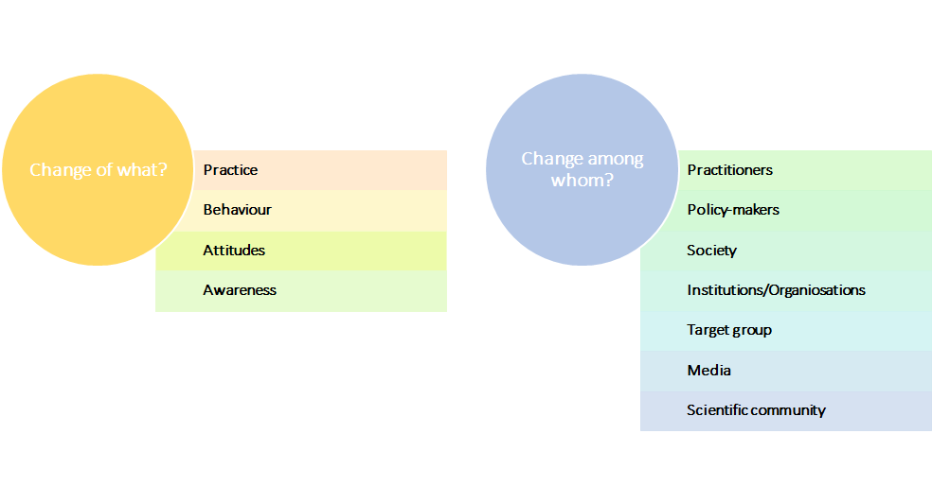

1. **Change in practices:** One aspect of intended change is the change in practices, which is the central object of a social innovation. Practices can be seen as something that is performed regularly or habitually, such as actions that are perceived as standard in a given field. Several of the interviewed PIs aimed at changing practices. Some interviewees reported that the objective of their research was to change the way medical treatment is executed or how and in which situations doctors prescribe drugs. Others emphasized that their aim was to change political decision-making or the training for practitioners. While in many cases change in practices was an explicit goal of several projects, it was also emphasised that such action-oriented change in practices often takes place only incrementally over a longer period. Furthermore, a change in practice is often related to and follows a change in, for example, attitudes and behaviour. Hence, achieving a transformation of practices can be a complex and long process.
2. **Change in behaviour:** Very similar to a change in practices is a change in behaviour. The difference is that while practices refer to *“the customary, habitual, or expected procedure or way of doing something”*[18], behaviour is defined as *“the way in which one acts or conducts oneself, especially towards others”*[19]. While the definitions differ, a clear demarcation between the two is not easily identifiable, especially since behavioural change often results in practice changes when done frequently. Both change dimensions are action-oriented and can be regarded as elements for contributions to social innovation. One interviewee said that one of his goals was to achieve a reflexive process for practitioners, which should ultimately change their behaviour in certain situations. However, he also stressed that once this behavioural change is incorporated, this could also result in a change of practices. This example highlights the interconnectedness of behaviour and practice, but also shows that even a changed behaviour does not necessarily lead to regularly changed practices, at least not immediately, especially if, for instance the framework conditions oppose a more generic roll-out of new practices.
3. **Change in attitudes:** Several PIs did not have the intention to initiate a change in practices or behaviour. Rather, their goal was to change the attitudes of a given sub-population or wider society. For instance, one interviewee who studied the effects of migration on housing and segregation argued that one important aspect that prohibits societal change is the attitude of policy-makers as well as the public. Accordingly, different stakeholders perceive recent migration flows negatively and as a potential for conflict, while this was not necessarily the case with past migration flows. Hence, most often a change in attitudes and perceptions is essential when trying to kick-off a change in behaviour or practices. Accordingly, when trying to accomplish a broader impact, it is also crucial to keep people who might not be obvious stakeholders (e.g., society as a whole) in mind. One interviewee, who investigated medical treatment with antidepressants, stated:

*“Another, further social component is the population's broad perception of psychotropic drugs. They are viewed critically in broad sections of the population, and I think part of this criticism also comes from the fact that they* (i.e. the prescription of drugs) *are not discontinued. A social component that is important for me is that this concern, this perception is addressed, and that it is perceived and taken up.” Interviewee 7*

1. **Change in awareness:** Another aspect that can be suspect to change is awareness. One-third of the interviewees said that one of their aims was to raise awareness regarding their research problem. This awareness-raising was either targeted at a specific group (e.g., decision-makers, institutions, businesses/industries) or directed at society at large. Again, the differentiation between a change in awareness and a change in attitude is often hard to make. One interviewee, for example, mentioned that in order to raise awareness amongst society, it is necessary to change the attitude of the media when reporting about an issue at stake. Accordingly, the interviewee stated that when working on a highly polarized problem, the press tends to have a hardened opinion towards this problem. This, however, influences both the attitude of society toward this problem as well as hinders the possibility to raise awareness about certain aspects of the issue. A change in awareness can act as ignition to a change in practices and hence can enhance or limit the opportunities for social innovation. Another interviewee summarised the link between a change in awareness and practices in the following way:

*“I wouldn't say / it's still far from over, it's really hard to say what will really work and what won't, but that will probably be even more intense in the next few years because there are new areas. But what I can say is I believe that this continuous discussion between researchers, between doctoral students, other researchers and authorities and residents, so to speak, the awareness of the problem of how these processes are to be designed at all and the interest in adapting formats, new formats trying out, looking for new forms of dialogue, that we at least make our contribution from the research side.” Interviewee 9*

5.2 Targeted outcomes and solutions

The generation of solutions, both tangible and non-tangible, to certain social groups or the population, or in more general words the generation of outcome defined as a use of project results by the targeted groups, is a central dimension of the definition of any innovation, including social innovation (see Table 1). However, we need to be realistic: research contributions to any innovation, regardless of whether we speak about techno-economic innovations or social innovations, are usually at a preliminary stage and one input among others to successful innovations. Both the scholarly contribution to social innovations (SI) and the scholarly contribution to techno-economical innovations precede the actual applications, which are usually outside the domain of academic research. Therefore, we refer in this study to the generation of potential solutions and contributions to outcome generation through the funded SNSF projects.

Moreover, we need to be aware that not every (technical, economic or social) innovation is necessarily based on scientific input, but it is undisputed that our society and economy are increasingly permeated by technology and knowledge and that scientific progress is increasingly needed to tackle the wicked challenges our societies and our planet is confronted with.

As expected, the survey results revealed that the usual level of contribution of research projects funded by SNSF to new or better services, products, processes or ways of doing things beyond academia is rather low.[20] Although the majority of respondents marked 3 or lower on a 0-10 scale for these specific result categories (see Figure 19), around 40 % of the respondents (n= 355) noted that their projects at least somewhat contributed to new or better products, services, processes or ways of doing things for the general population (4 or higher on a 0-10 scale). Among those, 18 % stated that the level of contributions to new or better services, products, processes or ways of doing things to benefited the general population was high (7 or higher on a 0-10 scale).

17% (n= 354) of the surveyed PIs responded that their SNSF funded projects had a high degree of benefit for policy-makers, public administration or governmental agencies in form of new or improved services, products, processes or ways of doing things. 12% indicated a high level of benefit for welfare and educational institutions; 11% to businesses and 9% to specific social groups. NGOs, advocacy or civil society groups were the least addressed by new or improved services products, processes or ways of doing things through the SNSF funded projects (see Figure 19).

Figure 19: Direct contribution to target group(s)

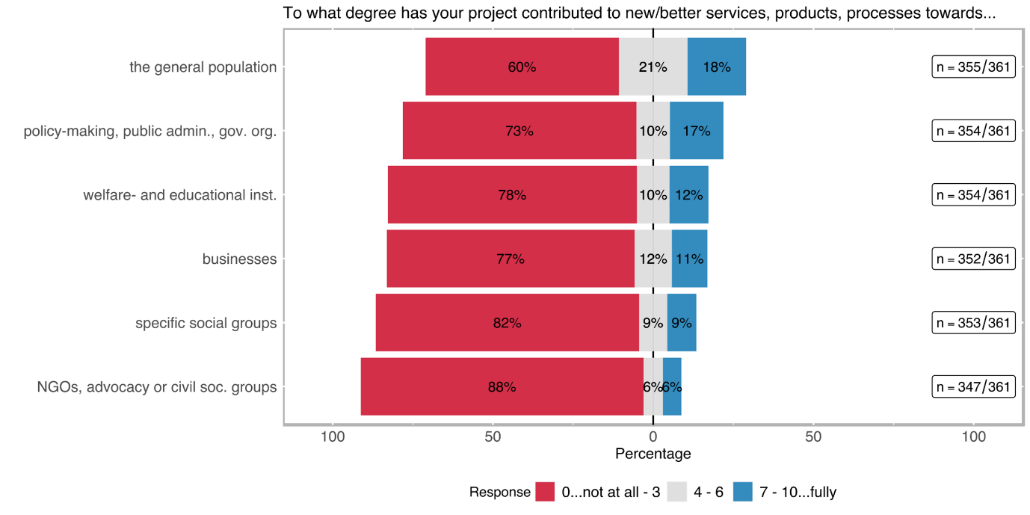

As shown in Table 9, the question *“to what degree has your project contributed to new or better services, products, processes or ways of doing things … towards academia”* was also raised. As expected, almost ¾ of the survey respondents (n= 357) mentioned a high degree (7 or more on a 0-10 scale) of benefitting academia by new or improved services products, processes or ways of doing things. We interpret this as the (high) direct contribution, which SNSF funded projects have made to the progress of science through newly generated knowledge. Only 13% of the respondents have classified their contribution as low in this respect.

Table 12: Direct contribution to target group(s)

|  |  |  |  |  |  |  |  |  |  |  |  |  |  |  |  |  |  |  |  |  |  |  |  |  |  |  |  |
| --- | --- | --- | --- | --- | --- | --- | --- | --- | --- | --- | --- | --- | --- | --- | --- | --- | --- | --- | --- | --- | --- | --- | --- | --- | --- | --- | --- |
|  | the general population (n=355) | | | busi­nesses (n=352) | | | | specific social groups[21] (n=353) | | | | welfare- and education-providing institutions[22] (n=354) | | | | NGOs, advocacy or other civil society groups (n=347) | | | | policy-making, public admini­stration, govern­mental agencies (n=354) | | | | academia (n=357) | | | |
| re­sponse | **abs** | **%** | | **abs** | | **%** | | **abs** | | **%** | | **abs** | | **%** | | **abs** | | **%** | | **abs** | | **%** | | **abs** | | **%** | |
| 0 | 116 | 32.68 | | 177 | | 50.28 | | 223 | | 63.17 | | 200 | | 56.50 | | 241 | | 69.45 | | 185 | | 52.26 | | 29 | | 8.12 | |
| 1 | 26 | 7.32 | | 32 | | 9.09 | | 30 | | 8.50 | | 32 | | 9.04 | | 27 | | 7.78 | | 26 | | 7.34 | | 3 | | 0.84 | |
| 2 | 39 | 10.99 | | 36 | | 10.23 | | 24 | | 6.80 | | 21 | | 5.93 | | 22 | | 6.34 | | 25 | | 7.06 | | 8 | | 2.24 | |
| 3 | 33 | 9.30 | | 27 | | 7.67 | | 13 | | 3.68 | | 22 | | 6.21 | | 16 | | 4.61 | | 22 | | 6.21 | | 8 | | 2.24 | |
| 4 | 15 | 4.23 | | 13 | | 3.69 | | 8 | | 2.27 | | 13 | | 3.67 | | 7 | | 2.02 | | 11 | | 3.11 | | 10 | | 2.80 | |
| 5 | 40 | 11.27 | | 24 | | 6.82 | | 13 | | 3.68 | | 12 | | 3.39 | | 10 | | 2.88 | | 20 | | 5.65 | | 27 | | 7.56 | |
| 6 | 21 | 5.92 | | 4 | | 1.14 | | 10 | | 2.83 | | 11 | | 3.11 | | 4 | | 1.15 | | 6 | | 1.69 | | 16 | | 4.48 | |
| 7 | 21 | 5.92 | | 9 | | 2.56 | | 11 | | 3.12 | | 14 | | 3.95 | | 9 | | 2.59 | | 22 | | 6.21 | | 46 | | 12.89 | |
| 8 | 22 | 6.20 | | 11 | | 3.13 | | 10 | | 2.83 | | 14 | | 3.95 | | 3 | | 0.86 | | 19 | | 5.37 | | 59 | | 16.53 | |
| 9 | 5 | 1.41 | | 6 | | 1.70 | | 4 | | 1.13 | | 6 | | 1.69 | | 3 | | 0.86 | | 5 | | 1.41 | | 41 | | 11.48 | |
| 10 | 17 | | 4.79 | | 13 | | 3.69 | | 7 | | 1.98 | | 9 | | 2.54 | | 5 | | 1.44 | | 13 | | 3.67 | | 110 | | 30.81 | |

We tested if the action-oriented intention to improve the human condition/welfare as expressed by some PIs (see section 5.1) directly correlates with a higher level of output contributions to non-academic audiences. As previously discussed, SI is per definition built upon its focus on new social practices or actions in a social context that address issues/needs better than already established approaches or practices (Howaldt, 2019). Although we do not want to exclude ex-ante that purely academic research motivations can also trigger social innovations or contribute to them (probably via several bifurcations), we expect that

* H3: the higher the motivation to *improve human condition/welfare* by the PI is, the higher the chances of direct contribution of the project results are to new or better services, products, processes, or ways of doing things when targeting
  + the general population,
  + specific social groups (e.g., women/men/non-binary, youth/elderly; migrants; or minorities/indigenous people), or
  + NGOs, advocacy, or other civil society groups.

Figure 20: Relation between the motivation to improve the human condition/welfare and the direct contribution of the project results towards...

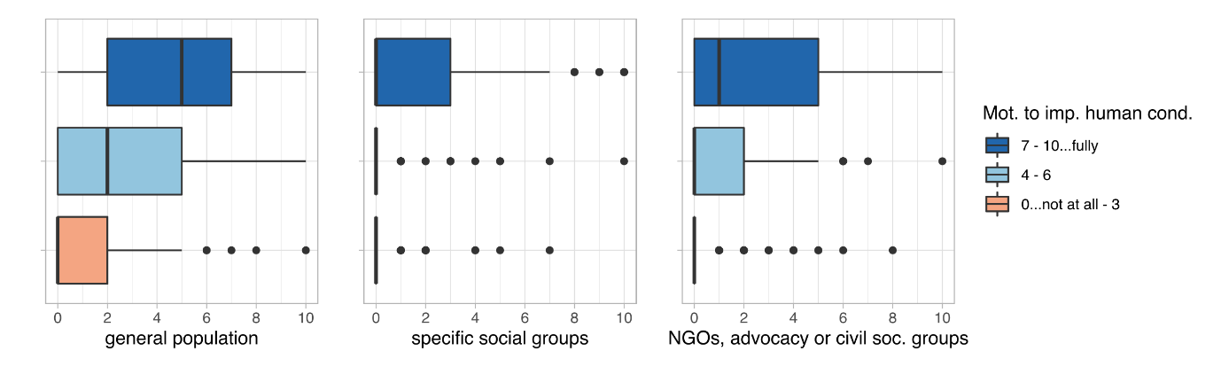

Figure 20 suggests that a high *motivation of a researcher to improve the human condition/welfare* may relate to direct contributions of project results to the target groups of research projects funded by SNSF. A deeper analysis of this variable shows statistically significant correlations with each of the outcome variables (p-values < 0.05, see Table 5). The strongest correlation is a moderate positive correlation with the *direct contribution to new or better services, products, processes, or ways of doing things* that were targeted towards the **general population** (rho ≈0.5) [H3.1].[23] Direct contributions for *specific social groups* and *NGOs, civil society organisations* are correlating relatively weaker (rho is 0.34 and 0.31, respectively) in comparison [H3.2, H3.3]. As anticipated, the motivation to generate an impact in improving the human condition/wellbeing has a significant relationship with the direct project results for specific social groups.

Table 13: Correlation matrix between the motivation to improve the human condition/welfare and the direct contribution of the project results to target groups

|  |
| --- |
| Correlation:  Mot.to imp. human cond. General popul. Spec. social gr.  Mot.to imp. human cond. 1.00 0.51 0.32  General popul. 0.51 1.00 0.38  Spec. social gr. 0.32 0.38 1.00  NGOs, civ. soc. gr. 0.33 0.42 0.55  NGOs, civ. soc. gr.  Mot.to imp. human cond. 0.33  General popul. 0.42  Spec. social gr. 0.55  NGOs, civ. soc. gr. 1.00  Sample Size:  Mot.to imp. human cond. General popul. Spec. social gr.  Mot.to imp. human cond. 355 350 342  General popul. 350 355 344  Spec. social gr. 342 344 347  NGOs, civ. soc. gr. 348 350 347  NGOs, civ. soc. gr.  Mot.to imp. human cond. 348  General popul. 350  Spec. social gr. 347  NGOs, civ. soc. gr. 353  P-Values:  Mot.to imp. human cond. General popul. Spec. social gr.  Mot.to imp. human cond. 0 0  General popul. 0 0  Spec. social gr. 0 0  NGOs, civ. soc. gr. 0 0 0  NGOs, civ. soc. gr.  Mot.to imp. human cond. 0  General popul. 0  Spec. social gr. 0  NGOs, civ. soc. gr.  **RESULT**   * H3.1: the p-value < α, i. e. there is a statistically significant association between the motivation to improve the human condition and the production of better services, product, etc. for the general population (correlation is also moderately strong, rho ≈ 0.5). * H3.2 and H3.3: are returning similar p-values, both smaller than α. This means that there is a statistically significant but weak correlation (0.3) between the motivation to improve the human condition and the production of better services, etc. for specific social groups, respectively NGOs, advocacy groups and civil society organisations. |

As shown in Figure 20, 17% of the surveyed PIs of SNSF funded projects (n= 354) responded a high degree of contribution of their projects to new or better services, products, processes or ways of doing things to benefit policy-makers, public administration and governmental organisations. Another 10% indicated a medium degree of contribution to benefit policy-makers, public administration and governmental organisations. To further explore the actual uptake of results by policy-makers, public administration and/or governmental agencies two additional questions were raised, which mainly aimed to measure how far the project results have been adopted by such public authorities and what the nature of impact of this uptake was.

An overwhelming majority of the respondents reported that there was little to no uptake of the project results by policy-makers, public administration, or governmental agencies. By including the 57 respondents that clicked ‘non-applicable’ to this question, then only around 17% of the total respondents rated the uptake of the project results by public authorities as moderate to high (see Figure 21).

Figure 22: Uptake of project results by policy-makers

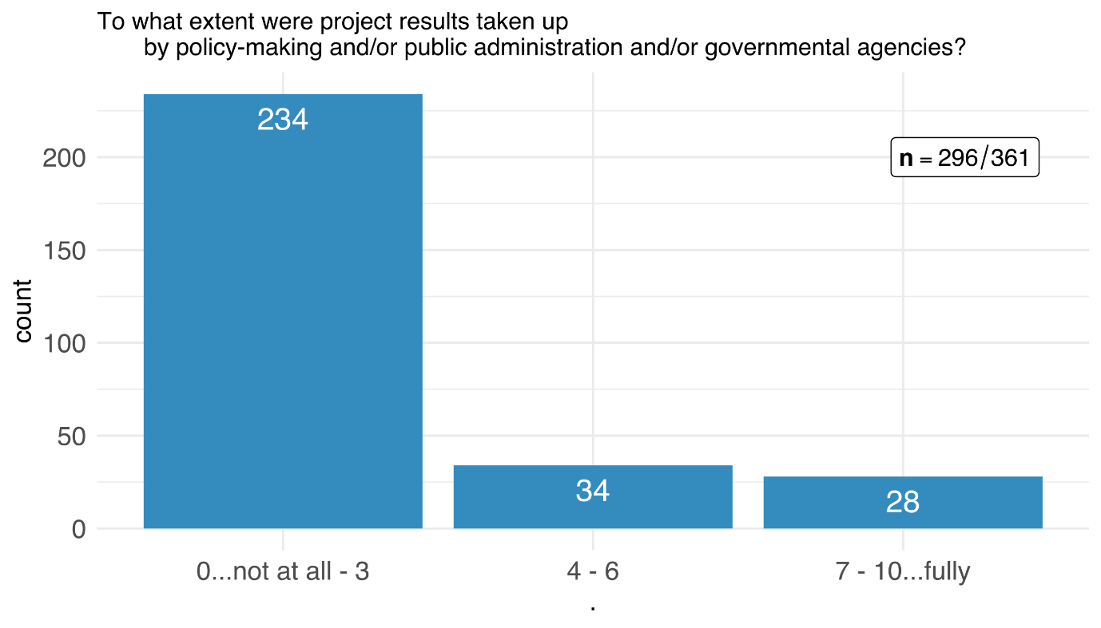

Note: 57 PIs ticked the “non-applicable” box. N= 353 if these “non-applicable” are included.

The nature of the policy uptake indicates what kind of a change the uptake by policymakers, public administration and/or governmental agencies caused. Nine PIs claimed that the results of their SNSF funded projects changed/influenced laws and regulations, 22 respondents noted that the results changed specific agenda-settings and 31 reported about changed policies (i. e. changes in policy measures) (see Figure 20). This means that 17 % of the SNSF funded projects had an impact on policy, public administration and/or governmental agencies, mostly in the way how policies or policy measures are designed and implemented.

Figure 23: Kind of uptake of project results by policy-makers

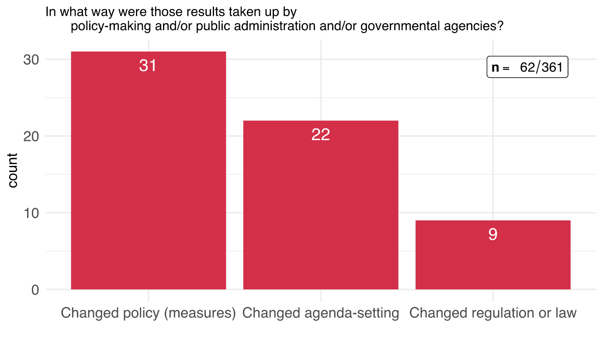

The last question in the outcome orientation section of the survey focused on impact statements and how the changes effected by the scrutinized SNSF funded projects corresponded to these statements. The statements were chosen to address SI-relevant aspects either directly or indirectly.

Figure 24: Impact statements – change affected through the funded research project

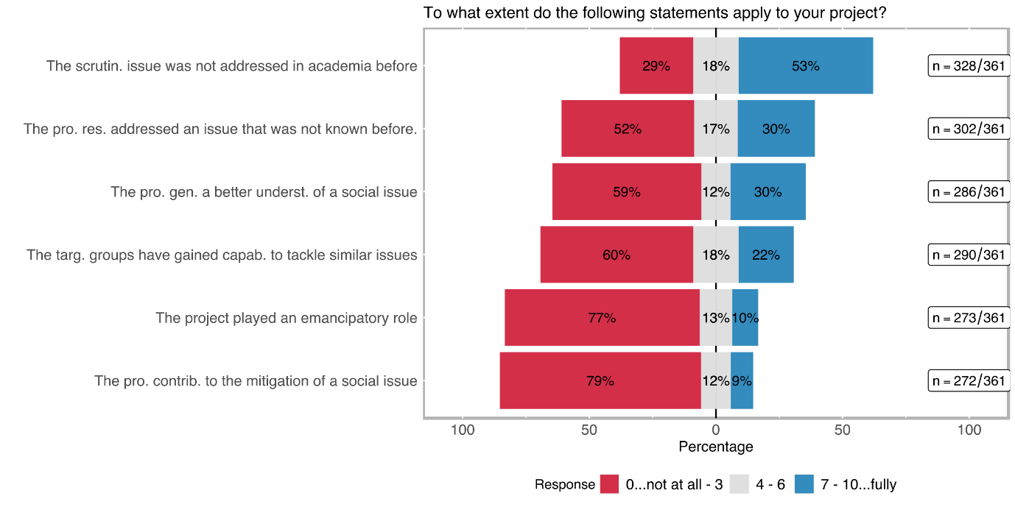

The academic rationale was prevailing among the survey respondents (see Figure 23); 53 % of the respondents (n= 328) rated the statement *the scrutinized issue was not (widely) addressed in academia before* with 7 or higher on a scale from 0 to 10. This result is followed by a similar statement postulating that *the project results addressed an issue that was not (widely) known before* in general. 30 % of the respondents (n= 302) rated this statement with 7 or higher. The statement that *the project generated a deeper/better understanding of a social issue* was similarly rated by the respondents (n= 296). These three response categories primarily indicate effects with regard to the progress of science.

However, it is striking that as many as 22% of the PIs (N= 290) indicated that their *targeted groups have gained capabilities to tackle similar existing or upcoming issues*. Moreover, 10 % and 9 %, respectively, of the SNSF-funded projects (n= 273 resp. 272) contributed highly to an *emancipatory impact/role for the target groups* or the *mitigation of a social issue* (see Figure 21). The latter three items indicate an orientation toward (social) innovation. These shares are however likely exaggerated. If the "non-applicable" answers were included, the respective proportions would drop by about 2 to 6 percentage points, depending on the question. Table 11 shows the adjusted results when the "non-applicable" answers are rated as 0 on a scale between 0-10 and thus added to the respective statistical population. But even with this adjustment to the safer side, SNSF projects do not only demonstrate very different impacts, but certainly also impacts that can be used to characterize them as contributions to (social) innovations. For example, almost 18% of the PIs surveyed stated that their *"target groups have gained capabilities to tackle similar or upcoming issues"* to a great extent. 8% confirmed that their project had a high *emancipatory impact* and almost 7% of the surveyed PIs emphasized that their projects highly *"contributed to the mitigation of a social issue".*

Table 14: Impact statements – change affected through the funded research project

|  |  |  |  |  |  |  |  |  |  |  |  |  |
| --- | --- | --- | --- | --- | --- | --- | --- | --- | --- | --- | --- | --- |
|  | capacity to tackle similar issues (n=290) | | Emancipa­tion (n=273) | | deeper/ better understan­ding of a specific social issue (n=286) | | mitigation of a social issue (n=272) | | issue not (widely) known in the society (n=302) | | issue not (widely) addressed in academia (n=328) | |
| Response /scale | **abs** | **%** | **abs** | **%** | **abs** | **%** | **abs** | **%** | **abs** | **%** | **abs** | **%** |
| 0-3 incl. non-appl. | 240 | 67.61 | 291 | 82.20 | 238 | 66.85 | 297 | 84.14 | 213 | 59.66 | 123 | 34.55 |
| 4-6 | 52 | 14.65 | 35 | 9.89 | 33 | 9.27 | 32 | 9.07 | 52 | 14.57 | 59 | 16.57 |
| 7-10 | 63 | **17.75** | 28 | **7.91** | 85 | **23.88** | 24 | **6.80** | 92 | **25.77** | 174 | **48.88** |
| *Non-applicable* | *65* | *18.31* | *81* | *22.8* | *70* | *19.66* | *81* | *22.95* | *55* | *15.41* | *28* | *7.87* |
| Sum incl. non-appl. | 355 |  | 354 |  | 356 |  | 353 |  | 357 |  | 356 |  |

In terms of the potential scalability of the results of the SNSF funded projects. 69 % of the respondents to the survey noted that the results generated throughout the project potentially have a high capability to be scaled up (see Figure 24), i. e. to achieve a higher impact if further developed and used. The potential for scaling-out to different geographic areas was highly rated as well. This is hardly surprising, because most scientific research is not regionally limited but strives for universal knowledge, insights and applicability. Interestingly, 36 % of the respondents also think that their project results can potentially scale-deep in the sense of changing cultural and social values.

Figure 25: Types of scalability

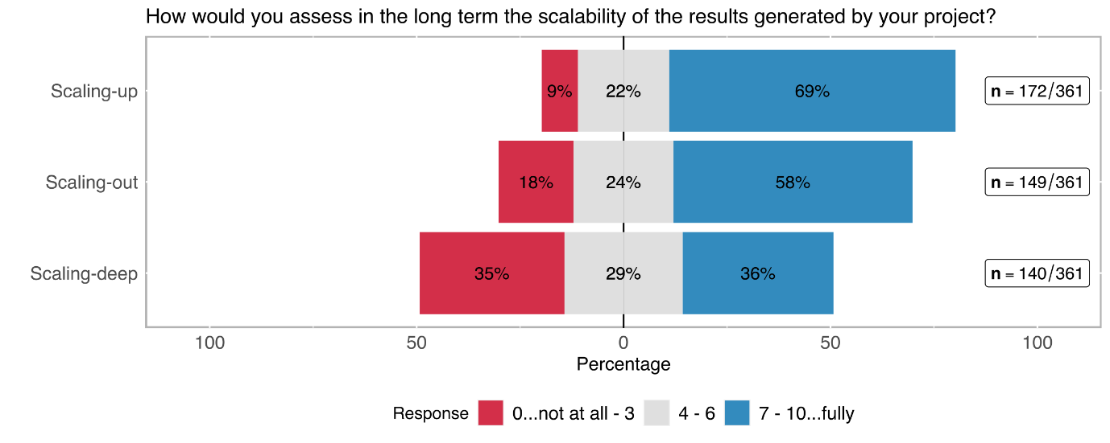

It is sometimes hypothesised, that wider impacts and better scalable solutions are developed, if stronger forms of participatory involvement of non-academic target groups in projects is undertaken[24]. We tested if a more central involvement of citizens in research processes would enable the creation of more widely applicable results and increased impacts for the involved individuals. In this sense,

* H6.1: the *more* *central the involvement of individual citizens* in research processes is,
  + the higher is the probability of the *scalability* of the results[25],
  + the more often a *deeper/better understanding of a specific social issue* is being generated, and
  + the higher the *emancipatory impact* of the research on participating groups is.

Figure 26: Relation between citizens' level of involvement and selected outcome variables

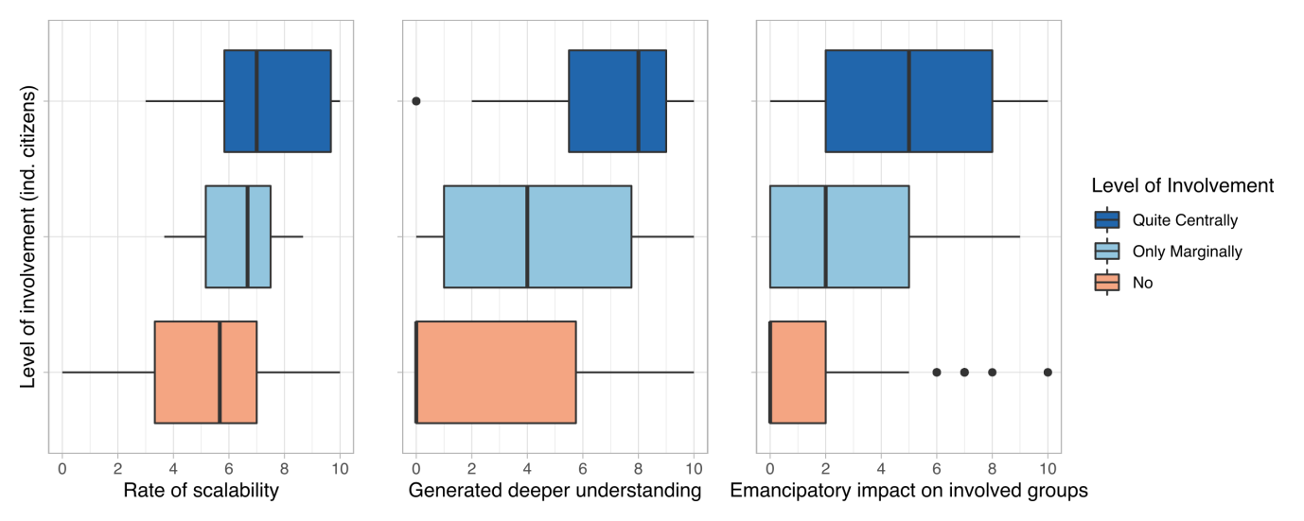

Figure 25 shows that there might be a vague relationship between the level of involvement of citizens in research processes and the generated results in terms of *scalability*, a *deeper/better understanding of a specific social issue* and the *emancipatory impact* on the involved groups. Indeed, as the statistical analysis shows (see Table 12), g*enerating a better/deeper understanding of a social issue* as well as *emancipatory* impact on the involved societal groups seem to be correlating relatively high with the level of involvement of citizens in research processes (rho > 0.45, p-value < 0.05 each). In addition, scalability seems to be rated slightly higher in research projects where citizens were involved centrally (rho ≈ 0.35, p-value < 0.05).

Hence, we can say that higher levels of *transdisciplinary involvement of citizens* have a statistically significant relationship on the *scalability of results*, a *deeper/better understanding of the studied issue*, and the *emancipatory impact* on the participating societal actors.

Table 15: Correlation matrix between citizens' level of involvement and selected outcome variables

|  |
| --- |
| Inv. of citizens Scalability Gen. understanding  Inv. of citizens 1.00 0.33 0.39  Scalability 0.33 1.00 0.35  Gen. understanding 0.39 0.35 1.00  Emancip. impact 0.43 0.41 0.65  Emancip. impact  Inv. of citizens 0.43  Scalability 0.41  Gen. understanding 0.65  Emancip. impact 1.00  n  Inv. of citizens Scalability Gen. understanding  Inv. of citizens 353 118 279  Scalability 118 121 114  Gen. understanding 279 114 286  Emancip. impact 267 115 266  Emancip. impact  Inv. of citizens 267  Scalability 115  Gen. understanding 266  Emancip. impact 273  P  Inv. of citizens Scalability Gen. understanding  Inv. of citizens 3e-04 0e+00  Scalability 3e-04 1e-04  Gen. understanding 0e+00 1e-04  Emancip. impact 0e+00 0e+00 0e+00  Emancip. impact  Inv. of citizens 0e+00  Scalability 0e+00  Gen. understanding 0e+00  Emancip. Impact  **RESULT**   * H6.3: the level of involvement of non-academic actors seems to have a statistically significant relationship with scalability, the generation of better understanding, and an emancipatory impact, as the p-values are smaller than 0.05 for each of these, although at a weak to moderate level of correlation. |

Further outcomes of SNSF funded research projects

The interviews with the PIs generally confirmed the survey results, but highlighted additional aspects related to the generation of outcomes beyond academia, which are briefly presented in this section.

1. **Opening up a discourse between academia and stakeholders:** Almost all interviewees who identified transdisciplinary aspects in their projects highlighted the opportunity for dialogue and exchange. It was argued that most often, academic research happens in a vacuum while solutions in practice differ from what has been suggested by academics. Hence, bringing together people from academia with non-academic stakeholders (e.g., practitioners, policy-makers, civil society) enabled both sides to communicate their knowledge and expertise and to work jointly on solutions. Exchange helps researchers and stakeholders to better understand each other while also creating common knowledge which could advance research endeavours as well as solutions on the ground. In several cases, this transdisciplinary exchange has led to further collaborations and jointly developed research plans.
2. **Empowering target groups:** One aspect that was highlighted by many people who worked with the projects’ target group was the empowerment of this specific group. A few interviewees emphasised that projects that talk about or research a certain group often fail to account for this particular groups’ perspectives, knowledge and vulnerabilities. Solutions, either academic or practical, are often readily present to target groups with no to little room for co-development. One interviewee stressed that the prototype produced within the scope of his project was significantly altered due to the many insights of the target group. At the same time, the vulnerable group received a chance to be heard, to raise concerns and influence outcomes that directly affect them. Correspondingly, several interviewees argued that real and positive impact is only achievable when the groups affected are heard and included in the research process. However, it was highlighted that not only solutions or products can be improved by including target groups in research processes. Rather, the system of academia, i.e., the way knowledge is created and results are gained, can profit from an exchange with target groups.
3. **Better products and services:** One particular aspect of a change process is the improvement of the usability of a product or service. More specifically, several interviewees from vastly different fields argued that without the support and feedback from non-academic stakeholders, the end product would not have been as promising.
4. **Learning and changing perspectives:** Interactions with non-academic stakeholders opens up new perspectives and interests. Correspondingly, several interviewees emphasized that working together with practitioners enabled them to increase their knowledge about certain issues that were not on their radar before. One interviewee who worked with practitioners from clinics stressed that these exchanges enabled him to think *“outside the box”* which ultimately led to an increased interest in transdisciplinary work. Another interviewee emphasized that the interactions with non-academic stakeholders fostered an “(…) innovation-push which came through learning from partners”. (Interviewee 10)
5. **Advancing academic research through transdisciplinary exchange:** Interactions with non-academic stakeholders can improve the way research is understood and done.In one case, the transdisciplinary exchange with citizens has resulted in the development of new research directions. One interviewee underlined that through the exchanges with professionals and practitioners, her research idea emerged and developed.

*“Here we have a conception of scientific work, and this is another element which is extremely important for me. It's almost political. We're not breaking with common sense. We are not in this vision of science as an epistemological break where there will be researchers and the ordinary world. When I go into the field to understand how professionals work, I'm not going to arrive with a normative vision. (…). I'm not going to arrive with a ready-made conception of how they should work or what their value should be. The only thing I don't question is my pragmatic approach. But on the other hand, for example, my working hypotheses will emerge from my encounter with the field, from the questions that professionals ask themselves.” Interviewee 1*

While PIs emphasized in general the importance of the knowledge of non-academic actors, one interviewee emphasised that PhD students also get the chance to put their research into practical context and eventually make it more relevant to the non-academic world. This can be rewarding, especially for early-stage researchers who struggle to get settled in academia.

1. **Advancing academic research through interdisciplinary exchange:** According to our interviewed PIs, bringing together different theories and methods from diverse fields has several advantages compared to staying within disciplinary boundaries. Many interviewees stressed that the outcomes of the project would not have been achieved if the project had been conducted within one research field. One interviewee reported that within his field, it is not common to work with people outside the field who, for example, consider the impacts of bacteria on humans. By bringing together insights from distinct fields, results that were gained from working with cattle could be then analysed with a focus on potential human impact. However, one interviewed PI highlighted that crossing disciplinary boundaries does not necessarily mean having a shared problem that researchers from different disciplines want to solve. Rather it also encompasses learning from others without working on the same project.

*“[...] It is less about social science studies being carried out by artists or something like that, but that one is through parallelizing the works, i.e. the humanities scholars, natural scientists, artists doing their work in the same room in parallel, so that sparks fly there like that. I call that aggravated neighborhood. So it's not about that, it's another concept of transdisciplinarity in theory, there's a problem that you can't solve on your own, that's why the disciplines come together. Everyone tries to solve the problem together. That's not how I do it. There is no common problem. There is a common place and this creates mutual accelerations, so to speak.” Interviewee 8*

1. **Achieving impact through the connection of fundamental and applied science:** Some of the interviewed PIs reported that while their research was fundamental, they tried to achieve greater impact by working together with applied scientists. Several PIs emphasized that although there is room for societal impact also in fundamental research, a lot more can be achieved when adding an applied perspective to research. This fosters translational science and results can be implemented and realized faster and more efficient outside academia.

Communication and Dissemination of results

The survey results (see Table 13) showed that PIs used a wide range of dissemination channels. Next to the publications in scientific journals (96%), which is the dominant dissemination channel, the surveyed PIs also often mentioned publications in conference proceedings (85%), and institutional or project websites (79%) for dissemination and communication purposes. This is followed at a distance by another group of dissemination channels that include monographies and book contributions (46%), traditional media (43%), journals and magazines targeting practitioners (42%), general events for a non-academic public (40%), social media (37%), online platforms (34%), provision of consultancy (33%), and targeted events for practitioners (32%). Only policy briefs were employed by just 10% of the responding PIs.

Table 16: Dissemination channels

|  |  |  |  |  |
| --- | --- | --- | --- | --- |
| Dissemination channel | no | | yes | |
|  | **abs** | **%** | **abs** | **%** |
| Peer reviewed journal publication (n=358) | 14 | 3.91% | 344 | 96.09% |
| Monography, contribution to a book (n=342) | 186 | 54.39% | 156 | 45.61% |
| Conference proceeding (n=356) | 52 | 14.61% | 304 | 85.39% |
| Policy brief(s) (n=333) | 301 | 90.39% | 32 | 9.61% |
| Traditional media (TV/radio/print/etc.) (n=346) | 196 | 56.65% | 150 | 43.35% |
| Professional journals/magazines targeting practitioners (n=343) | 198 | 57.73% | 145 | 42.27% |
| Own institutional or project website/blog (n=354) | 74 | 20.90% | 280 | 79.10% |
| Social media (n=347) | 219 | 63.11% | 128 | 36.89% |
| Online platforms (other than social media and project website/blog; e. g. data or code sharing, citizen science platforms) (n=343) | 228 | 66.47% | 115 | 33.53% |
| (You providing) consultancy (paid or unpaid) (n=342) | 226 | 66.08% | 116 | 33.92% |
| Targeted events for (non-academic) practitioners (n=343) | 233 | 67.93% | 110 | 32.07% |
| General events for a non-academic public (other than practitioners) (n=343) | 207 | 60.35% | 136 | 39.65% |

Figure 27: Distribution of dissemination channel

Dissemination can be a driver of change and we assume that motivational aspects and the intended purpose of the research seem to guide dissemination activities. Interviewees who identified a relevance for practice and transdisciplinary aspects early on in their research projects argued that workshops, training programmes and conferences that are open to non-academics are crucial for fulfilling impact outside of academia.

One aspect that was emphasised by almost all interviewees who undertook dissemination activities was the aspect of science communication to the public. They consider it as important to not only communicate research findings to specific stakeholders (e.g. practitioners) but also to wider society. Depending on the field and discipline, different project teams initiated different strategies to reach out to the public. For example, one interviewee gave talks in museums, while others talked to the media.

*“Well, we have always tried very hard to convey and make our information available in a form that / both in terms of the way it is presented, but also in terms of accessibility. For example, we have [results] publicly accessible and we also have, you can see that, we have a website where we also show it, where we actually make everything accessible, with just a few exceptions, that's an important thing for us. It is also a prerequisite that something like a transfer takes place and that ultimately other actors do something like social innovation with it.” Interviewee 19*

Generally, interviewees mentioned ten different dissemination channels. Some only used one, while others combined different channels:

1. **Publication in academic publication formats:** Almost all interviewed PIs confirmed that they published their results in academic journals or as a book targeted at the scientific community. The pressure to publish was stressed by many interview partners. Accordingly, academia requires researchers to actively publish (or perish), that was surprisingly often referred to as “quick and dirty”, which takes time away from other dissemination activities.
2. **Publication in non-academic publication formats:** Besides publishing articles in academic journals, some interviewees also published their results in non-academic publication formats. One interviewee, for example, said that he published his project findings in specific magazines for practitioners. Another highlighted university magazines, which required the team to reflect about how to make the topic interesting and accessible for students.
3. **Policy briefs:** A few interviewees said that they wrote policy briefs, some of which were commissioned by a political authority while others were not. One interviewee especially stressed that a policy brief could only be effective when then discussed with the responsible people. Therefore, writing such a report without a dialogue afterwards can prove less promising when trying to engage with decision-makers.
4. **Open-access material:** Four interviewees mentioned that they published their data sets with the aim to help other researchers to improve their work. Open-access databases can be important for further analyses, but they can also serve as a communication tool. One interviewee stressed that he not only makes his data freely available, but also uploads all project outputs (reports, articles etc.) on a website in order to make all findings publicly accessible.
5. **Lectures and teaching:** Lectures and teaching were also seen as an essential channel for communicating project outcomes. Most of the interviewed PIs who employed lectures as a source for dissemination did so in a university context, but some highlighted the importance of further training of practitioners too. Accordingly, one interviewee stressed that in his case it was essential to feed the project results directly into the training of practitioners, which is why he turned to experts rather than students for teaching. Another interviewee claimed that in order to reach people not only in Switzerland but also abroad, a Massive Open Online Course can help overcome distance in dissemination.
6. **Interviews and discussions:** Five interviewees mentioned that they gave interviews either for magazines or during discussion rounds. Others noted that they took part in round tables, which were mostly aimed at the general public. Those interviewees who participated in such activities highlighted that this gave them the chance to put their research more into context. One interviewee expressed that conferences are very useful for dissemination, although often very focused on topical details. Round tables and discussions, which are open to the public, are more characterised by openness and less scientific language.
7. **Conferences and presentations:** Two of the most used dissemination channels were conferences and presentations. Although conferences were mostly targeted at an academic audience, some interviewees mentioned that they presented their findings at conferences to either the public or practitioners. Similarly, others mentioned that they were invited to give presentations at other meetings. Many interviewees emphasised the informal parts of such events for widening one’s network for future collaborations.
8. **Media:** Around one-fourth of the interviewed PIs said that they talked to the media. Some of them stressed that journalists were very interested in their research and that they received numerous requests for interviews. Contrarily, others claimed that it was quite hard to raise journalists’ interest, because their research phenomenon was less of a “hot topic”. Nonetheless, all of them noted that the media can be an important source for dissemination as it is able to reach an audience, which researchers mostly cannot reach.
9. **Websites:** Sometimes, research projects were represented and summarised on specific websites. Those interviewees who mentioned open-access databases also referred to their projects’ websites as they provide opportunity for downloading there. In a few cases interviewees mentioned their website without showing open-access material.
10. **Excursions:** Two interviewees reported that they went on excursions where they visited practice partners and experts from other countries. This enabled them to put their findings into perspective and get feedback from people who work in different contexts. According to one interviewee, this allowed the research team not only to talk about their findings but also to acquire deeper knowledge about the structures and practices outside their research field.

Exploitation and follow-up activities

*Exploitation*

Based on the feedback of the interviewed PIs, exploitation activities can be roughly divided into activities aiming at commercialisation and activities aiming to contribute to education and knowledge transfer.

**1. Commercialisation**

* **Company/Start up:** Three of the interviewed PIs from the natural and technical sciences tried or still try to exploit their projects by founding a company or a start-up to translate their research into a product ready for the market. They mentioned that the founding process requires a lot of funding (from the public or private investors) and a lot of commitment from partners with different expertise and skills. Many partners from the original projects were involved in the companies or start-ups. At the time of the interviews, these companies were in different phases; one company was at a point briefly before bringing their first product onto the market; one company was in the set-up phase; one company was dropped after two years of existence. Some other PIs also considered founding a company to exploit their research results, but they then decided to remain in academia, to draw funding from academia and leverage the existing university infrastructure, e.g., in the form of grants.
* **Patenting:** Patenting is seen as an important tool for technological transfer and to find industry partners for further development, in particular in the fields of pharmaceuticals/chemistry and technology. Projects in these fields can result in several patents, which, however, do not necessarily result in a product.
* **Further tests in practice context:** For some interviewees, one goal of exploitation was to recruit a practice partner (e.g., a company, political administration) to further uptake and test their research in an applied context to better estimate the potential of their approach for impact in the real world. They see this as a logical next step for their research, allowing them to both further their scientific investigations and challenge them in the practice context.

**2. Education and knowledge transfer**

* **Consulting:** One of the interviewed PIs involved consulting companies as part of the exploitation activities, applying the knowledge gained from research. Importantly, in this project, the company was already involved in the proposal and implementation phase of the project.
* **Online Courses/ MOOC and further training:** Some of the projects’ results could be further exploited in the form of online courses, training (e.g., for teachers), developing curriculum modules and workshops. These formats were used as a form of knowledge transfer into the practice field.
* **Developing guidelines:** In addition to consulting, provision of courses or training, developing practical guidelines and principles for organisations and institutions was another form of exploitation.
* **Creating a database/publishing materials:** In one research project, a database was established to systematise and prepare material used in the project for a general audience; data could then be used by students or other researchers.

*Follow-up activities*

Usually, SNSF projects are not starting from scratch, but often build up on previous ones. Conversely, the results of current projects are often the inputs for future projects. The researchers are often very familiar with practice partners working in the same field. They have built partnerships and collaborated with both academic and practice partners. Because of the PIs’ general activities in their respective field of research, it was not always possible to distinguish between distinct single projects with regards to their exploitation and follow-ups during the interviews.

**1. Follow up projects:**

* **Pure research projects:** Based on research findings, methods or products developed in the SNSF funded projects, some follow-up projects dealt with expanding the previously achieved results, applying methods in new contexts, overcoming previous limitations, or investigating questions that remained open. Often, these were conducted with some of the same previous academic project partners or with former PhD students who are now in new positions. Follow-up projects, however, also emerged with new partners from other academic institutions. In some instances, the PIs themselves were not involved in the follow-up project, which was then led and advanced by a former PhD student or Post Doc. In one case, ideas for a follow-up project resulted from exploitation and communication activities, whereby the researchers were confronted with feedback from practice, which provided new perspectives and impulses on the topic. In another case, the impulse to continue with a follow-up project came from the patients that were involved in the previous study. Many smaller follow-up projects were financed with internal university funds, which also often served the purpose of examining the results for the readiness of exploitation and perhaps commercialisation. Most often, the funding for purely applied follow-up projects stemmed from internal funding or other funding schemes, but almost never from SNSF.
* **Practice/applied projects:** Often applied follow-up projects were funded by Innosuisse. Accordingly, many interviewees reported that theysubmitted proposals to Innosuisse to enable the transfer of projects results that were gained during the SNSF project. In a few cases, follow-up projects were taken up by industry partners, in which tools and applications were further developed.
* **Research projects with access/involvement of practice partners:** Some of the follow-up projects dealt with a similar topic as the previous SNSF project, but were able to gain access to new stakeholders and practice partners. This promised new avenues and opportunities of achieving impact beyond academia. There was also a follow-up project that combined research and practice by transferring the results from the SNSF funded project to other applied contexts including the development of guidelines for the responsible institutions. One PI participated in an art exhibition where he contributed an installation based on his SNSF funded research project. Efforts were also made to involve industry partners or private foundations in funding to enable follow-up projects.

**2. Further collaborations with project partners:** More than half of the interviewed PIs who were involved in collaborations with companies during the project implementation phase continued after the official end of the project. In other cases, further collaborations with national and international academic partners with the aim of submitting proposals for new projects, publishing papers, setting up labs, and working together on projects on different topics, were reported.

In some fields (e.g. education, medicine), the academic partners are already connected through their institution such as medical researchers and doctors who are both working at the same university hospital, or researchers in education science who do their research at the same institution that trains future teachers. Such institutional connections enable exchange and collaboration and facilitate ongoing communication.

**3. Staying in touch:** Many interviewed PIs are still in contact with their previous project partners and contacts from practice, despite the project's end. Some PIs also work at institutions that regularly interact with other practice institutions and foster student and employee mobility, often with the prospect of continuing the collaboration with the help of a new project.

However, the interviewed PIs do not stay in contact with all of their practice partners. If they found an interested and engaged practice partner during the project, they try to stay in touch and to exchange ideas and knowledge in the future. They value the contacts made during the SNSF project as a way of expanding their network and drawing on it when a new potential project or other opportunities for collaboration arise. Oftentimes, the contact between academic and practice partners had already existed before the project started, because the researchers have been active in the same field for years and have built expertise. Then these contacts are usually ongoing after the SNSF project has ended.

**4. Other long-term benefits of the project:** Another benefit in terms of sustainability is that researchers can increase their recognition within the scientific community, but also among relevant stakeholder communities from practice and industry.

1. LIMITATIONS AND BARRIERS ON THE ROAD TO IMPACT

The interviewed PIs identified several barriers when it comes to the exploitation and utilisation of their project results:

1. **Commercialisation:** Some researchers experienced difficulties in achieving the commercialisation of a product. Accordingly, product development often requires certification and additional administrative steps (e.g. for pharmaceuticals), which is often not perceived as worthwhile. One PI mentioned that the commercialisation of project outcomes is basically a different job, while others stressed limited time for such activities. Additionally, oftentimes product development and making it ready for market entry requires a lot of money, predominantly from investors, and collecting money from investors requires a company if this is done by oneself.

*“If you want to achieve an impact, if you want this to become a real product, you need to make a company, you need to get eventual capital, otherwise it is not going to work.” Interviewee 5*

In some cases, where commercialisation was a goal of the interviewed PIs, they found it difficult to find industry partners with whom they could commercialise the product. Some interviewees referred to different intrinsic logics, e.g. that industry partners often do not want to work together with academic partners because their research, materials and codes are often open access, which is detrimental for the companies' goals.

Some PIs also mentioned that findings generated from fundamental research are often perceived as too risky by industry as they are not tested in the “real world”.

1. **Time:** After the end of a project, researchers tend to do other research projects or to teach and present project findings at academic conferences. Many interviewees claimed that they have no time for exploitation and utilisation activities once the project is finished.

Quite a lot of interviewees stressed the high pressure to publish, which consumes a lot of time and energy. Several interviewees emphasised the situation of young researchers in academia who struggle to find long-term or permanent employment and face fierce competitive pressure. Hence, neither senior nor young researchers often have the time to spend more time than necessary on implementing outcomes if such activities go beyond the scope of their project.

1. **Funding:** Project funding is typically limited to three to four years, and a project is considered finished when the results can be presented (e.g. in a final report, a scientific paper or at a conference) and not when the results are exploited in an applied context. This means that mostly exploitation and utilisation work has no funding dedicated to it, which limits the work researchers can do in this area. Funding could be in the form of a follow-up study or a dedicated exploitation project. Existing funding schemes are not considered as exhaustive in this regard, as, for example, Innosuisse requires existing support of the industry and the involvement of business partners. Though part of exploitation work would be to identify and recruit these partners, this effort is usually not funded and not always supported (e.g. by Technology and Knowledge Transfer Offices).
2. **Administration and organisation:** Three PIs expressed that administration and organisation posed a challenge to their exploitation and utilisation activities. Different issues were anecdotally mentioned, such as delays caused by the need to resubmit to the ethics committee because of small changes within the project, or the change of administrative support staff of their universities, which resulted in fluctuating support for their project and their ideas, or delays of receiving funding due to specific legal provisions.

Also mentioned were difficulties to access sensitive data, the sharing of data and issues of accountability and responsibility. Accordingly, one interviewee emphasised that any effort for improving a situation can be undermined when regulations do not allow access or sharing of data that would be necessary to better understand a problem and - as a result - to communicate more in-depth results rather than general findings. Another interviewee mentioned complex funding regulations in some practice fields (e.g. health care and hospitals). He argued that such complicated systems make it difficult for researchers to understand the entangled web of rules and regulations but also directly opposing actions.

1. **Raising awareness and communicating the project and its relevance:**

* **Among the general population/ the public:** Some research topics are associated with already existing opinions or stereotypes in the general public, which makes it difficult to communicate their importance and relevance and to raise awareness.

*“I mean, the general impression is that it is a little bit difficult from general population to understand how severe is the problem. Actually, […] is mostly interpreted by the general population as something to do with wellness, not with medicine, and so this was difficult for us to let them understand that we are talking about a disease.” Interviewee 14*

In addition, some PIs were challenged to abstract and simplify the manifold facets of a research project and its results to better communicate the public relevance and scientific achievements. Some PIs confessed to find it difficult to communicate concrete conclusions or to suggest concrete actions for applied or practice contexts, which makes actual exploitation of the project results difficult.

One interviewee argued that sometimes researchers who work with target groups outside of their home country, do not report back the results to relevant stakeholders to the country the research was conducted in:

*“And that is what I found, perhaps in a deep sense this is also a problem of the scientific community, especially in these development contexts, that one, so to speak, with one's own motivation. That one wants to earn one's own salary and have a good life in Switzerland, in Austria - one goes to the slums, because there you can collect good primary substances and with that you run back home, tell great stories and the impact on the ground is actually non-existent or even extractive, or, in other words, that you take people's time away, or also with the hope that something would improve and effectively nothing ever flows back.” Interviewee 16*

Several interviewees emphasized the role of the expectations in disseminating results. One interviewee, for instance, stressed that one single project can only achieve limited impact in general. Another interviewee highlighted the importance of networks when it comes to dissemination. Appropriately, knowing the actors when communicating the results can be crucial for successful dissemination. Yet, the interviewee also stressed that even when you have invested time and energy to get to know relevant actors, the impact you can accomplish is limited.

*“Well, if you want to achieve something, you have to spend a long time getting to know the actors in the field, you have to understand what they are concerned about, you have to build up trust, you have to spoon in new ideas and after a lot of effort, sometimes after years, in the best case you have a context - now with my last project, which I have just completed - where you can work together joyfully and perhaps achieve something, but even then you have to be modest in the end.” Interviewee 16*

* + **Among policy makers and responsible institutions:** Communicating and introducing or at least suggesting change based on research findings can be difficult if policy makers or the responsible institutions are not willing to go for such change, especially if it is too costly, or if the conclusions based on the research findings would not lead to immediate impacts. Accordingly, one PI stressed that decision-makers lose interest if results take too long to be implemented and if change is not immediately noticeable.

*“They would use our results immediately like that, it is always the same - if nothing happens, no one cares.” Interviewee 12*

Another interviewee stressed that his topic (the prevention of an epidemic caused by a certain strand of bacteria) was not seen as urgent enough by policy-makers to implement actions as the last outbreak of the related illness lies decades behind.

One interviewee highlighted the pressure that politicians experience when dealing with topics such as migration, where enormously different interests within the political arena exist, which makes it difficult for academics to firstly bring all crucial stakeholders together and secondly, bring all stakeholders to agree on the topic. Similarly, several interviewees highlighted that the multi-level governance of Switzerland makes it difficult to achieve policy change.

Moreover, interviewees stressed that political will is often connected to particular people in the office, but when these people leave, topics that were previously interesting can become irrelevant to successors. Generally, several interview partners underlined the often limited interest from policy-makers for certain topics.

1. **Limited networking and exchange:** To achieve scaling and utilisation of project results, national as well as international networking, exchange and collaboration is important– specifically between researchers but also with practice partners, including industry. Some interviewees perceived quite limited exchange and collaboration with governments and the civil society within the German-speaking countries, which challenges scaling and exploitation of their project results. They argued that it would be in particular helpful if more structural or institutionalised exchanges, for instance in the form of scientific centres which foster interactions between different disciplines, universities, or countries would exist.
2. **Limited support or coaching:** Though most of the interviewed PIs stressed that they received support from their organisation in pursuing exploitation and utilisation activities, three PIs voiced that the limited support or coaching from their organisation posed a challenge to this. While they were not explicitly hindered, they did not receive support and were seen as outsiders with their research. Others simply lack institutional backup, which would support them in the next steps of applied work and the generation of impact in practice fields. They are left alone with applied and translational work, and have to do it on their own.
3. **Limited opportunities to continue projects:** Many interviewed PIs stated that it is difficult to exploit and utilise their projects without formal opportunities for the continuation of a project. Many ideas, questions, and conclusions only emerge towards the end of a project, and there is hardly an opportunity to follow up or deepen these ideas and avoid wasting expertise and know-how. The PIs suggested that funding agencies like the SNSF should actively encourage project continuation as part of a grant or as part of a new track so that these potential new insights can be followed-up and exploited. This kind of funding could focus on a follow-up study, on finding out whether results were taken up, or could just focus on dissemination and science communication to inform the public and relevant stakeholders, for instance, by preparing results for different audiences and travelling to different institutions, bodies, and organisations. In particular, PhD students would benefit from such a funding scheme endorsed by a funding agency like the SNSF, as they basically lose their job with the end of the project. Such a funding scheme would be helpful for exploiting their research work. It would also support those researchers who are forced to always be involved in a project in order to get paid.
4. **Difficulties in engaging relevant stakeholders:** When trying to communicate results and make them usable, some PIs experienced that their target group or stakeholders, e.g., policy makers, simply were not interested or developed other priorities in the meantime. Policy makers did not come to presentations they were invited to, and hence, in-depth discussions of the topic could not take place. In addition, stakeholders from practice often have difficulties with interpreting and translating scientific results for their practice; they rather want suggestions for concrete actions, or generalised statements, and need the information to be translated with regard for relevance for their own work
5. **Difficulties in achieving social impact:** Some PIs mentioned structural difficulties within academic practices in achieving social impact with their project. They refer to a lacking continuity of projects, of research teams, or in the composition of institutional bodies, which leads to changing interests and priorities and prevents one topic from being really implemented or turned into an applied context. They stressed that achieving social impact would require a more structured and sustainable way of exploitation and utilisation of a project. In addition, the novelty of project ideas is highly valued in academia and especially in research funding, which means that a new project should not be a follow-up or applied project of a previous one but should deal with a new and innovative topic. However, it would be exactly this continuous engagement with a topic that would be beneficial to achieve long-term impact.

Some PIs mentioned that especially fundamental research has too little application orientation to go for exploitation. Interviewees stressed that the road to impact is extremely long and can be tedious at times since the academic system is not geared towards generating immediate results. SNSF grants usually do not call for application orientation or efforts for transfer and translation. Moreover, efforts for exploitation or knowledge transfer are usually not rewarded in an academic career. Publishing in scientific journals remains the main currency of researchers.

1. **Limited knowledge if results are taken up:** Many PIs responded that they cannot assess whether their exploitation and utilisation activities were successful because they do not know the extent to which project results were taken up by practice partners. or were further spread. Finding out to which extent results were taken up by practice would require a follow-up inquiry, which is out of the scope of an SNSF funded research project. In addition, several PIs do not see themselves in the responsibility of ensuring an uptake of their project results. They rather see this as a task of policy makers, practitioners, and representatives of institutions who have the responsibility of making use of the results and of investing in their realisation.
2. EXCURSUS: THE VIEW FROM PRACTICE PARTNERS

In order to understand which impact the projects have had outside of academia, we also interviewed nine practice partners of PIs involved in SNSF funded projects. In general, the practice partners were associated with administrative offices, civil society organisations, or welfare- or education-providing institutions. Some of them had explicitly the role of providing a linkage between research and practice at their institution, or had a scientific background which supported them in their mediating role. Their tasks at their institutions can be described as project managers, contact persons, supervisors of project implementation at their institution, consulting partners, or experts.

Motivation and social purpose

The motivation for the interviewed practice partners or their institutions to participate in the projects was that the research project addressed some sort of problem or research questions the practice partners experienced as a problem in their own work. Accordingly, they hoped that the research could not only address this problem but also contribute to a solution and that they would benefit from their participation.

Specifically, their motivations for engagement in an SNSF funded project were …

1. … interest in the topic and the **wish to gain knowledge** about the projects’ results as basis for evidence-based decision-making. They expected that the project can provide stimulating discussion and new insights. Research projects often bring together people with different expertise and knowledge, whether it is in the project team or by organising events or conferences. One practice partner expressed that a stimulating exchange with different partners was important to discuss new information .
2. … interest in the topic and the **wish to** **apply** the results in their field of practice. The interviewed practice partners hoped that the project results would be transferable to their practice and could be applied as solutions for perceived problems. They required an effort in knowledge transfer from the researchers and wanted to implement the results.

With the results and knowledge transfer from the research projects, the interviewed practice partners also hoped that the project …

1. … will fill a research gap and provide data relevant to their field of work;
2. … raises awareness about certain issues and challenges that they experience in their field of practice;
3. … identifies and promotes activities to address problematic issues in their field of work;
4. … provides some Independence from industry: One practice partner explained that by participating in the research project, he could learn and develop new strategies for his practice field while collaborating with a commercial company would have created dependencies, which might have biased project results or the communication of results.

Social purposes that were identified were related to

* improving clinical practice
* initiating change among responsible institutions (e.g., public administration, welfare- and education-providing institutions)
* raising awareness on problematic issues from different practice fields
* improving care and care situation in hospitals.

Impact and change for practice partners

According to the interviewed practice partners, the SNSF funded project generated only limited change in the partners’ everyday practice. One practice partner mentioned that he talked to his manager after the project collaboration to reflect on the change the project had and could have had. He claimed that while his team had high expectations, the project did not create change within the organization. However, there was impact and change on the level of dissemination, understanding and awareness.

1. **Feedback:** For most practice partners, it was nevertheless a positive experience to get feedback and insights from people like researchers, who come from a different fields of work and have different perspectives on their practice work. Positive feedback supports and strengthens the practice partners confidence in their work.
2. **Engagement of different target groups and stakeholders:** Generally, several interviewed practice partners appreciated that the collaboration with academic partners also enabled the exchange with other actors. Two practice partners reported that they organized conferences together with their academic partners in order to facilitate exchange between practitioners and scientists. While this exchange was perceived as meaningful, both interviewees said that it did not result in greater impact or change.

*“Little, little. We took note of that, and of the results. We had / there was another exchange. We organized a conference between practice, administration and science, where we also discussed with people from the school practice what they think of the findings, but I would not attest to a lasting effect here.” Practice Partner 1*

1. **Change in awareness:** Half of the practice partners said that the project had a positive effect on the raising awareness of their organisation’s goal. Correspondingly, one interviewee said that the cooperation with academic partners advanced the organisation’s goal by raising awareness amongst policy-makers and the broader public. Similarly, another practice partner said that she experienced a slight change in the narrative surrounding her organisation, both in the political as well as public discourse.
2. **Increased research activity:** Another aspect that was expressed by two practice partners was the increased knowledge through expanded research activities. Accordingly, the exchange with researchers allowed the accumulation of knowledge, which resulted in more interest in issues at stake for the practice partners. One interviewed practice partner said that his organisation and, more general, his field, benefited from the project as several doctoral students wrote their dissertations on issues the organisation is dealing with.

*“Indirect further effects are of course that we have these researchers who did their dissertation there, because that creates know-how, that's actually / that was an important goal on the part of the [organizsation], that's why we're now launching a similar project again, because we simply need research on the subject, we need people who acquire competences, and that's also been successful in parts.” Practice Partner 1*

How can change and impact be facilitated?

**Fig. X: Ways to improve impact generation between academia and practice**

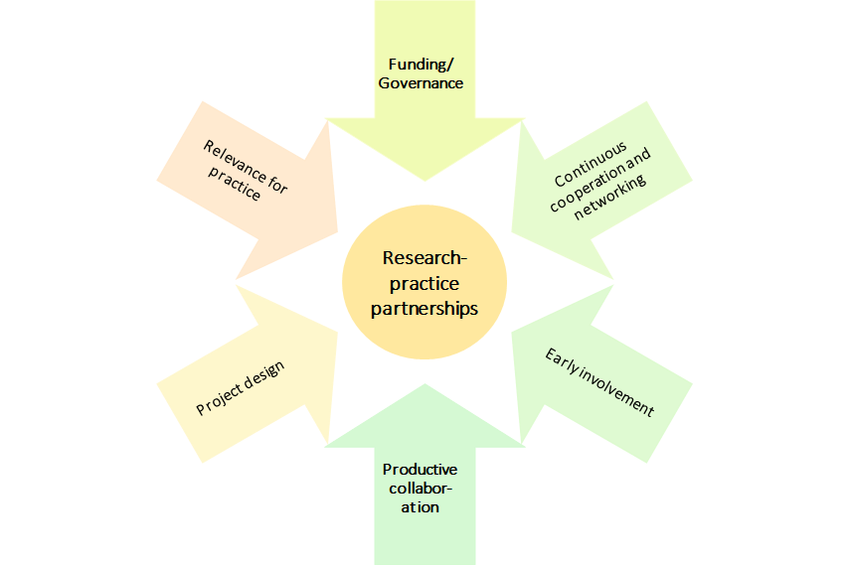

As shown in Figure XYZ, interviewees from practice identified seven ways to enhance impact from project collaborations with academia.

1. **Transfer from academic to practical knowledge:** Seven practice partners mentioned the limited use of academic knowledge for the “practical world”. One interviewee, for example, stressed that the *“distance between practice and research is huge”.* Many projects were simply not designed to fit knowledge accumulation outside academia. Hence, findings could not effectively be translated from academia to practice.

*“And of course, we asked the question a few times, how do you transfer this knowledge into practice […] because the project is very descriptive, and rightly so, but the question is, how do you then get a kind of practical transfer from these very descriptive results without too much structuring" Practice Partner 2*

In order to facilitate this transfer, projects need either an explicit design to enhance collective knowledge creation already at the early stages of a project or clear dissemination strategies to facilitate this transfer. Another way to ensure the transfer of knowledge is to refer to support from intermediaries or knowledge brokers.

1. **Long-lasting collaborations:** Three interviewed practice partners reported that there was no contact with academic partners beyond the project end. However, all of them noted that further exchange could have promoted impact as long-term change cannot be achieved within a few months or one year. To enhance impact through long-lasting collaborations between academic and practice partners specific programmes or funding schemes would be beneficial. However, they should be designed flexibly, allowing both parties to bring in their knowledge and resources.
2. **More dissemination and networks with other stakeholders:** A few practice partners reported that they would have wished for more dissemination of the project results and raising awareness of the role of practice partners. It was also highlighted that although there were some dissemination activities, they did not go far enough and failed to implement change. Moreover, missing networking was identified as a barrier to change. One interviewee, for instance, said that he would appreciate a platform that makes research available and connects researchers and practice partners.
3. **Increase relevance for practice:** A few practice partners also mentioned that academic research is often focused on theory development rather than addressing issues that concern practice partners. Accordingly, they cannot find relevance to their works in most academic research. In order to increase the relevance of academic knowledge for practice, practice partners should be included in a project early on in order to share their perspectives.
4. **Develop mutual goals and questions:** Similarly, it was stressed that there were no common goals within the collaboration framework of the project, which lowered the motivation of practice partners as well as their scope for action. One interviewee said that he had the feeling that the transdisciplinary approach rather benefited the researchers (e.g. because it was necessary to generate funding) but did not sufficiently include the interests of the practice partners. Hence, partnerships between academic and practice partners need to address the needs and goals of all partners.

*“We sometimes have interests, but the exact research question or the central interest of the research sometimes doesn't fit, and if it could only be slightly adapted it would sometimes be more useful for us, like that. That's the way it is, that's a theoretical assumption, but we sometimes see in projects where it's possible to get involved a bit earlier, that you can also give them add-ons that can then be used and are more useful to us.” Practice Partner 4*

1. **Intentional transdisciplinary design:** In addition, the level of involvement of practice partners could be increased within the projects. Correspondingly, an explicit framework that allows for mutual decision-making and mutual research activities could enhance the impact of collaborations. Contrarily, fixed and stringent ideas and presumptions should be avoided. Moreover, one interviewee partner said that research activities should be better tailored to the organisational context rather than designed beforehand.
2. **Foster bottom-up processes:** Two practice partners mentioned that the impact of the project was limited because the systems they operate in did not allow bottom-up processes. Accordingly, decisions were made on the top end of the “hierarchy”, which neglected the knowledge and experiences that are generated by people operating on the lower end of the hierarchy.

*“Yes, it's difficult to say from the bottom up, because change is very difficult there. Of course, it would have to be rinsed from the bottom up, so there would really have to be problems in practice, which would have to be passed on upwards, which would ultimately have to be changed politically.” Practice Partner 4*

Interactions with academic partners and challenges in these interactions

1. **Proposal phase:** Three interviewees reported that they interacted with academic partners during the proposal phase. However, these interactions played out very differently in all three cases. In one case, the exchange during the proposal phase was limited to some informal exchanges and some preliminary networking in order to ensure collaborations during later stages of the project. One interviewee reported that he experienced his role rather as a consulting role. Accordingly, he met twice with the research team to give some insights into his role and provide some ideas for the proposal. However, he said that the communication was rather restricted and did not have vast effects on the proposal development itself. Another practice partner involved in the proposal phase was able to contribute significantly to the writing of the proposal. Correspondingly, the practice partner said that he met several times with the research team where they “put backgrounds together and developed the project together”.

In general, however, we can conclude that in-depth exchanges with practice partners were missing during the proposal phase, which in some cases also limited the impact of further interactions. In order to increase the impact of cooperative interactions, exchanges should ideally start at an early project phase as this facilitates mutual trust-building and knowledge transfer and reduces the transaction costs. Questions that could be answered during this phase could be:

* Why and how is this issue relevant in practice?
* How can practice partners be involved in the later stages of the project?
* How could results be used in practice?

1. **Implementation phase:** Almost all practitioners reported exchanges with their academic partners during the implementation phase. Three modes of interaction could be identified:

* **Discussions:** Four interviewed practice partners said that they engaged in regular discussions about the project state with their academic partners. While they were not directly involved in the gathering of data or the implementation of the project, they gave continuous feedback and the researchers updated them about the projects’ progress. While one interview partner said that the interactions were sometimes bumpy due to misunderstandings or conflicts, most others said the discussions went very smoothly:

*“[…] it was always very uncomplicated and quick, so I could really send an email if I had questions, or if it was more complex, I could call and either it could be solved immediately, or an appointment was made for a meeting, and, yes, that was all that was necessary, so it was well supervised, you had your contact persons, and in the end it was a bit of a self-runner.” Practice Partner 3*

* **Exchange about results:** Other practice partners said that their exchange with academic partners was limited to the exchange about project results. Additionally, practitioners stressed that this partly resulted in limited usability of the results for practice since the generation of results was *“a one-way street rather than mutual effort”.* While this was sometimes the case because researchers did not reserve time for deeper exchanges, one interviewee stressed that he had limited finances in order to participate in more meetings:

*“I think I have to say that the exchange in the whole project, that is, between the whole project and me, individually, decreased a lot at the point where I simply no longer had a role, I had no finances.” Practice Partner 6*

Hence, in order to enable practice partners to effectively contribute to the project, funding could be provided.

* **Productive collaboration:** Two practice partners highlighted that they were intensively involved in the implementation phase. One of them reported that he supported the researchers with the development of a questionnaire and subsequently with the collection and interpretation of data. The other practitioner helped the project team with the recruitment of participants and also supported the team with the analysis of the results. Both interview partners stressed that this extensive collaboration enabled them to bring in their perspectives as well as to use the gained knowledge in practice.

1. **Exploitation phase:** Half of the interviewees reported exchanges during the exploitation phase. These were either:

* **Informal meetings:** Two practitioners said that they frequently met with the researchers during the dissemination phase. These meetings were mostly informal and included discussions regarding the usability of the results. These informal meetings also fostered the personal relationships between the researchers and the practitioners, which increases the probability of future collaborations.
* **Presentations:** In some cases, the researchers presented the project and its results at meetings with the organisations where either the practice partners or additional people from the respective organisation were present. While this was highly appreciated by the practitioners as well as their managers, it often did not go further in terms of future contact and cooperation.

*“We see the motivation and the efforts of the producers, I would say now, to make their research tangible, so they offer to come by, to present, also put it in context, for example. We see that. That's how it went in this case, and yes, but the contact remains relatively loose.” Practice Partner 7*

* **Conferences:** Three interviewed practice partners said that they either participated in or co-organized a conference with their academic partners. One interviewee emphasized extensive interactions during the dissemination phase. Correspondingly, he organized conferences as well as other formal events together with the academic partners, which enhanced the outreach to other stakeholders and widened the impact of the project.

*“We went to this exchange conference and we said "yes, come on, no, let's take that with us, let's play with it in practice, let's try to make it concrete and make it tangible in our context".” Practice Partner 8*

Some interviewed practice partners stressed that their involvement in the project declined over the different project stages. Accordingly, one interviewee mentioned that he was included in the writing of the proposal as well as the collection of data, however, he felt that communication was losing substance during the exploitation phase. While he attributed this to the lack of time and funding, he acknowledged that the potential outcome could have been even bigger if he had been able to contribute to the exploitation phase.

Benefits for practice partners

1. **Increasing knowledge:** While the impact on the practitioners’ work has overall been limited, many of them highlight the personal impact they gained from the collaboration. Accordingly, four practice partners highlighted that they gained remarkable knowledge from the exchange with academic partners since it allowed them to switch perspectives and get insights into research. One interviewee said that his work is so stressful that he does not have enough time to read every research article that might be interesting for him. However, by specifically working together with researchers who focus on his field, he had the chance to get insights into current publications and innovative work that is being done. Another interviewee underlined that he is still in regular contact with his academic partners, who update her on new research and findings that might be essential for her work.
2. **Building skills:** In addition to building up knowledge, practitioners also benefited from increasing specific skills relevant to their work. Correspondingly, two practice partners mentioned that they had the chance to work on their skills during the collaboration by having access to new data and new methods. Hence, these interviewees said that the academic partners provided them with resources that they could use to improve their skills and practices.
3. **Enlarging network:** One benefit that was mentioned by all practice partners is the aspect of an increased network. Researchers did not only collaborate with the practice partners alone but included them in their wider network. Thus, practitioners had the chance to interact with actors that are also relevant to their work. One researcher said that after the collaboration, he felt that power relations changed from being very hierarchically to being more equally distributed. Accordingly, before the project, she experienced misunderstandings and a lack of interest from other stakeholders. This, however, changed when she had the chance to communicate with others and got the chance to point out the challenges in her organisation.
4. **Contributing to change/impact:** Although the impact of the project on changing practices was limited according to most interviewees mostly because of structural limitations, the opportunity to contribute to a potential change was seen as beneficial for practitioners. They argued that despite the failure to achieve immediate structural change, practice partners had the feeling of being able to add to processes that can eventually lead to long-term change. This has two main benefits. First, one interview partner claimed that through being included in such a process, she felt empowered and heard since she had the feeling to be working with others on an equal footing. Second, one practitioner mentioned that he felt motivated to contribute to the creation of impact afterwards since he realised what can be possible when collaborating with others.

Sustainability and exploitation

1. **Follow-up project with academic partner:** One interviewed practice partner reported about a follow-up project with the academic partner. The practice partner mentioned that due to the trust that was built during the first collaboration, both parties agreed to continue working on relevant issues. Accordingly, the academic partner was already planning to start another project and the practitioner was hence asked whether he wanted to be involved again.
2. **Follow-up project without academic partner:** One interviewee said that he could use the collaborative project as a starting point to work on a follow-up project with other partners. Accordingly, the project raised his interest in a new method, which was only sparsely touched upon within the project. Accordingly, he wanted to further develop this method with other stakeholders but also with his academic partner who unfortunately had no time to contribute to the follow-up project.
3. **Continuing contact with academic partner:** Three practice partners mentioned that they are still in touch with their academic partners. While one stressed that this contact is only very loose, the two others said that they still have meetings with their academic partners where they update each other on their work. Both of these interviewees said that they could imagine future collaborations again, but the situation has not yet arisen.
4. **Bottom-up dissemination:** Two interviewed practice partners said that they were able to disseminate the project results to upper levels within their organisations. Although both of them claimed that they could not achieve a broader impact, they had the feeling of being heard by the management level. Furthermore, both of them argued that the positive experiences from the projects increased the willingness of the managers to further support employees to participate in such projects.
5. **Discussions:** Three practice partners said that they were or are still in the discussion either with colleagues from their organisation or with other experts. While these discussions do not happen on a regular basis, they provide fruitful ground for future project ideas. One interviewee said that he was explicitly approached by another expert in his field because this expert heard from him because of the research project. Hence, participating in research projects also allows practitioners to widen their network apart from the academic partner.
6. WRAP-UP 1: VALUATION OF FURHTER OUTCOME CATEGORIES OF SNSF FUNDED RESEARCH

The challenges discussed in the previous chapters as well as the manifold opportunities regarding the social innovation potential of SNSF funded projects show that there is sufficient leeway to increase the (social) impact of research projects. Hence, based on the interviews we identified ten areas of activity that can be seen as possible stations on the pathway to generate (social) impact and potentially more contributions to social innovation (see Figure CCC).

**Figure CCC: Intervention portfolio for (social) impact generation**

1. **Change priorities of universities:** Many interviewed PIs experienced support from their institutions in pursuing transdisciplinary and translational projects, both in terms of a supportive culture and concrete support offers like coaching. However, they also argued that the universities’ priorities are not focused on social innovation or social impact but rather on increasing outreach, communication/dissemination, and popularity. Achieving real outcomes are not perceived as the foremost goals. If researchers want to implement their results to achieve social change, they are expected to do that on top of their usual activities and not instead of those; this approach limits resources in terms of time and money. One way of refocusing these priorities and promoting applied and translational research is by teaching, in which students can be made aware of all the possible outlets and applications of science.
2. **Avoid top-down approaches:** Many interviewed PIs perceived top-down approaches, in which a research topic and approach are defined by a call or grant which requires a specific composition of the collaboration team, as artificial, even hampering social innovation at the end. They argued that good science and productive collaborations would develop naturally if given time and space. Similarly, a top-down approach of defining standards or indicators to measure and evaluate the impact of projects was considered restrictive, as social innovation is a multifaceted concept, and there are various different ways of being innovative.
3. The interviewed PIs further called for **more flexibility …**
   * **…to involve a broader spectrum of disciplines and different fields (e.g., also from the arts) and to allow funding for projects with different designs/rationales.** Transdisciplinary projects require flexibility to foster the involvement of non-scientists. This requires, on the one hand, creation of spaces for non-scientists to approach a research project in their own way without forcing the academic definition of what research is, and on the other hand, to give space for different approaches and rationales in the research design. This increased flexibility could be achieved if the evaluation criteria are designed in a more adaptable way.
   * **… to accustom different research fields, traditions and methodologies**. One aspect of lacking flexibility is that researchers tend to adapt their proposals not to what they think is innovative, relevant and reasonable, but to what they think the reviewers will understand and approve based on non-disrupted pre-defined review categories. But it is also acknowledged that the review of a transdisciplinary and interdisciplinary project proposal is not trivial, as it requires very broad knowledge and far-fetching understanding of different fields and applied contexts.

In addition, not all research fields fit into a straightforward planning scheme. Many directions in fieldwork and exploratory studies only develop after first investigations and research steps, and thus cannot be planned because they might change depending on new insights. Some researchers expressed the concern that currently the methodologies and research traditions predominantly common in the natural sciences are forced onto research from the field of SSH, which restricts their research and their approaches. Some of the PIs argued that terms like “method” or “methodology” are sometimes seen as critical in the humanities, and research methods like experiments are often irrelevant for a humanities researcher. They feel that their proposals and projects are evaluated based on criteria that do not apply to their fields and that their projects need to adapt to standards that do not fit their specific research. Accordingly, project funding schemes should adapt their evaluation criteria.

* + **… to allow for goals other than publication productivity and to widen the evaluation of what a good project is and what research should be.** The system of research in general, but also funding agencies like the SNSF heavily incentivise publishing in scientific journals as the main outcome of a project. However, translation or even implementation of project results in practice fields is not considered for publication by scientific journals and thus does not provide value for researchers’ careers and evaluations. Flexibility for different research designs and the involvement of different academic and non-academic actors could also be fostered if different outcomes would be encouraged.

*“[…] because the criteria for good science are: did you get money, did you hire people - it is the same as if you were managing a hotel or a company. […] but definitely, that is really not something I am proud of - I was stuck in this network of constraints and you just try to survive.” Interviewee 14*

* + **… to change directions during the project if new ideas for research strategies or insights arise.**

1. **Support for administration and flexibility regarding bureaucracy**: The administrative part of project planning and implementation can pose a challenge during the project, which – according to some interviewed PIs, sometimes hamper the extent of potential exploitations. PIs wish for more flexibility and support in the administrative process, which can be difficult, in particular in clinical research projects or other projects researching living subjects where specific ethics protocols need to be fulfilled. The administration is increasingly perceived to be overburdening and diminishing the freedom and flexibility of researchers. The SNFS and other funding agencies could provide a service to support scientists in handling administrative aspects of project proposals and project implementation. Also, flexibility in financing and funding could encompass extra time and money for individual cases.
2. **Enabling and encouraging project follow-up and prolongation:** As discussed in the previous chapter, the three-to-four-year framework of project work can hamper a project’s contribution to (social) innovation, as it restricts time for dissemination, for follow up with practice partners, and investigation of new questions or ideas that developed during the project. Some PIs emphasised an issue regarding the way of how new proposals are evaluated; they claimed that there is too much focus on the novelty of the topic and approach, compiling a new project team, and doing something different than before. At the same time, the academic career requires researchers to swiftly jump from one project to the next in order to be funded, which leaves little time for project dissemination and exploitation, not at least due to the fact that new proposals need to be developed already during the lifetime of the ongoing project. However, implementing change and achieving impact is a long-term process that requires stability and continuity.

This issue also reveals a fundamental contradiction between the concepts of scientific impact and social innovation. Practices for achieving scientific impact include frequent change of project members (such as PhD students), frequent change of topics and research questions, and novelty. However, practices for achieving (social) innovation include long-term knowledge and capacity building as well as continuous efforts for communication, dissemination, and relationship building among stakeholders and practitioners.

*“This whole funding and application policy is actually somewhat at odds with the ability of research, to research social innovations, to accompany them, and actually to accompany them in such a way that the other actors then also notice how important the research is by seeing the continuity and seeing the knowledge build and not seeing - now a graduate student comes along and now another graduate student comes along and so on.” Interviewee 9*

*“You have funding for three years, and then within three years you start the same project again? So this is not original! That's not new!’ Whether it's articles or research projects, I've had this kind of remark very often.” Interviewee 15*

There are different ways of designing opportunities for prolongation and follow-up. Suggestions expressed by the interviewed PIs refer to two levels:

* First, on the level of the funding scheme: funding schemes could include a fast track to apply for funds, for instance, to develop a market-ready product, or a funding instrument specifically for implementation and transfer work, which funds one or several applied follow-up projects.
* Second, on the level of the project, differentiated by project phases. In the proposal phase, it could be required or asked that proposals already include a plan or concept of project exploitation. In addition, calls for proposals could encourage longitudinal research designs, in which the same people are followed and investigated over a longer period of time to better capture changes. Towards the end of the project, the SNSF could allow for or plan three to six months of extra project time devoted to dissemination, communication and exploitation of results.

*“Our daily routine is that when the SNSF money runs out, we have to land the next one and have relatively little time to continue working on the project, although there is no point in stopping there. There are other logics at play here. If only the SNSF were to add a buffer so that the results could be distributed even more widely.” Interviewee 22*

*“But that you would then have another six months, perhaps, to really speak to various organisations, bodies, institutions, and perhaps also to prepare the results in a slightly different way, in addition to articles or monographs, so that you could also better bring them to the people, that is simply not possible within a project.” Interviewee 23*

1. **Foster structures/systems/institutions for internationalisation and collaboration among researchers:** Some PIs also stressed that international networks and collaborations are essential for creating impact. One way this could be achieved is by creating and fostering a network of European scientists where Switzerland takes on a prominent role so that scientists working in Switzerland will also be able to join European coordinated projects. Other PIs also mentioned the possibility of creating more National Competence Centres for collaboration on big, important topics.
2. **Promote transdisciplinary work:** Overall many of the interviewed PIs expressed interest in systematically connecting research and practice by promoting and engaging in transdisciplinary projects. In particular, this should not be left on the shoulders of the individual researchers who then have to do that on top of their usual academic work, but it should be systematically enforced by institutions such as the SNSF and universities. The promotion of transdisciplinary work is seen as vital to achieve social impact and, as such, to contribute to social innovation. It could take different forms:
   1. **Strengthen dialogue and transfer between research and practice:** Creating opportunities for connecting and strengthening the dialogue and transfer between researchers and relevant stakeholders from practice. Diversity is key here, as it is perceived as important to bring together people with different skills and profiles. Support could start by connecting researchers with relevant practice partners, such as policy-makers. It was argued taht SNFS could use its reputation to actively promote funded projects among policy makers and practitioners and accelerate networking. SNSF could also facilitate connections with applied experts from the university of applied sciences.
   2. **Increase structured/institutionalised cooperation with and involvement of stakeholders:** Some of the interviewed PIs perceived the involvement of stakeholders, ideally from an early stage on, as vital for achieving outcomes and for contributing to social change. Communication and knowledge transfer should go beyond simply sharing reports. Cooperations could also focus on jointly identifying problems and developing research questions so that the findings can be more readily implemented in practice and achieve higher impact. This could also be addressed by particularly supporting young researchers with a practice background or recruiting practitioners or people from the industry for coaching researchers. Cooperation with practice partners who can then also bring in their problems and the joint development of solutions were perceived as potential pathways to foster social impact.

*“The interaction with the actors on the ground and the kind of expertise they bring up and thinking about how we should organise ourselves so that we can overcome certain barriers together, that's what I find exciting.” Interviewee 16*

*“But if you want to have an impact, you have to create a cooperation with these policymakers. You have to invite them to university, you have to make sure they understand what you are doing, […] and have a more proactive approach.” Interviewee 17*

Importantly, these efforts for cooperation and involvement should not be left on the shoulders of the researchers alone; rather, it is necessary to create structures or institutions that provide guidance and support already during project development and implementation.

*“If one of the ultimate goals of the SNF is to change society through science, I believe some centralisation is needed there - if we leave researchers by the task of doing that by themselves, that is fine, but they need some guidance, some audit, at least, during, not ex-post, like we are doing now, but during the project development.” Interviewee 17*

An example of support structures mentioned by the interviewees are regional centres in which researchers and practitioners come together to exchange. Project results should be feed into these centres, while practitioners can receive support or training in scientific methods and in understanding these results.

1. **Support for commercialisation:** Five interviewees mentioned that they would have appreciated support in producing patents and protecting their ideas. Moreover, general support for getting in touch or creating networks with industry or the involvement with relevant partners was seen as a potential facilitator for commercialisation.
2. **Support in media work and science communication:** Support in overall media work would be appreciated, including “marketing” of ideas and products, “marketing” on social media, cooperation with journalists, as well as science communication with practitioners and the general public. Researchers often do not feel confident in dealing with media and are afraid that their ideas are incorrectly or inaccurately communicated.
   * **“Marketing”:** Many of the interviewed PIs regarded the development of “marketing” ideas that target the society and policy makers as helpful. They also stressed that “marketing” their own research is very tiring - albeit necessary - especially as researchers do not have the time to do “marketing” on top of their research.
   * **Social media:** Some PIs expressed interest in getting support for communicating results on social media platforms because there, they argued, researchers can better control their messages.
   * **Science communication:** Researchers are used to communicating with other researchers about their projects and findings, but often find it difficult to transfer the findings into a format, which appeals the interest of the general public. In particular, researchers fear that their transfer work could result in inadequate generalisations or misunderstandings of their findings. In order to support researchers with dissemination, experts in science communication could be consulted. These experts could help researchers in translating their insights and findings into an accurate but digestible version for communication in non-scientific areas and for the general public.
   * **Trustworthy journalists:** One researcher expressed that she would like the SNF to work together with journalists who are rigorous and trustworthy and who will cooperate with researchers to write about their findings. In this context, it is important that vulnerable or excluded groups are not misrepresented or exploited for the purpose of the article. It is also important that a long-term relationship with this journalist can be developed in order to build trust.

*“If that was a freelance journalist, for example, then, if I were to plan something like that again, then I had good experiences with her and then I would perhaps approach her specifically and say - could you imagine, perhaps under the conditions, to do so and so. And then the person would perhaps see where they could cooperate with which newspaper, for example. Then that would be the concrete support, I think, that you could work together with such an experienced person.” Interviewee 18*

1. **More funding:** In general, many of the interviewed PIs, would wish for more funding:

* for involving and cooperating with applied institutions and practice partners
* for applied research projects
* for infrastructure, employees, equipment, conferences and events
* for time to publish in general and especially for higher quality publications
* diverge more funding to social sciences and humanities

*“I am full of admiration, but there are billions for those who go to study the stars and non-billions for those who go to study individuals on Earth.” - Interviewee 15*

1. WRAP-UP 2: TOWARDS A MODEL OF ASSESSING SNSF’ CONTRIBUTION TO SOCIAL INNOVATIONS

Our proposal aims to trace contributions of research funded by SNSF to social innovations, and to systematise these contributions in a valuation framework. In addition, we aim to identify to what extent contributions to social innovation in SNSF-funded research projects are possible at all, and where further support measures, either provided by SNSF or from outside (e.g. by the universities), could create an added value that could not be tapped so far.

1. LITERATURE

Antons, D., Grünwald, E., Cichy, P. and Salge, T.O. (2020), ‘The application of text mining methods in innovation research: current state, evolution patterns, and development priorities’, in R&D Management, 50: 329-351. https://doi.org/10.1111/radm.12408

Benneworth, P. (2015), ‘Tracing How Arts and Humanities Research Translates, Circulates and Consolidates in Society. How have Scholars been Reacting to Diverse Impact and Public Value Agendas?’, *Arts and Humanities in Higher Education,* 14 (1), 45-60.

Blei, D. M., Ng, A. Y., & Jordan, M. I. (2003), ‘Latent dirichlet allocation’, in Journal of machine Learning research, 3(Jan), 993-1022

Bonno, Pel et al. (2020), ‘Towards a theory of transformative social innovation -- A relational framework and 12 propositions’, in Research Policy 49.8 (2020): 104080

Bornstein, N, Pabst, S and Sigrist, S. (2014), Zur Bedeutung von sozialer Innovation in Wissenschaft und Praxis. W.I.R.E, Forschungsbericht erstellt im Auftrag des Schweizerischen Nationalfonds (SNF).

Brundenius, C. (2017), ‘Challenges of rising inequalities and the quest for inclusive and sustainable development’, in C. Brundenius, B. Göransson, and J. M. Carvalho de Mello, (eds*) ‘Universities, Inclusive Development and Social Innovation’*, Switzerland: Springer, 9 -69.

Cana, Umit and Bilal Alatas (2020), ‘A new direction in social networkanalysis: Online social network analysis problems and applications’, In Physica A: Statistical Mechanics and its Applications 535: 122372, doi: 10.1016/j.physa.2019.122372

Cunha, J. and Benneworth, P. (2013), ‘Universities’ contributions to social innovation: towards a theoretical framework’, paper presented at EURA Conference 2013, 3-6 July, Enschede, The Netherlands.

Davidovitch, N., and Eckhaus, E. (2018), ‘Effect of faculty on research cooperation and publication: Employing natural language processing’, in *Economics & Sociology* 11.4 (2018): 173

Dees, J. G. (1998), ‘The Meaning of Social Entrepreneurship’, Graduate School of Business. Stanford University.

Degelsegger, A. and Kesselring, A. (2012), ‘Do Non-Humans Make a Difference? The Actor-Network-Theory and the Social Innovation Paradigm’, in H. W. Franz, J. Hochgerner and J. Howaldt (eds), *‘Challenge social innovation Potentials for business, social entrepreneurship, welfare and civil society’*, Berlin and New York: Springer, 57-72.

Ferner, Cornelia, et al. (2020) ‘Automated Seeded Latent Dirichlet Allocation for Social Media Based Event Detection and Mapping`, in Information 11.8 (2020): 376.

Godin, B. (2012), ‘Social Innovation: Utopias of Innovation from c.1830 to the Present’, project on the Intellectual History of Innovation, Working Paper N. 11. Montreal.

Gök, A., Milosevic, N., Nenadic, G., Catalano, G., Daraio, C., Gregori, M., Moed, H. F. and Ruocco, G, eds. (2019) Using machine learning and text mining to classify fuzzy social science phenomenon : the case of social innovation. In: 17th International Conference on Scientometrics and Informetrics, ISSI 2019. International Society for Scientometrics and Informetrics, ITA, pp. 2171-2176. ISBN 9788833811185

Hellsten, I., Opthof, T. and Leydesdorff, L. (2020): N-mode network approach for socio-semantic analysis of scientific publications. Poetics, Volume 78. <https://doi.org/10.1016/j.poetic.2019.101427>

Howaldt, J. (2019), ‘New pathways to social change – creating impact through social innovation research’, *fteval Journal for Research and Technology Policy Evaluation,* 48/July 2019, 37-48.

Howaldt, J., Kopp, R. and Schwarz, M. (2015), *‘On the theory of social innovations: Tarde's neglected contribution to the development of a sociological innovation theory’*, Weinheim: Beltz Juventa. <https://nbn-resolving.org/urn:nbn:de:0168-ssoar-419633>

Howaldt, J., Butzin, A., Domanski, D. and Kaletka, C. (2014), ‘Theoretical Approaches to: Social Innovation. A Critical Literature Review’, a deliverable of the project ‘Social Innovation: Driving Force of Social Change’ (SI-DRIVE), Dortmund: Sozialforschungsstelle.

Howaldt, J. and Schwarz, M. (2010), ‚Social Innovation: Concepts, Research Fields and International Trends’, IMO International Monitoring. Dortmund: Sozialforschungsstelle, TU Dortmund University.

Li, X., Ouyang, J., Zhou, X., Lu, Y., and Liu, Y. (2015), Supervised labeled latent Dirichlet allocation for document categorization. *Applied Intelligence*, *42*(3), 581-593.

Lindstedt, N. C. (2019), Structural Topic Modeling For Social Scientists: A Brief Case Study with Social Movement Studies Literature, 2005–2017. *Social Currents*, *6*(4), 307–318. <https://doi.org/10.1177/2329496519846505>

Lizuka, M. (2013), ‘Innovation systems framework: still useful in the new global context?’, UNU-MERIT Working Papers #2013-005.

Moulaert, F., Mac Callum, D. and Hillier, J. (2013), ‘Social Innovation: intuition, precept, concept, theory and practice’, in F. Moulaert, D. MacCallum, A. Mehmood, and A. Hamdouch, (eds), *The International Handbook on Social Innovation: Collective Action, Social Learning and Transdisciplinary Research*, Cheltenham: Edward Elgar, pp. 13-24.

Murray, R., Caulier-Grice, J and Mulgan, G. (2010), ‘The Open Book of Social Innovation’, NESTA and the Young Foundation.

Novotny, H., König, T. and Schuch, K. (2019), ‚Impact Re-Loaded’, *fteval Journal for Research and Technology Policy Evaluation,* 48/July 2019, 8-9.

Nussbaum, M. (2010), *Not for Profit. Why Democracy Needs the Humanities.* Princeton: Princeton University Press.

Perotte, A. J., Wood, F., Elhadad, N., and Bartlett, N. (2011), Hierarchically supervised latent Dirichlet allocation. In *Advances in neural information processing systems* (pp. 2609-2617).

Pol, E and Ville, S. (2008), ‘Social Innovation: Buzz Word Or Enduring Term? Working Paper 08-09, Wollongong: Department of Economics, University of Wollongong.

Prüfer, P. and Rexroth, M. (2005), Kognitive Interviews. ZUMA-How-to-Reihe Nr. 15.  
<https://www.gesis.org/fileadmin/upload/forschung/publikationen/ge-sis_reihen/howto/How_to15PP_MR.pdf>

Ramage, D., Rosen, E., Chuang, J., Manning, C. and Mcfarland, D. (2009). Topic Modelling for the Social Sciences.

Reale, E., Avramov, D., Canhial, K., Donovan, C., Flecha, R., Holm, P., Larkin, C., Lepori, B., Mosoni-Fried, J., Oliver, E., Primeri, E., Puigvert, L., Scharnhorst, A., Schubert, A., Soler, M., Soòs, S., Sordé, T., Travis, C. and Van Horik, R. (2018), ‘A review of literature on evaluating the scientific, social and political impact of social sciences and humanities research, *Research Evaluation,* 27 (4), 298–308.

Roberts E. M., Brandon M. S. and Edoardo M. A. (2016), A Model of Text for Experimentation in the Social Sciences, *Journal of the American Statistical Association*, 111:515, 988-1003, DOI: 10.1080/01621459.2016.1141684

Schäfer, T. and Kieslinger, B. (2016), *‘Supporting emerging forms of citizen science: A plea for diversity, creativity and social innovation’*, Journal of Science Communication, 15(2), 1-12.

Schuch, K. (2019), ‘The contribution of social sciences and humanities to social innovation’, in J. Howaldt, A. Schröder, C. Kaletka, and M. Zirngiebl, M. (eds.), *Atlas of Social Innovation*, *2nd Volume: A World of New Practices’*, Munich: Oekom Verlag, 95-98.

Schuch, K. and Salamon, N. (2021), ‘Reflections on the presumably difficult relation between social innovation and social sciences‘, in J. Howaldt, C. Kaletka and A. Schröder (eds), A Research Agenda for Social Innovation, Edward Elger Publishing (forthcoming).

Shirk, J. L. et al. (2012). Public participation in scientific research: a framework for deliberate design. Ecology and Society 17(2). Spaapen and Drooge, 2011

Smith, Steven T., Edward K. Kao, Danelle C. Shah, Olga Simek, and Donald B. Rubin (2018), ‘Influence Estimation on Social Media Networks Using Causal Inference’, in IEEE Statistical Signal Processing Workshop (SSP), doi: 10.1109/SSP.2018.8450823

Stanley Wasserman and Katherine Faust (1994), ‘Social Network Analysis: Methods and Applications’, Vol. 8. Cambridge university press.

Wen, Sheng et al. (2015), ‘A Sword with Two Edges: Propagation Studies on Both Positive and Negative Information in Online Social Networks’, in IEEE Transactions on Computers, vol. 64, no. 3, pp. 640-653, doi: 10.1109/TC.2013.2295802

Asendorpf, J. B., Banse, R. and Mücke, D. (2002). Double dissociation between implict and explicit personality self-concept: the case of shy behavior. J Pers Soc Psychol 83(2):380-393. https://doi.org/10.1037//0022-3514.83.2.380

Egloff, B. and Schmukle, S. C. (2002). Predictive validity of an implict association text for asessing anxiety. J Per Soc Psychol 83(6):1441-1455. https://doi.org/10.1037//0022-3514.83.6.1441

Fazio, R. H. and Olson, M. A. (2003). Implict measures in social cognition research: their meaning and use. Annu Rev Psychol 54(1):297-327. https://doi.org/10.1146/annurev.psych.54.101601.145225

Froschauer**,** U. und Lueger, M. (2003): Das qualitative Interview. Zur Praxis interpretativer Analyse sozialer Systeme. Wien: Facultas wuv.

Greenwald, A.G., Nosek, B. A. and Banaji, M. R. (2003). Undertanding and using the implicit association test: I. An improved scoring algorithm. J Pers Soc Psychol 85(2): 197-216. https://doi.org/10.1037/0022-3514.85.2.197

Greenwald, A.G., McGhee, D. E. and Schwartz, J. L. (1998). Measuring individual differences in implicit cognition: the implicit association test. J Pers Soc Psychol 74(6):1464

Greenwald, A.G. and Banaji, M. R. (1995). Implicit cognition: attitudes, self-esteem, and steretypes. Psychol Rev 102(1):4-27

Kaisler, R. E. and Missbach, B. (2020). Co-creating a patient and public involvement and engagement ‚how to guide‘ for researchers. Research Involvment and Engagement 6(32). [**https://doi.org/10.1186/s40900-020-00208-3**](https://doi.org/10.1186/s40900-020-00208-3)

Karpinski, A. and Hilton, J. L. (2001). Attitudes and the implicit association test. J Pers Soc Psychol 81(5):774-788

Kim, D-Y 82003). Voluntary controllability oft he implicit association test (IAT). Soc Psychol Q 661(1):83-96

Lueger, M.(2000). *Grundlagen qualitativer Feldforschung*. Methodologie – Organisierung – Materialanalyse. Wien: WUV – Universitätsverlag.

[Mayring](https://www.weltbild.at/suche/Philipp%20Mayring), P. (2015) *Qualitative Inhaltsanalyse.* Neuausgabe, 12. vollständig überarbeitete und aktualisierte Auflage. Beltz.

Prüfer, P., and Rexroth, M. (2005) Kognitive Interviews. ZUMA-How-to-Reihe Nr. 15.  
<https://www.gesis.org/fileadmin/upload/forschung/publikationen/ge-sis_reihen/howto/How_to15PP_MR.pdf>

Reale, E., Nedeval, M., Thomas, D. and Primeri, E. (2014). Evaluation through impact: a different viewpoint. fteval Journal for Research and Technology Policy Evaluation. Issue 39, Sept. 2014, pp. 36-41.

Schäfer, T. and Kieslinger, B. (2016). Supporting emerging forms of citizen science: A plea for diversity, creativity and social innovation. Journal of Science Communication, 15(2), 1-12.

Schuch et al. (2016). RRI in Österreich. Positionspapier ‚Verantwortungsbewusste Forschung und Innovation‘. Begriffsbestimmung, Herausforderungen, Handlungsempfehlungen. Plattform RRI Österreich. (engagement chapter written by K. Schuch). <https://www.rri-plattform.at/index.php/activities/>; accessed on 11 August 2020.

Shirk, J. L. et al. (2012). Public participation in scientific research: a framework for deliberate design. Ecology and Society 17(2).

Staley, K. (2009). Exploring impact: public involvement in NHS, public health and social care research. INVOLVE. NHS; <https://www.invo.org.uk/posttypepublication/exploring-impact-public-involvement-in-nhs-public-health-and-social-care-research/>; accessed on 10 August 2020.

Steiner, g., Geissler, B., Schreder, G. and Zenk, L. (2018). Living sustainability, or merely pretending? From explicit self-report measures to implicit cognition. Sustainability Science. https://doi.org/10.1007/s11625-018-0561-6

1. ANNEX

I. Fields/domains of interview partners

|  |  |
| --- | --- |
| **Field/Domain** | **Number of interviews** |
| Neuroscience | 2 |
| Psychology | 3 |
| Education and learning sciences | 3 |
| Economics | 1 |
| Other Languages and Literature | 2 |
| Social Sciences | 3 |
| Theology | 2 |
| Political Science | 2 |
| Organic Chemistry | 1 |
| Computer Science | 1 |
| Visual Arts and Art History | 2 |
| Biophysics | 1 |
| Architecture and social urban science | 1 |
| Physics | 1 |
| Information Technology | 1 |
| Medical Microbiology | 1 |
| Legal Sciences | 3 |
| Swiss History | 1 |
| Medical Technology | 1 |
| Medicine | 1 |
| Arts | 1 |
| General History | 1 |
| Neurophysiology and Brain Research | 1 |
| Bioengineering | 1 |
| Social Work | 2 |
| Molecular Biology | 1 |
| Humanities | 1 |
| Sociology | 1 |
| Ethnology | 2 |
| Astronomy, Astrophysics and Space Sciences | 1 |
| Geochemistry | 1 |
| German and English languages and literature | 1 |

Table 17: Self-assessment in terms of transdisciplinary experience, familiarity with SI, project's contribution to SI

|  |  |  |  |  |  |  |
| --- | --- | --- | --- | --- | --- | --- |
| Rating | Transdisciplinary experience  (n = 352) | | Familiarity with SI  (n = 360) | | Project's contribution to SI  (n = 112) | |
| *0..lowest*  *10..highest* | abs | % | abs | % | abs | % |
| 0 | 19 | 5.26% | 116 | 32.22% | 5 | 4.46% |
| 1 | 17 | 4.71% | 36 | 10.00% | 3 | 2.68% |
| 2 | 26 | 7.20% | 33 | 9.17% | 12 | 10.71% |
| 3 | 31 | 8.59% | 37 | 10.28% | 13 | 11.61% |
| 4 | 21 | 5.82% | 25 | 6.94% | 7 | 6.25% |
| 5 | 37 | 10.25% | 37 | 10.28% | 13 | 11.61% |
| 6 | 32 | 8.86% | 17 | 4.72% | 8 | 7.14% |
| 7 | 58 | 16.07% | 19 | 5.28% | 17 | 15.18% |
| 8 | 40 | 11.08% | 20 | 5.56% | 22 | 19.64% |
| 9 | 27 | 7.48% | 6 | 1.67% | 6 | 5.36% |
| 10 | 44 | 12.19% | 14 | 3.89% | 6 | 5.36% |
| no response | *9* |  | *0* |  | *1* |  |

Table 18: Level of interdisciplinary and transdisciplinary involvement

|  |  |  |  |  |  |  |
| --- | --- | --- | --- | --- | --- | --- |
| Involved stakeholder group | no | | only marginally | | quite centrally | |
|  | **abs** | **%** | **abs** | **%** | **abs** | **%** |
| ACADEMIC |  | | | | | |
| researchers from other disciplines (n=361) | 80 | 22.16% | 133 | 36.84% | 148 | 41.00% |
| NON-ACADEMIC |  | | | | | |
| company/business representatives (incl. farmers) (n=352) | 269 | 76.42% | 54 | 15.34% | 29 | 8.24% |
| representatives of NGOs, advocacy or other civil society groups (n=354) | 302 | 85.31% | 35 | 9.89% | 17 | 4.80% |
| policy makers, public administrations, representatives from governmental agencies (n=355) | 260 | 73.24% | 64 | 18.03% | 31 | 8.73% |
| individual citizens (e. g. as beneficiaries, customers, or concerned persons) (n=353) | 266 | 75.35% | 52 | 14.73% | 35 | 9.92% |
| media representatives (traditional media, digital media (e. g. bloggers), journalists, community-led media, etc.) (n=351) | 232 | 66.10% | 105 | 29.91% | 14 | 3.99% |
| representatives from welfare- or education-providing institutions (such as schools, kindergartens, hospitals, or care centres) (n=352) | 275 | 78.13% | 48 | 13.64% | 29 | 8.24% |

Table 19: Nature of transdisciplinary involvement per stakeholder group

|  |  |  |  |  |  |  |  |  |  |  |
| --- | --- | --- | --- | --- | --- | --- | --- | --- | --- | --- |
| Involved stakeholder group | consultative[26] | | contributory[27] | | | collaborative[28] | | | co-created[29] | |
|  | **abs** | **%** | **abs** | | **%** | **abs** | **%** | | **abs** | **%** |
| ACADEMIC |  | | |  | | | |  | | |
| researchers from other disciplines (n=278) | 37 | 13.31 | 57 | | 20.50 | 109 | 39.21 | | 75 | 26.98 |
| NON-ACADEMIC |  | | |  | | | |  | | |
| company/business representatives (incl. farmers) (n=80) | 28 | 35.00 | 30 | | 37.50 | 16 | 20.00 | | 6 | 7.50 |
| representatives of NGOs, advocacy or other civil society groups (n=51) | 26 | 50.98 | 17 | | 33.33 | 5 | 9.80 | | 3 | 5.88 |
| policy makers, public administrations, representatives from governmental agencies (n=94) | 49 | 52.13 | 33 | | 35.11 | 7 | 7.45 | | 5 | 5.32 |
| individual citizens (e. g. as beneficiaries, customers, or concerned persons) (n=82) | 41 | 50.00 | 26 | | 31.71 | 7 | 8.54 | | 8 | 9.76 |
| media representatives (traditional media, digital media (e. g. bloggers), journalists, community-led media, etc.) (n=114) | 77 | 67.54 | 28 | | 24.56 | 8 | 7.02 | | 1 | 0.88 |
| representatives from welfare- or education-providing institutions (such as schools, kindergartens, hospitals, or care centres) (n=74) | 32 | 43.24 | 20 | | 27.03 | 16 | 21.62 | | 6 | 8.11 |

**

**Getting in touch with the ZSI – Zentrum für Soziale Innovation**

Address:

Linke Wienzeile 246

1150 Vienna

Austria

Phone:

0043-1-4950442-0

eMail:

[*office@zsi.at*](mailto:office@zsi.at)

www.zsi.at

1. cf. *What is transdisciplinary research?* at <https://naturalsciences.ch/transdisciplinarity> [last accessed: March 2022]
2. Shirk, J. L. et al. (2012). Public participation in scientific research: a framework for deliberate design. Ecology and Society 17(2).
3. Staley, K. (2009). Exploring impact: public involvement in NHS, public health and social care research. INVOLVE. NHS; <https://www.invo.org.uk/posttypepublication/exploring-impact-public-involvement-in-nhs-public-health-and-social-care-research/>; accessed on 10 August 2020.
4. RTI abbr. Research, Technology and Innovation
5. Schuch et al. (2016). RRI in Österreich. Positionspapier ‚Verantwortungsbewusste Forschung und Innovation‘. Begriffsbestimmung, Herausforderungen, Handlungsempfehlungen. Plattform RRI Österreich. (engagement chapter written by K. Schuch). <https://www.rri-plattform.at/index.php/activities/>; accessed on 11 August 2020.
6. Public participation i soften understood as citizen participation, which in no way means a restriction to formal representative democratic forms of participation. Participation can mean the involvement of stakeholders (e.g. interest groups), but also the participation of people who are usually not involved in RTI-relevant processes of decision-making (so-called laypersons). Such people are sometimes seen as experts in their own ‘Lebenswelt’. Different participation processes can also be classified according to other dimensions, such as the type of representation (laypersons, stakeholders, experts), the way they are addressed (value, interests, knowledge) and the form of political action (exploratory, framework-setting) (Schuch et al, 2016).
7. Murray, R., Caulier-Grice, J. and Mulgan, G. (2010): The Open Book of Social Innovation. Ways to design, develop and grow social innovation. The Young Foundation and NESTA.
8. To reduce the overall time needed to fill in the online questionnaire, filters based on responses to previous questions were used. This is an example of such a filter – only those participants would actually get to self-assess their project’s contribution to SI who were at least moderately familiar with the concept of SI (5 or higher).
9. See Schuch (2019), 94–97. for an analysis of the contribution SSH fields offer to SI and Paunov et al. (2017) for different types of contributions from different disciplines to innovation in a broader sense.
10. The Kruskal-Wallis method is a non-parametric alternative to ANOVA
11. Pairwise Wilcoxon rank sum test is a non-parametric substitute to the pairwise t-test.
12. Note that an interview bias exists, because we selected potential interviews based on their proximity to familiarity with understanding the concept of social innovation and/or transdisciplinary research experience to harvest information from those who have the deepest record of understand of these two items.
13. Research programmes, for instance, allow only a certain corridor for action; some call for more applied research, while others derive their justification from publishing as many papers as possible in highly ranked journals.
14. After the consideration of dominant variable types and distributions, as well as the often non-linear relationship between variables, the Spearman correlation method was chosen to test for correlations. The *correlation coefficient* is indicated by the English spelling of the common symbol of Spearman’s rank correlation coefficient symbol **ρ**, i. e. **rho**. The reason for this is to clearly distinguish between the very similar-looking **ρ (rho)** and **p**, as in the **p-value** that is often shown in parentheses.
15. Study-wide, the α value is 0.05.
16. Please take not of the interview bias caused by the selection of interviewees (i.e. those with a high familiarity with SI or transdisciplinary research).
17. The target groups were “welfare and educational institutions”, “specific social groups”, “the general population”, “policy-makers and public administration”, “NGOs, civil society groups” and “businesses”.
18. <https://www.merriam-webster.com/dictionary/practice>
19. <https://www.merriam-webster.com/dictionary/behavior>
20. The exact question in the survey was “To what degree has your project directly contributed to new or better services, products, processes or ways of doing things that were targeted towards …. (i) the general population, (ii) businesses, (iii) specific social groups (e.g. women/men/non-binary; youth/elderly; migrants; or minorities/indigenous people); (iv) welfare- and education providing institutions (such as schools, kindergartens, hospitals, or care centres); NGOs, advocacy or other civil society groups; policy-making, public administration, governmental agencies; academia).
21. e. g. women/men/non-binary, youth/elderly; migrants; or minorities/indigenous people
22. such as schools, kindergartens, hospitals, or care centres
23. We suspect that the relatively high significant association between motivation to improve the human condition/welfare and the general population has to do with the contribution of medical research in addition to SSH.
24. For a brief discussion about the scale of the research and scalability of the research results in the context of citizen participation, see P. 56 in Svidroňová et al., *Co-Creation and Citizen Involvement in Social Innovation: A Comparative Case Study across 7 EU-Countries*.
25. The concept of scalability has been operationalised under 3 different categories in the survey (deep -, out -, and up scalability). However, after a dimension reduction process in the analysis (explanatory and confirmatory factor analysis), it has been decided to compile the sub-variables of scalability into one single scalability variable because of the similarity of their explained variances. Either because of the similarity of concepts or because of the lack of the knowledge on different forms of scalability the responses under different categories were highly similar (or because of common method bias).
26. provide information via interviews, online questionnaires, etc.
27. consultative + contributing through collecting data, validating data, disseminating results, etc.
28. contributory + interpreting data and/or drawing conclusions
29. collaborative + participated in designing study and/or determining objectives